The Field (or Pitch):
- Overall Dimensions = 100-130yds x 50-100yds (91-120m x 49-91m):
  - Recommend size = 110-120yds x 70-80yds (100-110m x 64-75m).
- The Scoring Posts:
  - Consists of four posts without a crossbar or net.
  - Goalposts (the 2 inner ones) = 8yds wide x 16yds high (7.32m wide x 15m high).
  - Behind posts (the 2 outer ones) = 6yds wide x 11yds high (5.5m wide x 10m high).
- Goal Area = 20yds x 6yds (18.3m x 5.5m).
- Penalty Area = 44yds x 18yds (40.3m x 16.5m).
- Center Circle = 20yds (18.3m) in diameter.
- Corner Arc = 1yd (1m).
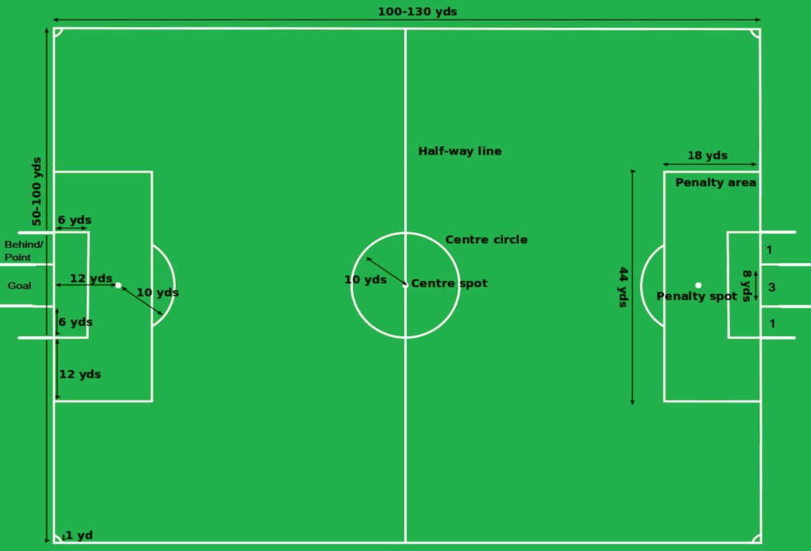
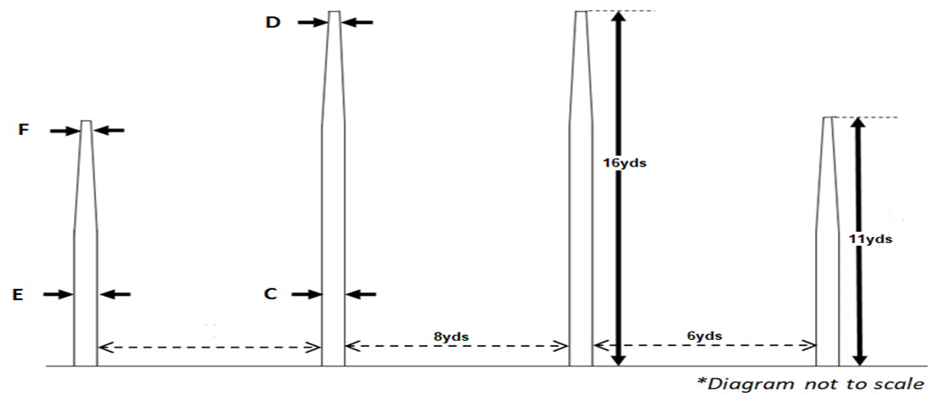

The Ball:
- Option #1 = Size 5 Soccer Ball:
  - Circumference = 68-70cm (27-28").
  - Weight = 410-450g (14-16oz).
  - Inside Pressure = 8.7-16.1psi
- Option #2 = Size 5 Gaelic football:
  - A round leather football made of 18 stitched leather panels, similar in appearance to a traditional volleyball (but larger).
  - Circumference = 68–70 cm (27–28”).
  - Weight = 480-500g (17–18oz) when dry.

General Rules:
- A game or match consists of 2 45-minute halves with a 15-minute halftime:
  - When play is unduly delayed, such as the ball going out of the playing area, the clock is not stopped and time is added on for stoppages in play (such as when the ball goes out of bounds, injuries, goals/behinds being kicked, or when the umpire is setting the angle of a free kick on goal; similar to Soccer).
  - The half or match ends immediately when a field umpire hears the siren, with the exception that a player is allowed to kick for goal after the siren from a mark or free kick which was paid before the siren.
- A game/match is overseen by 6 officials:
  - 1 Field Umpire - the field umpire (also known as a central umpire) is responsible controlling general play, and is positioned within the field of play. The field umpire is the only type of umpire permitted to award free kicks or initiate stoppages in play, and he executes ball-ups to restart play.
  - 2 Boundary/Sideline Umpires - the boundary umpire is responsible for determining 1) when the ball has left the field of play and whether it has done so on the bounce or on the full, 2) when an offside offence has occurred, 3) overseeing substitutions, and 4) indicating the amount of stoppage time (signaled to him by the referee) and the players substituted using an electronic board.
  - 2 Goal Umpires (1 per goal) - Goal umpires are responsible for all adjudications relating to the goal-line, to determine whether or not a ball has scored a goal, behind, or failed to cross the goal-line. After each half, the umpires check their scores, and confirm that the ground scoreboard matches the official score.
  - 1 Replay Umpire.
- Overtime/Shootout Rules:
  - The captain will select 3 shooters.
  - The captain will choose the order in which the three offensive players will shoot.
  - Each team will alternate shots, which must be taken from 43yd/40m out from the goal.
  - In a shootout, a goal is worth 3 points. Behinds don’t count.
  - The team with the most points after all offensive players have shot is declared the winner.
  - If the score is tied after all offensive players have shot, the game will go into a sudden death shootout in reverse order (i.e. 1,2,3,3,2,1) until one team has more points than the other at the end of the round.
- Teams change ends at the end of each half.

Positions:
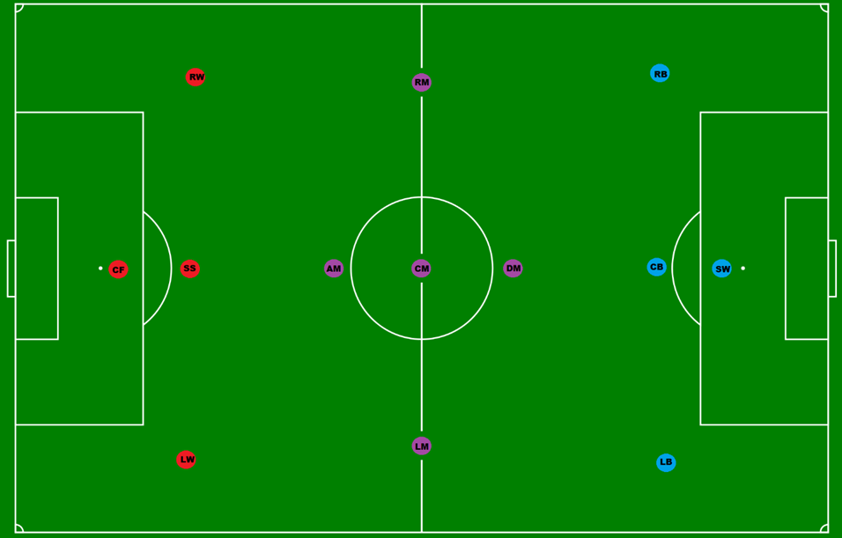
- 11-a-side (3-5 Forwards, 1-5 Midfielders, 3-5 Defenders):
  - Formations are described by categorizing the players according to their positioning along (not across) the pitch, with the defensive players given first; For example, 4–4–3 means four defenders, four midfielders, and three forwards.
  - Teams can have any formation they want, & may change formations during a game to aid their cause.
  - There are no goalkeepers.
  - Example Formations:
    - 4-3-4 / Basic
    - 5-3-3 / Defensive Pyramid
    - 3-3-5 / Offensive Pyramid
    - 3-5-3 / Diamond
    - 5-1-5 / Balanced
    - 5-4-2
    - 5-2-4
    - 4-2-5
    - 4-4-3
    - 3-4-4 (offensive & defensive variants)
    - 3-6-2
    - 4-5-2
- Forwards:
  - Forwards are the players who are positioned nearest to the opposing team's goal.
  - The primary responsibility of forwards is to score goals and to create scoring chances for other players.
  - Forwards may also contribute defensively by harrying opposition defenders and goalkeepers whilst not in possession.
  - Example Positions = Center Forward (CF), Second Striker (SS), Left Winger (LW), & Right Winger (RW):
    - Center Forward (CF):
      - A center forward (main striker) has the key task of scoring goals and for this reason acts as the focal point of the majority of attacking play by a team. As such, how well a striker is performing tends to be measured purely on goals scored despite the fact that they may be contributing in other ways to a team's success. The center forward is often paired with a second striker who may play around him or in a slightly withdrawn role respectively, though it is not unknown to play two recognized center forwards.
    - Second Striker (SS):
      - The second strikers (withdrawn striker or support striker) tend not to be as tall or as physically imposing as a center forward. They are required to be more "nippy", quick, mobile, and skillful, helping to create goals and scoring opportunities for center forwards, utilizing spaces created in the opposition's defense to provide passes to the strikers, picking up loose balls around the area, or attempting to dribble with the ball and score themselves. The position itself is a loosely defined one, a player who lies somewhere between the out-and-out striker and the midfield, who can perform this role effectively due to their vision, technical skills, creativity, and passing ability.
    - Winger (LW/RW):
      - A winger (left winger and right winger) is an attacking player who is stationed in a wide position near the touchlines. They can be classified as forwards, considering their origin as the old outside forward who played out on the "wing" (i.e. side of the pitch). A winger's main attribute is usually speed which is used to attack and dribble past opponent's full-backs in order to get behind the defense and to then deliver crosses and passes into the center for their attackers. Occasionally, left and right footed wingers may swap sides of the field as a tactical move to enable the winger to cut inside against the opposing full-backs weaker foot, looking for a shooting opportunity or just as a means of opening up the defense.
- Midfielders:
  - Midfielders are players whose position of play is midway between the attacking forwards and the defenders.
  - Their main duties are to maintain possession of the ball, taking the ball from defenders and feeding it to the strikers, as well as dispossessing opposing players.
  - Example Positions = Central Midfielder (CM), Left Midfielder (LM), Right Midfielder (RM), Attacking Midfielder (AM), & Defending Midfielder (DM):
    - Center Midfielder (CM):
      - Central midfielders provide a link between defense and attack, fulfilling a number of duties and operating primarily in the middle third of the pitch. They will support their team's attacking play and endeavor to win the ball back on defense. A central midfielder is often an important initiator of attacks and can be sometimes described as a "playmaker." They will also offer an additional line of defense when the team is under sustained attack and when defending set pieces. Central midfielders are always busy in a game and are often therefore sometimes described as the engine room of the team. Their central position enables them to have an all-round view of the match. A central midfielder is expected to have good vision, be adept at long and short passing and have great stamina because of the ground they cover in a game. The central midfielder shares some similarities to a basketball center in that they also contest the ball-ups (similar to tip-offs). For this reason, the central midfielder is typically the tallest player on either team.
    - Wide Midfielder (LM/RM):
      - A wide midfielder (left midfield and right midfield, or generally side midfielder) is a midfielder who is stationed to the left or right of central midfield. In general they need to be highly skilled, especially in kicking. Wingers also require considerable pace and stamina, as they run up and down the ground linking play between defense and attack. They will still support attacking play and sometimes be expected to act as a semi-winger.
    - Defensive Midfielder (DM):
      - A defensive midfielder (holding midfielder or midfield anchor) is a central midfielder who is stationed in front of the defenders to provide more defensive protection, thus "holding back" when the rest of the midfield supports the attack. The defensive midfielder screens the defense by harrying and tackling the opposition teams' attackers and defenders. They also help tactically, for instance, by directing opposing attacking players out to the wing where they have more limited influence, and by covering the positions of full-backs, other midfielders and even the center-backs if they charge up to support the attack. Although the duties of defensive midfielders are primarily defensive, some midfielders are deployed as deep-lying playmakers, due to their ability to dictate tempo from a deep position with their passing. Sometimes a defensive midfielder will be paired with a central midfielder who will act as the deep-lying playmaker. Whenever the central midfielder ventures forward the defensive midfielder will hold back. Defensive midfielders require good positional sense, work rate, tackling ability, and anticipation (of player and ball movement) to excel. They also need to possess good passing skills and close control to hold the ball in midfield under sustained pressure. Most importantly, defensive midfielders require great stamina as they are the outfield players who cover the greatest distance during a professional match. DM’s can be classified as either a defender or midfielder.
    - Attacking Midfielder (AM):
      - An attacking midfielder is a midfield player who is positioned in an advanced midfield position, usually between central midfield and the team's forwards, and who has a primarily offensive role. According to positioning along the field, attacking midfield may be divided into left, right and central attacking midfield roles. These players typically serve as the offensive pivot of the team, as their main role is to create goal-scoring opportunities using superior vision, control, and technical skill. The attacking midfielder is an important position that requires the player to possess superior technical abilities in terms of passing and, perhaps more importantly, the ability to read the opposing defense in order to deliver defense-splitting passes to the strikers; in addition to their technical and creative ability, they are also usually quick, agile, and mobile players, which aids them in beating opponents during dribbling runs. AM’s can be classiefied as either a forward or a midfielder.
- Defenders:
  - Defenders play behind the midfielders and their primary responsibility is to provide support to the team and to prevent the opposition from scoring a goal.
  - They remain in the half of the field that contains the goal they are defending.
  - Example Positions = Center-Back (CB), Sweeper (SW), Left Fullback (LB), & Right Fullback (RB):
    - Center-back (CB):
      - The job of the center-back (CB) is to stop opposing players, particularly the strikers, from scoring, and to bring the ball out from their penalty area. Centre-backs are often tall, strong and have a good jumping, heading and tackling ability. Successful center-backs also need to be able to concentrate, read the game well, and be brave and decisive in making last-ditch tackles on attacking players who might otherwise be through on goal. Sometimes, center-backs concentrate less on ball control and passing, preferring simply to clear the ball in a "safety-first" fashion.
    - Sweeper (SW):
      - The sweeper is a more versatile type of center-back that, as the name suggests, "sweeps up" the ball if the opponent manages to breach the defensive line. Their position is rather more fluid than other defenders who mark their designated opponents. The sweeper's ability to read the game is even more vital than for a center-back as they are responsible for organizing the defense and is the key defender in front of goals. They are usually one of the taller and stronger players on the team.
    - Full-back (LB/RB):
      - The left-back and the right-back (generally referred to as the full-backs) are the defenders stationed either side of the center-backs to provide protection from attacking wide players. They often have to defend against the opponent's wingers, who will try to take the ball past them down the flanks in order to cross or pass into the penalty area to their attackers. The positions require the players having decent speed over short bursts and good hand eye co-ordination. Full-backs usually do not go up to support the attack but may move up as far as the halfway line depending on the defensive line being held. Endurance and strength are unnecessary, although agility is required.
- Substitutions:
  - Each team has a max of 3 substitutions per half unless a player is injured:
  - If that is the case, the substitution doesn't count towards the allowed number of substitutions.
  - Each team has an unlimited number of substitutions allowed at the halftime break.
  - A team is allowed 45 seconds to replace an ejected or injured player.
  - To substitute a player, a team needs to meet the following requirements:
    - During a normal stoppage of play:
      - i.e. a goal/corner kick, free/penalty kick, when a coach enters the field/pitch to tend to an injured player, throw-in, or ball-up.
    - The referee must know that the team wishes to substitute a player.
    - The player leaving the game has exited the field.
    - The player coming into the game must wait for the referee's signal.
    - The player coming into the game must enter the game at the center line.

Advancing the Ball:
- A player can soccer dribble the ball along the ground (i.e. maneuvering of a ball by a single player while moving in a given with the legs) for an unlimited amount of time:
  - However, they cannot cross the center line while doing so.
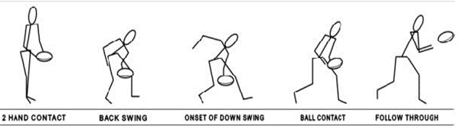
- A player running with the ball must either bounce (dribble like basketball) or solo (dropping the ball onto your boot and kicking it back into your hand; i.e. kick to self) at least once every 16yds/15m:
  - The players are allowed to bounce or solo the ball as many times as they please.
- Passing/Kicking the ball in any direction:
  - A player may also kick the ball by either 1) out of their hands or 2) along the ground.
  - Handballing (#1 / #2):
    - i.e. a player holds the ball stationary with one hand and punches the ball with the clenched fist of the other hand; similar to volleyball.
  - Handpassing:
    - i.e. a player holds the ball stationary with one hand and strikes the ball with the open palm of the other hand.
  - To handball & handpass correctly, the hand holding the ball must not move relative to the player's body.
- A player may hold the ball for unlimited time when he is not being held by an opponent.
- A player cannot throw the ball or pick up a ball with their knees.
- A player on the ground or on their knees may not pick up the ball or drag it back under them:
  - If they do, they will have a free kick awarded against them. When in this position, a player can only knock the ball on.
- A player lying on or over the ball is considered to be in possession.
- A player in possession of the ball and held by an opponent must dispose of the ball immediately by kicking or handballing the ball.
- If the ball is dropped by a team-mate or opponent, it is “play on”.
- Offside Rules:
  - No more than 1 player from each team (2 total players) in either the Goal or Penalty Areas at any time.
  - No more than 2 players from each team (4 total players) can be in the combined Goal/Penalty Areas at any time.
  - No more than 7 players can be on either side of the center line per team (Example = 4 F/D + 3 M for teams using a 4-3-4 formation).
  - All players must stay with their zones:
    - Forwards = in front of the center line.
    - Midfielders = anywhere but no more than 3 players on either side of the center line.
    - Defenders = behind the center line.
    - For coed teams, there must be a minimum of 3 female players on the field (i.e. at least 1 in each zone), & 10 players on the roster.
- Types of Kicks:
  - Punt Kick (Video):
    - The most used kick where the ball is dropped vertically and kicked before it hits the ground. It is regarded as more accurate, and easier for a teammate to mark. It can also be used for scoring goals and behinds if kicking straight on.
  - Hook Kick (Video):
    - Predominately used to score goals and behinds, it is also used to pass to teammates over considerable distances for marks.
  - Push Kick:
    - Allows you to send a highly accurate, short pass to a teammate.
  - Instep Kick:
    - Relies on the upper surface of your foot, also called “the laces.” Mainly used for shooting, the instep kick entails running straight to the ball, placing your support foot beside the ball and swinging your kicking leg swiftly forward. Contact the ball with your laces, keeping your ankles locked. When used by beginners, the instep kick can be inaccurate, so the push pass is often a better choice.
  - Inner Side of Instep Kick:
    - For long-distance passes or shots. Offering slightly more foot contact area and control than the regular laces kick. Run up to the ball at a 45-degree angle, place your support foot beside and behind the ball, contact the ball with the inner side of your instep, and kick the ball with an appropriate force for the ball to reach your target. Lock your ankle as firmly as possible.
  - Outside Kick:
    - Uses the outside of your foot to surprise and deceive the opposition. This kick is more likely to be used and mastered at the elite level. While typically used as a short shovel pass to nearby teammate, once you master it you can also employ the outside kick for shooting, corner kicks or distance kicking. Take a long approach stride and contact the ball with the outside of your foot, keeping your ankle locked.
  - Other types of kicks:
    - Drive Pass / Chip Pass / Bending the ball / Inswinging Corner Kick / Outswinging Corner Kick.
- Marking Rules:
  - A mark is allowed when the ball is caught from a kick which has traveled a minimum distance of 15m (16yds), and the ball has traveled in the air without being touched by another player; the player taking the mark may play on immediately, or go back and kick over the position where he took the mark.
  - Upon taking a mark, the referee will blow the whistle to signify the mark and a player is entitled to an unimpeded kick of the ball to either:
    - Advance their team towards their goalposts without the free kick ("play on"), or
    - Go back and kick over the position where they took the mark to advance their team towards their goalposts with the free kick, or
    - Go back and kick over the position where they took the mark to score a goal/behind.
    - All players taking a mark may kick the ball either 1) out of their hands, or 2) from the ground.
    - The nearest opposition player stands on the spot where the player marked the ball, which is also known as the mark, and becomes the man on the mark while the player who caught the ball must retreat at least 6 steps:
      - If the player hasn't attempted a kick after 10 seconds (or 30 if inside the penalty or goal area) have passed, normal play will resume (i.e. “Play On”).
    - The criterion for a mark is that it be caught cleanly, i.e. the player have complete control of the ball, for any length of time. As such, if the ball is caught in one grab, and then punched out from between the player's hands, a mark is paid, even if he has held it for only an instant. Similarly, if a ball is controlled, and then dislodged by another player or the ground, the mark will still be paid.
    - If two players mark the ball simultaneously, the referee will award the mark to the man in front (i.e. the player who has the front position in the marking contest):
      - If he cannot determine which player is in front, then the referee will award possession of the ball to the team that is next to receive the ball according to the held ball rules.
  - Spoiling the mark:
    - Spoiling is the technique typically employed by opposition defenders to legally stop a player from catching the ball. Spoiling is performed by hand or fist (as a punching action) either before or shortly after the player has caught the ball in their hands.
  - The rules are quite strict on defensive spoiling methods. Players are not allowed to:
    - Push other players out of marking contests.
    - Make forceful front on contact with an opponent in a marking contest if they are not simultaneously attempting to mark or spoil the ball.
    - Make high contact is allowed unless such contact is incidental to attempting to mark or spoil the ball and/or if the contact is made on a neutral-vertical plane.
  - The number of consecutive marks teams are allowed for each possession is 6:
    - Teams can still make/complete long passes after they reach the limit, but the mark will no longer be paid.
    - No marks will be paid for backwards kicks, except for kicks inside the team’s forward half.
- Free Kick Rules:
  - Free kicks may be given against players either with or without the ball:
    - A free kick is taken between 0-20m from the spot where the infringement occurred.
    - The player taking the kick can score on the kick directly.
  - Kick-in after behind:
    - If a ball is kicked back into play from the in goal area, following the scoring of a behind, and subsequently goes 'out of bounds' without being touched by a player of either team despite bouncing, it is treated as if having gone out of bounds on the full. The attacking team is awarded a free kick.
  - "Play On":
    - An umpire need not hold up play by awarding a free kick to a player who has been infringed. Where the player or a team-mate has possession and is in an advantageous position, the umpire calls 'play-on' and allows play to continue. This is referred to as 'paying the advantage'.
  - Relayed Free Kicks:
    - A player who is infringed upon, immediately following the disposal of the ball, may have a fellow team-mate take the free kick from the spot where the ball landed after being disposed of. This is at the umpire’s adjudication.
- Changes in Possession:
  - When an umpire/referee awards a free kick to an opposition player.
  - Following an unsuccessful kick at goal.
  - When an opposing player intercepts a pass.
  - When the player in possession drops the ball and it is recovered by an opposition player.
  - When the ball is wrestled from a player's possession.
  - When the ball goes out of bounds (i.e. the team that had last touch loses possession).

Contact Rules:
- Permitted:
  - Shoulder-to-shoulder contact (i.e. bumping) with the ball carrier (or any player within 5m of the ball if no one has possession).
  - Blocking any player who doesn’t have the ball (i.e. shepherding; within 5m only).
  - Sliding tackles (only while the ball is on the ground).
  - Slapping the ball out of an opponent's hand.
- Prohibited:
  - Tackling/pulling/pushing/holding/kicking/striking/tripping an opponent.
  - Spiting at an opponent.
  - Charging an opponent from the front or back.
  - Blocking a shot with the foot.
  - Sliding tackles when the ball is not on the ground, jumping at an opponent when the ball is not in the air
  - Using both hands to tackle.
  - Wrestling the ball from an opponent's hands.
  - High contact (unless such contact is incidental to attempting to mark or spoil the ball).
  - Deliberately taking/hacking/chopping the arms while they are attempting to mark a ball.
  - Making forceful front-on contact with an opponent in a marking contest (only if they are not simultaneously attempting to mark or spoil the ball),
- For coed games, the following rules apply:
  - All one-percenters, such as shepherding, blocking, spoiling or smothering are strictly penalized with a free kick.
  - Marking contests are strictly enforced to avoid contact via a drop-zone rule.
  - When any contact is made by an opposition player, a free kick is awarded to the opposition player that is infringed.
  - For deliberate contact, an immediate send-off rule applies and red and yellow cards are shown as in soccer.
  - There is no contesting for possession with the exception of removing a player's tag, which substitutes for a tackle and gives the player 3 seconds prior opportunity to dispose of the ball before the Holding the ball rule is applied.

Fouls (“Technical” & “Aggressive”):
- All of the following fouls (“Technical”) will also result in a penalty/free kick at the spot of the foul (or at the penalty mark if inside the combined goal/penalty areas):
  - Changing hands: Throwing the ball from your right hand to left or vice versa.
  - Going 16yds/15m without releasing (i.e. bouncing or soloing) the ball.
  - Not disposing of the ball correctly by using a handball or a kick.
  - Hand passing a goal or behind outside of the goal area.
  - Picking the ball directly off the ground if on their knees.
  - Lying on the ball.
  - Throwing the ball (it may be "hand-balled" by striking with the fist or “hand-passed” by striking with the palm).
  - Performing a sliding tackle on an opponent while the ball is on the ground.
  - Entering the center circle before the ball is bounced at the restart of play.
  - Kicking the ball over the boundary line without it bouncing first or being touched by another player.
  - Deliberately forcing or taking the ball over the boundary line.
  - Kicking the ball out of bounds (Only if the ball did not bounce and was not touched).
  - Running more than 15 meters / 16 yards without bouncing the ball or touching the ball on the ground.
  - Offsides - When a team has ether 1) more than 7 players are allowed in each team's either half of the field, 2) more than 1 player in either the Goal or Penalty Areas at any time, or 3) more than 2 players in the combined Goal/Penalty Areas at any time.
  - Controlling the ball with their hands for more than six seconds before releasing it from possession (only if inside the combined goal/penalty areas.
- All of the following fouls (“Mildly Aggressive”) will also result in both a yellow card & a penalty/free kick 10m from the spot of the foul (or at the penalty mark if inside the combined goal/penalty areas):
  - Failing to comply with an umpire’s instruction to use a mouth guard.
  - Failing to return the ball quickly and on the full to a player who has been awarded a free kick.
  - Wasting time, deliberately or inadvertently, by kicking the ball forward after one's team has conceded a free kick.
  - Deliberately wastes time in returning the ball to the player who is to take the kick.
  - Holding the player who is to take the kick thereby preventing play continuing, or
  - Refusing to stand on the mark at the point indicated by the umpire.
  - Running over the mark before or as the ball is kicked. (Any player in the opposing team can give this penalty).
  - Arguing with, disputing the decision of an umpire (example = show dissent with the referee's decision to award a free kick to the opposing team).
  - Running over the mark - The man standing on the mark cannot move forward, and must respond if called to recede by the umpire.
  - Running through the mark - Other defensive players who are not standing on the mark may not run across the imaginary line between the man standing the mark and the man taking the kick, unless following his direct opponent.
  - Entering the protected zone - Defensive players may not impede an opponent by entering or remaining within the corridor of space extending 10m (or 11yd) either side of the imaginary line between the man standing the mark and the man taking the kick, and extending backwards, unless following his direct opponent.
- All of the following fouls (“Very Aggressive”) will also result in both a black card & a penalty/free kick 15m from the spot of the foul (or at the penalty mark if inside the combined goal/penalty areas):
  - Performing a sliding tackle on an opponent while the ball is not on the ground.
  - Blocking a shot with the foot.
  - Pushing an opponent.
  - Jumping at an opponent when the ball is not in the air.
  - Grabs the opponent with the ball above the shoulder or below the knees.
  - Using both hands to tackle.
  - Wrestling the ball from an opponent's hands.
  - Deliberately pulling down an opponent.
  - Deliberately tripping an opponent with hand, arm or foot.
  - Interferes with an opponent attempting to mark in the air by punching or bumping.
  - Shepherds/bumps an opponent other than the ball carrier (or any player not within 5m of the ball if no one has possession).
  - Using abusive or provocative language or gestures towards either players or umpires.
  - Remonstrating in an aggressive manner with a match official.
  - Deliberately taking, hacking or chopping the arms while they are attempting to mark a ball.
  - Deliberately body collide with an opponent after he has played the ball away or for the purpose of taking him out of the movement of play.
  - Any free kick resulting from an interchange infringement or a line-up has an additional 10-metre penalty applied to it; these are the only circumstances under which a 20-metre penalty is automatically applied to a free kick without further infringement.
- All of the following fouls (“Extremely Aggressive”) will also result in both a red card & a penalty/free kick 20m from the spot of the foul (or at the penalty mark if inside the combined goal/penalty areas):
  - Refusing to leave the field of play, on the instruction of the umpire, for attention, after an injury involving bleeding.
  - Refusing to leave the field of play when ordered off (red card) or rejoin the game after being ordered off.
  - Tackling an opponent.
  - Kicking and/or striking an opponent.
  - Spitting at an opponent.
  - Biting an opponent
  - Making contact with the head while attempting to bump a player.
  - "Charging" (i.e. lines up and charges / run-up and attack an opponent for a bump).
  - Deliberately making forceful front-on contact with an opponent in a marking contest (only if they are not simultaneously attempting to mark or spoil the ball),
  - Deliberately making high contact (unless such contact is incidental to attempting to mark or spoil the ball).
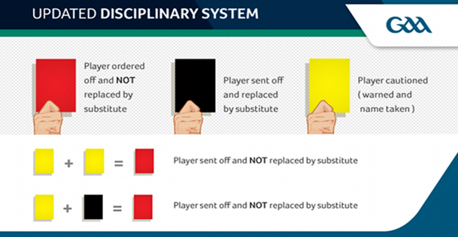
  - Scragging the player who has taken a mark (i.e. to tackle the player or impede him from taking the kick as quickly as he would like).
  - Using unnecessary roughness against a player who has already taken a mark.
- Cards:
  - A yellow card means a warning/caution for the offending player, who will be given a black card for a 2nd offense, & a red card for a 3rd offense:
    - In addition to this, a penalty is awarded regardless of where the incident takes place.
  - A player who receives a black card is to be given a 15-minute sin bin, but an immediate replacement is allowed:
    - In addition to this, a penalty is awarded regardless of where the incident takes place.
    - If a team receives three black cards they won't be able to replace the next player who commits an offence worthy of a black card.
  - A player who receives a red card is to be sent off for the rest of the game and no replacement is allowed until the next period:
    - In addition to this, a penalty is awarded regardless of where the incident takes place.
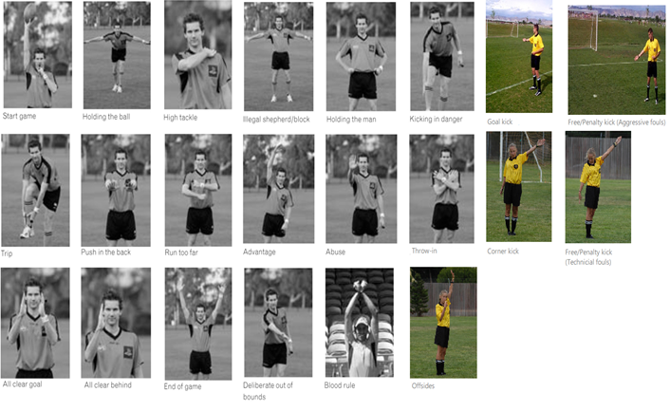

Starting & Restarting Play:
- Teams determine the choice of goal by tossing a coin.
- Ball-up:
  - The field umpire starts play by blowing his whistle and bouncing the ball in the center circle so that it rebounds vertically to be contested by the players in the center square. At the start of play, no player may enter the center circle, and only four players from each team are permitted in the center square until after the ball has been bounced.
  - Both halves begin with the ball-up.
- The other common situations when play is restarted are:
  - After a goal or behind has been scored:
    - Any player of the defending team (preferably the one closest to the goalposts) kicks the ball from behind the goalposts (i.e. goal kick), but only after the goal umpire has finished waving his flags.
    - The player must kick the ball out to restart play.
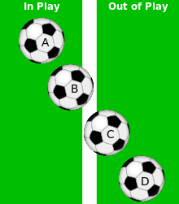
    - The ball must leave the penalty area before any other player can touch the ball for all goal kicks; If the ball does not leave the Penalty Area, then the kick must retaken.
  - After the ball has gone out of bounds (outside the sidelines):
    - If the ball bounced or crossed the line along the ground, then the boundary umpire restarts play with a throw-in with possession going to the team that didn’t touch the ball last.
    - If the ball did not bounce and went over the boundary line as a result of a deliberate kick/handball/hand/pass that was not touched, the opposing team receives a free-kick from the spot from where the ball went out.
    - The closest player to the ball from the opposing team takes the free kick.
    - Balls A-C are still in play, whereas Ball D is not.
  - After the ball has gone out of bounds (outside the end-lines):
    - If the defense knocks it out of play, the offense is awarded a corner kick. The corner kick is taken from the corner nearest to where the ball left the field.
    - If the offense knocks it out of play, the defense is awarded a goal kick. The ball must leave the Penalty Area before any other player can touch the ball for all goal kicks; If the ball does not leave the Penalty Area, then the kick must retaken.
    - When a pack of players prevents either team gaining clear possession. The umpire bounces the ball where play came to a halt.
- The ball is deemed to be out of play in the following situations:
  - A goal or behind is scored. Time is not stopped from when the goal umpire finishes waving his flags to when the ball is kicked in.
  - The ball goes out of bounds:
    - If any portion of the ball is on or over the boundary line, the ball is still in play.
    - A player can be over the boundary line and in possession of the ball without the ball being considered 'out of bounds' given part of the ball is still in play.
    - Time is not stopped from when the ball goes over the boundary line until the boundary umpire throws the ball back into play.
  - Whenever the field umpire signals to the time-keeper that time is to be stopped by raising his arm and blowing his whistle.

Scoring Rules:
- Goals are worth 3 points:
  - The goal umpire signals a goal with two hands raised at elbow height & then confirms the signal with the other goal umpire by waving green flags above his head.
  - Players can score goals by either:
    - Kicking the ball with either the foot and/or shin.
    - Handballing/handpassing the ball with the hand:
      - However, the ball can only be handballed/handpassed for either a goal or behind inside of the goal area; both feet must be either 1) inside the lines and/or 2) on the lines for a goal/behind to count.
- Behinds (or Points) are worth 1 point:
  - The goal umpire signals a goal with one hand raised at elbow height and then confirms the signal with the other goal umpire by waving white flags above his head.
  - A behind is also awarded to the attacking team if:
    - The ball touches any part of an opposition player before passing between the goal posts.
    - The ball hits a goal post.
    - Any player sends the ball between the goal posts by touching it with any part of the body other than a foot outside of the goal area.
  - Players can score behinds by touching any part of body.
  - In the event of a rushed behind, a free shot on the penalty mark will be given to the opposite team:
    - A rushed behind occurs when the ball passes through the goalposts and was last touched by a defending player.
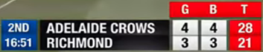
- Teams' scores are written in a goals-behinds-total format:
  - Example: 2-10-16 is 2 goals and 10 behinds, which is a total of 16 points.

Uniform Rules:
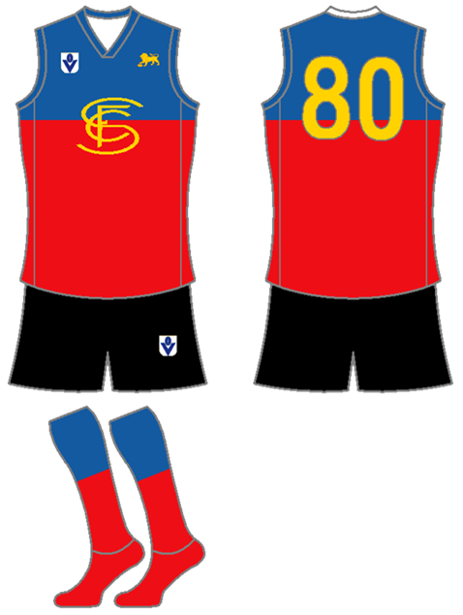
- AFL Guernseys, shorts, shoes/cleats (rubber only), soccer shin guards, and mouth guard are required:
  - Rugby helmets (i.e. scrum caps), Soccer GK, & American football gloves are optional.
  - Long sleeves are required for cold weather games. Sleeves must be any of the following:
    - White.
    - Black.
    - The team’s main color.
- Both teams must wear their dark color uniforms during games (similar to this NAL Championship Game) unless either of the following occurs (i.e. mandatory “Color Rush”):
  - The teams share similar colors.
  - If someone is colorblind (i.e. teams with red or green uniforms will not participate).
- If that is the case, the designated home team will wear their dark color uniforms and the away team will wear either of the following:
  - Their lighter color uniforms.
  - An alternative darker color uniform.
- Uniform # System:
  - Forwards = 00-31.
  - Midfielders = 32-64.
  - Defenders = 65-99.

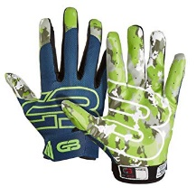
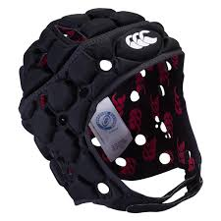
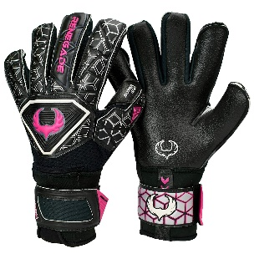
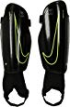
Season Structure:
- Each team will receive premier points for entry into the postseason:
  - Points are now used to determine which teams will advance into the postseason. Points are being implemented in order to encourage attacking play throughout a game and to reward teams for "coming close" in losing efforts.
  - 3 points for winning a game.
  - 2 points for winning a game in overtime.
  - 1.5 points for drawing a game.
  - 0 points for losing a game.
  - 1 bonus point for losing by 10 points (or fewer) or in overtime.
  - .5 bonus point for scoring at least 100 points.
  - All teams can only have a max of 2 bonus points per game.
- At the end of the regular season, the team with the best regular-season record (i.e. highest point total) is awarded the Supporter’s Shield:
  - For those who don't know, it echoes the practice of the top European soccer leagues in which the team with the best regular-season record is the champion, similar to the Supporter’s Shield in MLS.
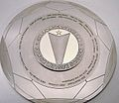
  - The Supporter’s Shield winner is guaranteed home-court advantage in all rounds of the playoffs they compete in, including the UGAARFL championships.
  - However, the award can just be a certificate in a frame.
  - Regular-season rankings will be based on the amount of premier points that each team has.
  - Tiebreaker criteria when competitors are level on points:
    - The team that won the head-to-head match (if applicable) is ranked first.
    - If this game was a draw, then the team with the more wins is ranked first.
    - Point difference (PD) = is the number of points scored in all league matches minus the number of points conceded.
    - Points for (PF) = is the total number of points scored by a team over the course of the regular-season.
    - Points against (PA) = is the number of goals scored against them by their opponents over the course of the regular-season.
    - Fewest disciplinary actions.
    - Strength of schedule = two-third (66 2/3%) for the opponent's record and one-third (33 1/3%) for the opponents' opponents record.
    - Total number of points scored on the road.
    - Road point difference.
    - Total number of points scored @ home.
    - Home point difference.
    - If still identical, a play-off is required.
    - Coin toss (2 teams) or drawing of lots (at least 3 teams).
- The UGAARFL Preseason:
  - All teams must host an open 4-day tryout no more than 1 month prior to the start of the season:
    - A max of 100 potential players plus all of the players from the previous year are allowed.
    - Players will be tested on their dribbling, kicking, & throwing techniques.
    - All positions will be evaluated in tryouts.
    - All tryouts must take place on Saturday & Sunday (i.e. the tryout occurs in 2 phases over 2 weekends).
    - Registration fees:
      - A pre-registration fee of 2019 $15 can be applied no more than 1 day before the start of the tryouts/preseason.
      - Registration after that time and the day of will require an application fee of 2019 $80.
      - Both fees must be adjusted for inflation at least once every 5 years.
  - All teams must play 1 preseason scrimmage open to the public at least 2 weeks prior to April 1.
- The regular season is an 8-game season that starts in April & ends in June:
  - Each team plays all three teams in their division twice (1h/1a) (6 Games).
  - Each team plays 1 team from the other division twice (1h/1a) based on the final division standings from the prior season (i.e. North #1 plays South #1, etc.) (2 Games).
  - All team practices must occur after 5pm local time.
  - The post-season is a 2-team single-elimination tournament (i.e. 1 team from each division).

Roster & Salary Rules:
- 18-man active roster (6 Forwards, 6 Midfielders, & 6 Defenders) for each game; 12 reserves (4 Forwards, 4 Midfielders, 4 Defenders) for a total of 30 players on the roster.
- Each player will earn no more than $200 per week.

Ticket Pricing Minimums:
Type: | Individual: | Full-Season: | Group (1 game):
Adults (18-64) | $8 per person | $35 per person | $5 per person
Children (5 to 17; 4 & under are free) | $5 per person | $20 per person | $3 per person
Seniors (ages 65 & up)
All ticket prices are in 2017 US$ & must be adjusted for inflation. | Includes only a single game | Includes all 5 home games | The group must include at least 5 people, regardless of their ages

