Roster & Salary Rules:
- Each team has at least 5, but no more than 8 players & 1 head coach.
- All players will earn no more than $1,040 per game.
- Players from the ATP and WTA take a break from their tour schedules to partake in the league.
- Both teams must wear their dark color uniforms during games (similar to this NAL Championship Game) unless either of the following occurs (i.e. mandatory “Color Rush”):
  - The teams share similar colors.
  - If someone is colorblind (i.e. teams with red or green uniforms will not participate).
  - WTT Example: Chicago Smash vs New York Empire.
- If that is the case, the designated home team will wear their dark color uniforms and the away team will wear either of the following:
  - Their lighter color uniforms.
  - An alternative darker color uniform.

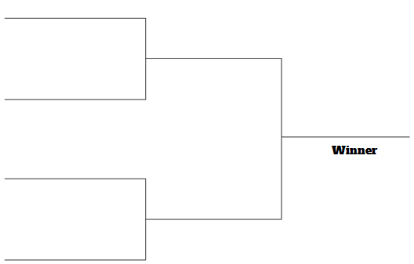
Regular Season Structure:
- Format:
  - The regular-season is a 12-game (6h/6a) season that starts in late June and ends in August.
  - Each team plays 2 matches (1h/1a) against the other 5 teams in their division (10 Matches).
  - Each team plays 2 matches (1h/1a) against 1 team from the other division based on the final division standings from the prior season (i.e. East #1 plays West #1, etc.) (2 Matches).
- There must be at least 3 days in between matches for all teams.
- The top 2 teams in each division in the regular season qualify for the playoffs.
- The winner of the WTT Finals is awarded the King Trophy.

Gameplay Rules:
- Each match consists of 5 sets:
  - Each set features a different configuration (men's singles, men's doubles, women's singles, women's doubles, and mixed doubles).
  - Prior to each match, coaches decide the order in which the sets will be played.
  - The first team to reach 5 games wins each set. A 9-point tiebreaker is played if a set reaches 4-all.
  - One point is awarded for each game won.
- Scoring is no-advantage (i.e. there is no requirement to win a game by two scores):
  - At deuce, whoever scores the next point wins the game.
  - The first team to reach five games wins each set. A nine-point tiebreaker is played if a set reaches four-all.
  - One point is awarded for each game won.
  - If necessary, extended play and a super tiebreaker are played to determine the winner of the match.

