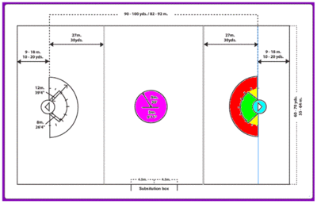
General Rules:
- During play, a team consists of 12 players:
  - 1 Goalkeeper (GK).
  - 3 Defenders (D).
  - 3 Midfielders (M).
  - 3 Attackers (A).
- A player's lacrosse stick must be either of the following:
  - 40-46” (1.0-1.2 m)
  - 52-72” (m).
- Besides a lacrosse stick, each player must also wear a certain amount of protective equipment, including a lacrosse helmet with facemask, lacrosse gloves, arm and shoulder pads, and back/kidney pads (rib pads are optional).
- Four long–sticks per team are allowed on the field at any one time.
- During a typical game, the number of officials is three.
- Dive shots are allowed.
- Television coverage = Lax Sports Network (Regular Season & Postseason) & CBS Sports Network (Final only).
Roster & Salary Rules:
- Each team's roster consists of 26 players; all players are eligible to be selected for the 19-player active roster during the regular season and the playoffs.
- All players still generally earn annual salaries of no more than $10,000 per season. Because of this, players and staff generally hold other jobs, and the league does not provide health insurance coverage.
Timing Rules:
- A traditional game consists of four 15-minute periods with the teams changing ends each period; 2 minutes between periods.
- Time Outs - Each team may take three 45-second timeouts per half; A TV game has one timeout per period.
- If the game is tied at the end of regulation play, a 5-minute sudden death overtime is played.
- Shot Clock - A 45-second clock begins (counting down) when a team assumes possession of the ball. The offensive team must put a shot on goal during that time or they will lose possession. If they do shoot on goal (without scoring) and recover possession of the ball (via rebound/loose ball recovery), the clock is reset for a new 30 seconds
- 10-Second Violation - Occurs when team on offense fails to advance the ball past midfield within 10 seconds after taking possession at their end.
- Play is restarted with a face-off after the end of each score or end of a quarter.
Draft Structure:
- The UWPLL Draft takes place in the last week of August and lasts two (2) rounds.
- All teams can only draft 2 players per draft.
- All potential players must have a college degree in order to be eligible for the draft.
- The selection order is based on each team's amount of bonus points in the previous season and whether the team reached the playoffs. Teams that did not reach the playoffs the previous season are ranked in reverse order of their records (so the team with the fewest wins is awarded the first selection).
- Ties between teams with identical records are determined by the following tiebreakers (in order): strength of schedule, division tiebreakers, conference tiebreakers, and a pre-draft coin flip.
- Order of Draft Picks:
  - Non-playoff Teams (1-3)
  - Eliminated in First Round (4-7)
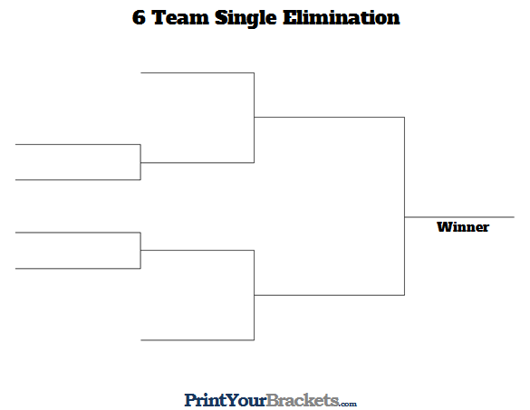
  - UWPLL Runner-up (8)
  - UWPLL Champion (9)
Season Structure:
- Each team must begin preseason training in the first week of March.
- Each team plays 1 preseason scrimmage prior to the start of the season on the last Saturday of March.
- Each team plays a 9-week season starting on the second Saturday of April and ending on the first Saturday of June, with one bye week:
  - Each team plays 1 game (4h/4a) against the other 8 teams in the league in a round robin format.
  - The postseason is a 6-team single-elimination tournament in which the top 6 teams with the largest amount of points are automatically chosen:
    - The #1 & #2 seeds in each get a 1st-round bye.
- Uniform Rules:
  - Both teams must wear their dark color uniforms during games (similar to rugby or this NAL Championship Game) unless either of the following occurs (i.e. mandatory “Color Rush”):
    - The teams share similar colors.
    - If someone is colorblind (i.e. teams with red or green uniforms will not participate).
    - UWPLL Example: Atlanta Blaze & Boston Cannons.
  - If that is the case, the designated home team will wear their dark color uniforms and the away team will wear either of the following:
    - Their lighter color uniforms.
    - An alternative darker color uniform.
- Bonus Points System:
  - 4 points for winning a game
  - 2 points for drawing a game
  - 0 points for losing a game
  - 1 bonus point for losing by 5 points (or fewer) or in overtime.
  - 1 bonus point for scoring 15 goals (or more).
- At the end of the regular season, the team with the best regular-season record (i.e. highest point total) is awarded the Trophy:
  - For those who don't know, it echoes the practice of the top European soccer leagues in which the team with the best record is the champion, similar to the Supporter’s Shield in MLS.
  - The Morrow-Robertson Trophy winner is guaranteed home-field advantage in all rounds of the playoffs they compete in, including the UWPLL Championship.
- Tie-breaker - If only two teams are level on league points:
  - The team that won the head-to-head match (if applicable) is ranked first.
  - If this game was a draw, then the team with the more wins is ranked first
  - Point difference (PD) = is the number of points scored in all league matches minus the number of points conceded.
  - Points for (PF) = is the total number of points scored by a team over the course of the regular-season.
  - Points against (PA) = is the number of goals scored against them by their opponents over the course of the regular-season.
  - Fewest disciplinary actions.
  - Strength of schedule = two-third (66 2/3%) for the opponent's record and one-third (33 1/3%) for the opponents' opponents record.
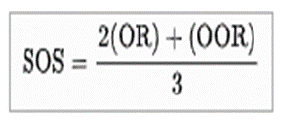
  - Total number of points scored on the road.
  - Road point difference.
  - Total number of points scored @ home.
  - Home point difference.
  - If still identical, a play-off is required.
  - Coin toss (2 teams) or drawing of lots (at least 3 teams).

