Roster & Salary Rules:

Championship / League 1:
- Each USL club is allowed up to 30 players on its first team roster; all 30 players are eligible for selection to each 18-player game-day squad during the regular season and playoffs.
- USL has two transfer windows—the primary pre-season transfer window lasts three months from mid-February until mid-May, and the secondary mid-season transfer window runs one month from early July to early August.
- There are 3 types of contracts in USL:
  - MLS contract, on loan to a USL team:
    - This contract is between the player and MLS, and is subject to that organization’s CBA. As such, the depensation of these players trends higher than the USL average.
    - The player may play for a USL team on loan terms ranging from one day to an entire season.
    - MLS contracts range from $53,000 to $2 million per year.
  - USL contract only:
    - This contract is between the player and his team, and is not subject to a CBA, as currently none exists.
    - Teams which are owned by MLS, such as Seattle Sounders 2 and Atlanta United 2, have both MLS- and USL-contracted players.
    - USL-only contracts range from $25,000 to $45,000 for both leagues.
    - The salary cap is $8,235,000 per USL team for players holding this type of contract.
  - Academy:
    - A player may be part of a non-professional academy program within an MLS organization and earn minutes with the USL side without relinquishing his amateur status.

League 2:
- As USL League 2 seasons take place during the summer months, the player pool is drawn mainly from elite NCAA & NAIA college soccer players seeking to continue playing high-level soccer during their summer break, which they can do while still maintaining their college eligibility, as the USL League 2 is not considered a true "professional" league.
- A maximum of 8 players on each team's 26-man roster can be over 23 years old, while at least 3 players on each team's roster must be at least 18 or younger.
- All teams can choose to employ players who are paid for their performances, but who still meet the age eligibility criteria:
  - All current college players cannot play alongside professionals, but may play against them:
    - What this also means, however, is that League 2 teams with paid players cannot have any currently active NCAA players on their rosters, but may employ NAIA players, U Sports players, community/junior college players, ex-NCAA players who have already graduated, or other local players who do not play college soccer at all.

Season Structure:

All Leagues:
- Bonus Points System:
  - 3 points for winning a game in regulation.
  - 2 points for winning a game in overtime (in either in the two 15-min periods or the penalty shootout).
  - 1.5 points for drawing a game.
  - 0 points for losing a game in regulation.
  - 1 bonus point for losing a game in overtime (in either in the two 15-min periods or the penalty shootout).
  - 1 bonus point for scoring at least 3 goals.
  - At the end of the regular season, the team with the best regular season record (i.e. highest point total) is awarded the USL Supporters' Shield:
- For those who don't know, it echoes the practice of the top European soccer leagues in which the team with the best regular-season record is the champion.
- The USL Supporter’s Shield winners are guaranteed home-field advantage in all rounds of the playoffs they compete in, including the championship.
  - In the event of an end-of-season tie in total accumulated points, the following tie-breakers will be used:
    - The team that won the head-to-head match (if applicable) is ranked first.
    - If this game was a draw, then the team with the more wins is ranked first
    - Goal difference (GD) = is the number of goals scored in all league matches minus the number of points conceded.
    - Goals for (GF) = is the total number of goals scored by a team over the course of the regular-season.
    - Goal against (GA) = is the number of goals scored against them by their opponents over the course of the regular-season.
    - Fewest disciplinary actions.
    - Strength of schedule = two-third (66 2/3%) for the opponent's record and one-third (33 1/3%) for the opponents' opponents record.
    - Total number of goals scored on the road.
    - Road goal difference.
    - Total number of goals scored @ home.
    - Home goal difference.
    - If still identical, a play-off is required.
    - Coin toss (2 teams) or drawing of lots (at least 3 teams).

Championship / League 1:
- USL Championship & League 1 will target U.S. communities with a minimum population from 150,000.
- All USL Championship / League 1 soccer teams must play in stadiums with a minimum capacity of 2,000.
- Each team plays 2 preseason games (1h/1a) with any combination of domestic and/or international teams beginning in early February:
  - These teams should preferably be from the following:
    - Sister cities (both domestic & international).
    - MLS parent clubs.
    - Local college teams.
    - Events such as the Carolina Challenge Cup or the international Pacific Rim Cup.
  - Teams can play more preseason games if they qualified for other events such as the CONCACAF Champions League.
- USL Championship / League 1 now use a split-season schedule, Similar to the modern (now defunct) North American Soccer League (NASL) & Liga MX:
  - The USL Championship / League 1 regular-season runs from early March to late November with its teams playing 30 games (15h/15a) in a balanced schedule (excluding all of the exhibitions with European teams):
    - The “spring” season begins in mid-March and ends in late June (2019 Example = March 3-June 29), followed by a 4-week break in July.
    - The “fall” season begins in early August & ends in early November (2019 Example = August 3-November 2).
    - Conferences must consist of 15 teams each:
      - All teams east of the Mississippi River must be placed in the East Conference (with the exception of Memphis, Wisconsin & Illinois), with all teams west of the river being placed into the West Conference.
    - Each team plays 2 games (1h/1a) against all 15 other teams in their division (28 games).
    - Each team plays 2 game (1h/1a) against 1 team from the other divisions in the other conference based on the final division standings from the prior season (i.e. East #1 plays West #1, etc.) (2 games).
  - Each USL team plays 1 game (2h/2a) against 4 random international soccer teams in other leagues during the 4-week break in July midway through the season (4 games):
    - A break in July that coincides with the international transfer window allows teams to acquire (or sell) players during the summer, providing ample time for new players to compete acquainted with their new club and league.
    - All USL teams can use this break to generate additional revenue by hosting international friendlies (4h), going on tour (4a), or any combination of both (1h/3a, 2h/2a, or 3h/1a).
    - These games will technically act as “preseason” games for the international clubs, but both teams can only have 6 substitutions per game.
    - Examples = Premier League, Liga MX, and Bundesliga.
    - These teams should preferably be from sister cities, but they don’t have to be:
      - Indy Eleven examples = 1. FC Köln, Northampton Town, Associação Atlética Ponte Preta, etc.
      - Jacksonville Armada FC examples = Olimpo, Chippa United, Changwon City FC, etc.
- The Post-Season:
  - Unlike European soccer leagues, the USL regular season is followed by the 12-team USL Cup Playoffs in late November, ending with the USL Cup finals in Mid-December:
    - The post-season is a 12-team single-elimination bracket:
      - All 12 teams will be seated 1 through 6 per conference based on the number of bonus points that they have, & will never be reseeded.
      - 1st Round (Conference Quarterfinals) = 3v5 & 4v6; #1 & #2 seeds get byes.
      - 2nd Round (Conference Semifinals) = 1 vs 3/5 & 2 vs 4/6.
      - 3rd Round (Conference Championship) = (1/3/5 vs 2/4/6).
      - 4th Round = USL Cup.
    - The teams that make it are the top 6 teams in each conference.
    - The post-season must take place after the FIFA November window.
    - The playoff extra time structure follows IFAB standards: two full 15-minute periods, followed by a penalty shootout if necessary.
    - In addition, the tournament winners qualify for the group stage of the CONCACAF Champions League.
    - There must be at least 4 off-days between each group matchday (2019 USL Championship example listed below):
      - Saturday, November 16: Two Western Conference Group Games
      - Sunday, November 17: Two Eastern Conference Group Games
      - Thursday, November 21: Two Western Conference Group Games (There’s nothing wrong with Thanksgiving games.)
      - Friday, November 22: Two Eastern Conference Group Games
      - Tuesday, November 26: Two Western Conference Group Games
      - Wednesday, November 27: Two Eastern Conference Group Games
      - Sunday, December 1: Western Conference Final
      - Monday, December 2: Eastern Conference Final
      - Friday December 6: MLS Cup Final (hosted by finalist with better regular-season record)
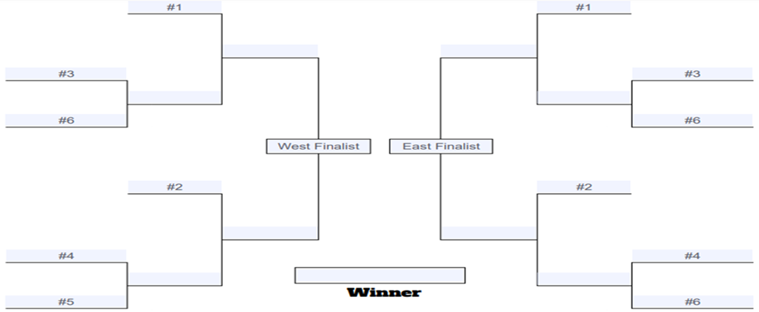
- Promotion & Relegation (USL Championship & League 1 only):
  - The top 4 teams in each division in USL League 1 will be promoted to USL Championship.
  - The bottom 4 teams in each division in USL Championship will be relegated to USL League 1.
  - All USL Championship / League 1 teams (with the exception of the reserve teams) can apply for MLS membership.
  - All of the reserve teams (example = Atlanta United II) & affiliated teams (example = Indy Eleven) are eligible to be promoted and/or relegated.

League 2:
- The USL League 2 is the merger of the Premier Development League (PDL) & the National Premier Soccer League (NPSL). The league's motto is "An International League with a Regional Focus".
- USL League 2 is organized in a mostly decentralized structure and is managed as a team-run league:
  - Each year the member clubs help elect a chairman, treasurer, and secretary and an eight-member board of directors.
  - Each team is individually owned and operated, and is responsible for maintaining league minimum standards.
  - New teams seeking membership into the NPSL are subject to approval from an executive committee of existing team owners.
  - Member clubs have the right to make localized decisions for their respective markets, conferences, and divisions based on what they believe is best for their particular division.
  - Each conference is managed by the individual member clubs and elect a conference commission each year.
- All cities can have no more than 2 professional soccer teams within their entire Metropolitan Statistical Area (MSA):
  - Examples of Metropolitan Statistical Areas = Dallas–Fort Worth metroplex, Norfolk-Virginia Beach (Hampton Roads), Riverside–San Bernardino (Inland Empire) or Minneapolis–Saint Paul (Twin Cities).
- USL League 2 has a one-time $15,000 (for purely amateur teams) or $45,000 (for teams with a mix of paid & amateur players) franchise fee and a $5,250 annual league fee in order to join the league.
- USL League 2 requires that all teams play in stadiums with at least 500 seats, a scoreboard, and locker rooms with showers for both teams and officials. The home team is also responsible for providing water and food for the visiting team, ensuring there is a trainer or doctor on-site for the match, and paying the referees fees at the end of each game.
- The USL League 2 regular-season runs from May to July:
  - All divisions must aim to play a regular-season schedule of 12 games (6h/6a), with divisions being free to organize their games as they see fit.
- The USL League 2 Playoffs are played in July and August:
  - The playoff is a 5-week, 24-team single-elimination tournament:
    - The 6 divisions only get 4 teams.
  - All matches in the League 2 playoffs are played with the higher seeded team hosting the match, until a Champion is decided at a predetermined neutral location for a playoff weekend, in which both the Semi-final and Championship matches are played.
