Number of Players & Positions:
- The coaching staff for all SCL franchises will consist of the following & a max of 5-8 support staff:
  - A head coach/manager (who may also double as their team's respective general manager)
  - 1-2 bullpen catcher coaches/managers
  - A first base coach/manager.
  - A bullpen coach/manager.
  - A bench coach/manager.
  - A hitting coach/manager.
  - A third base coach/manager.
  - A pitching/bowling coach/manager.
- 11 players are on the field at any one time:
  - 27 players on the active roster.
  - 42 total players on the roster.
  - Example Roster Setup = 22 Pitchers, 3 Catchers, 8 Infielders, 7 Outfielders, & 2 Designated Hitters (DH).
  - When a team is scheduled to play a day-night doubleheader, it is allowed to carry 28 players on the active roster for those days only.
  - All teams can only have 12 pitchers on their active roster (both starting rotation & the bullpen).
- Positions:
  - Pitcher (P):
    - The Pitcher may have 1 or 2 Designated Hitter (DH) if he so desires, or he can bat himself.
    - Designated Hitter (DH) Rules:
      - The DH must be declared on the starting lineup.
        - A DH cannot be added to the lineup after lineups become official at the plate meeting. The DH role may not be eliminated during the game.
        - Once you start with a DH, you must keep the DH for the entire game. The only exception is if your team drops to only 9 players due to injury, sickness, ejections, or players leaving early due to strategic substitutions.
      - The DH may bat in any spot in the batting order. However, the DH spot in the batting order may not change during the game:
        - That is, if you have the DH in the three-hole at the start of the game, the DH remains in the three-hole for the entire game, irrespective of substitutions into and out of the DH slot.
      - The DH is eligible for substitution and re-entry into the game:
        - Whatever substitution and re-entry rules are in effect for the league and level, these rules apply equally to the DH. This means you can sub in a new DH during the game, and in most cases re-enter the original DH later in the game
      - The DH may be entered into the game defensively:
        - Combined with the free re-entry & temporary 6-outfielder rules, this means that a manager can make defensive moves that include the DH, including swapping a defensive player for the DH, whereupon the defensive player that was just swapped out becomes the new DH.
        - In short, the manager can shuffle his ten players in the batting order among the 9 defensive positions. These are defensive swaps, not substitutions.
      - Using a DH is required for all teams, and the DH role may not be eliminated during the game:
        - Once you start with a DH, you must keep the DH for the entire game. The only exception is if your team drops to only nine players for any medical reason.
  - Catcher (C)
  - 1st Baseman (1B)
  - 2nd Baseman (2B)
  - 3rd Baseman (3B)
  - Shortstop (SS)
  - Five Outfielders (OF).

- Unlimited substitutions are allowed throughout the match:
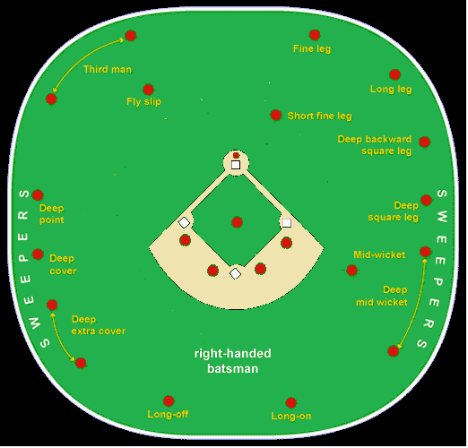
  - All starting players may be removed and re‐enter the game once (except in cases of injury), but must re‐enter in their original position in the batting order.
  - Non‐starters are not allowed to re‐enter unless an injury occurs.
  - When a starter re‐enters, the player in the starter’s batting position in the batting order must be removed from the game and is ineligible for the remainder of the game unless an injury occurs.
- Salary:
  - All players, regardless of position, will be paid no more than $290 per week.
  - Players must also pay a $50 application fee in order to tryout for the league prior to September 1st
  - Players must also cover their own health insurance.

Season Structure:

Preseason:
- Fall Training for both players begins on September 1st:
  - SCL players participate in fall training following a telescoped schedule that generally lasts from September 1–31.
  - All SCL teams will play no games during fall training.

Regular Season:
- All regular season games will be held at Central Broward Park & Broward County Stadium (20,000) in Lauderhill, Florida:
  - This will be the case until both Grand Prairie Stadium (7,000) & Church Street Park (3,500) once the renovations for both stadiums are done; then, the SCL will use a tour-based schedule similar to the Current Premier Lacrosse League (PLL).
  - All teams will practice in local college, high school and/or middle school baseball stadiums in addition to Mills Pond Park before the school day is completed.
- The composition of the teams are as follows:
  - East (Blue & Black) = players from states east of the Mississippi River.
  - North (Purple & Green) = players from everything north of the Missouri Compromise line, including northern California.
  - South (Yellow & Brown) = players from everything south of the Missouri Compromise line, including southern California.
  - West (Red & White) = players from states west of the Mississippi River.
  - Internationals (Grey & Orange) = players from outside the US (including Canada).
  - All domestic players can play for multiple teams (i.e., a player from Indiana can play for either the East or North teams).
  - To be eligible to participate in the league, a player may not be under contract with a pro league nor be eligible for the current year's draft.
- The season for the South Coast League will start on the 1st Saturday of October & will run to the 1st Friday of November:
  - 2022 example = October 1 to November 4.
  - All teams won’t practice on days that they have games.
  - Each SCL team plays 16 games (i.e., All SCL teams will play the other 4 teams 4 times)
  - All SCL games must be played on the following:
    - Tuesday, Wednesday, Thursday, & Friday evenings (7:05 pm).
    - Saturday & Sunday afternoons (12pm or 3pm).
  - Each SCL series will consist of 2 games. All series will be organized in the following ways:
    - Saturday & Sunday
    - Tuesday & Thursday
    - Wednesday & Friday
- Each team will receive bonus/premier points for entry into the postseason:
  - Points are now used to determine which teams will advance into the postseason. Points are being implemented in order to encourage attacking play throughout a game and to reward teams for "coming close" in losing efforts.
  - 3 points for a win by at least 6 points.
  - 2 points for a win by either 1) 5 points or less or 2) in extra innings (i.e. overtime).
  - 1.5 points for a draw/tie.
  - 1 "bonus" point for scoring at least 1 grand slam.
  - 1 "bonus" point for losing by either 1) 5 points or less or 2) in extra innings (i.e. overtime).
  - 1 "bonus" point for scoring at least 10 more points than the opponent.
  - 0 points for a loss by at least 6 points.
  - All teams can only have a max of 2 bonus points per game.
  - At the end of the regular-season, the team with the best regular-season record (i.e. highest point total) regardless of what league they participate in is awarded the SCL Supporter’s Shield:
    - For those who don't know, it echoes the practice of the top European soccer leagues in which the team with the best record is the champion, similar to the Supporter’s Shield in MLS.
    - The Supporter’s Shield winners are guaranteed home-field advantage in all rounds of the playoffs they compete in, except the MiLB championships.
  - Tiebreaker criteria when competitors are level on points:
    - The team that won the head-to-head match (if applicable) is ranked first.
    - If this game was a draw, then the team with the more wins is ranked first
    - Point difference (PD) = is the number of goals (or points) scored in all league matches minus the number of points conceded.
    - Points for (PF) = is the total number of points scored by a team over the course of the regular-season.
    - Points against (PA) = is the number of goals scored against them by their opponents over the course of the regular-season.
    - Fewest disciplinary actions.
    - Strength of schedule = two-third (66 2/3%) for the opponent's record and one-third (33 1/3%) for the opponents' opponent’s record.
    - Total number of points scored on the road.
    - Road point difference.
    - Total number of points scored @ home.
    - Home point difference.
    - If still identical, a play-off is required.
    - Coin toss (2 teams) or drawing of lots (at least 3 teams).

Postseason:
- The top 2 teams will play a best-of 3 series starting on the 1st Tuesday after the 1st Friday of November.

Minimum Ticket Pricing Standards:
Type: | Individual | Groups (i.e. at least 8 persons)
Lawn Sections | $11 per person | $7.33 per person
Seated Sections | $30 per person | $20 per person
- All lawn sections will allow people to bring their own food & drinks in coolers.
- All seated sections will have unlimited concessions as part of the ticket price (i.e. All-You-Can-Eat Menu of Hotdogs, Hamburgers, Cheeseburgers, Chicken Sandwiches, Popcorn, Cookies and Soda/Water.

Gameplay Rules:

The Field:
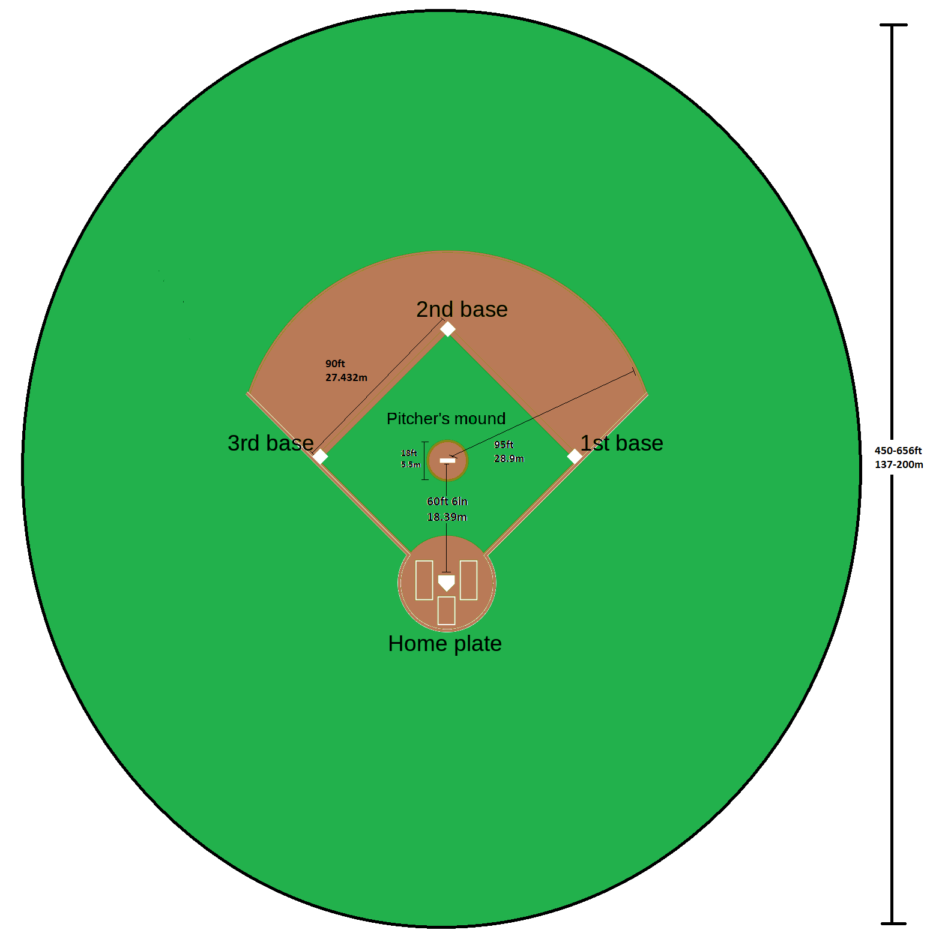
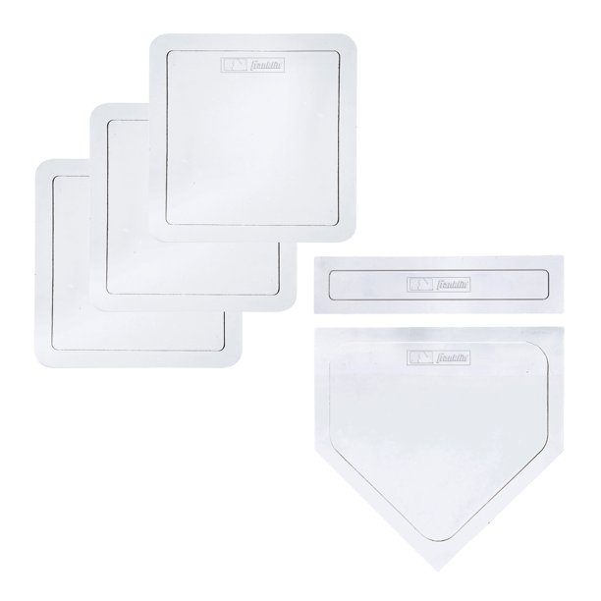
- Overall Dimensions:
  - Diameter = 450-656' (137-200m).
  - A rope demarcates the perimeter of the field and is known as the boundary.
- Bases:
  - Home Plate:
    - A five-sided slab of whitened rubber, 17” square with two of the corners removed so that one edge is 17” long, two adjacent sides are 8½ inches and the remaining two sides are 12” and set at an angle to make a point.
  - Option #1 = a slab of rubber 15" long and 3-5" thick.
  - Option #2 = 3.5’ (1.066m) cylindrical, hexagonal or octagonal poles 2-3”. (0.076m) in diameter.
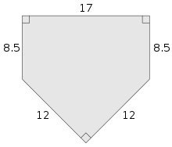
  - Option #3 = cricket wickets:
    - 3 wooden stumps that are 28” (71.12 cm) tall positioned so they are 9” (22.86 cm) wide with 2 wooden bails are placed in shallow grooves on top of the stumps.
    - The bails must not project more than 0.5” (1.27 cm) above the stumps, and must be 4.31” (10.95 cm) long.
    - These are also acceptable.
  - Distance between the Bases = 27.4m (90').
- Pitching Mound:
  - 18' (5.5m) in diameter, with the center 59' (18m) from the rear point of home plate, on the line between home plate and second base. The front edge of the pitcher's plate or rubber is 18"(46cm) behind the center of the mound.
  - 6" (15.2cm) in front of the pitcher's rubber the mound begins to slope downward.
  - The top of the rubber is to be no higher than 10" (25.4cm) above home plate.
  - The mound must be placed as close to either 1) the center of the field or 2) either end of a cricket pitch as possible.
  - Teams must use portable pitching mounds.
  - Distance between Bowler & Batsman = 60' 6" or 18.4 m (approx. 52' or 15.8 m between pitcher's starting point and batter at delivery).
- Batter's Box:
  - The place where the batter stands when ready to receive a pitch from the pitcher.
  - It is usually drawn in paint on the grass surrounding home plate.
  - There are 2 batter's boxes, one on each side of home plate.
  - The batter's boxes are 4' wide and 6' long.
  - The batter's boxes are centered lengthwise at the center of home plate with the inside line of each batter's box 6" from the near edge of home plate.
  - A right-handed batter would stand in the batter's box on the left side of home plate from the perspective of the catcher and umpire. A left-handed batter would stand in the batter's box to their right.

Equipment:
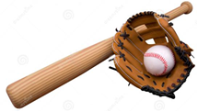
- The bat is round like a baton with a tapered handle ending at a knob:
  - It is no more than 2.625" in diameter at the thickest part and no more than 42" (1067 mm) in length.
  - It typically weighs no more than 36oz (1 kg).
  - Both metal and wooden bats are allowed.
- The core of the ball is cork, rubber or a mixture of the two and is sometimes layered:
  - A ball is 9-9.25" (23cm) in circumference.
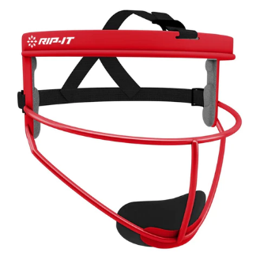
  - Legal weight for the ball is not to be under 5oz but never to be over 5.25oz.
- Gloves in non-throwing hand are required, and fielders may also use additional hard plastic headgear and padding.
- Pitchers must use either 1) the pitcher's masks in softball or 2) the new padded cap.
- Catchers must use plastic shin guards, padded chest protectors, and wire masks molded into a hard plastic shell.
- Batters must use a hard plastic helmet, but may use shin guards and gloves.
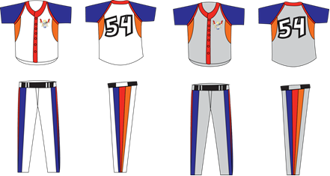
- Baseball uniforms are used:
  - Similar to rugby, both teams must wear their dark color uniforms during games unless either 1) the teams share similar colors or 2) if someone is colorblind.
  - If that is the case, the designated home team will wear their light color uniforms and the away team will wear either 1) their darker color uniforms or 2) an alternative darker color uniform.

Length of Match:
- Each team gets 2 or 3 innings each.
- End of a Half-Inning:
  - The team batting last reaches the amount of runs needed to win the game.
  - When all 11 batters are either dismissed or stranded on base.
- Batting Order:
  - The away team gets the pick for the coin toss.
  - The team that wins the coin toss has the choice of batting first or last.
  - All teams must have a 11-man batting order in which either the DH or the pitcher/bowler must bat.
  - The batting order is predetermined by each team's manager:
    - Every player must bat in the half-inning.
    - Example = 1B, 3B, SS, OF, OF, C, 2B, OF, DH or P, OF, and OF.
  - The team batting order alternates each day:
    - Example: Day #1 = home team bats first, Day #2 = away team bats first, etc.
- Mercy Rules - Games are called if one team is ahead by at least 35 runs by the end of the 1st inning.
- All overtime innings will revert to a format similar to the traditional inning format from American Baseball:
  - During extra innings, the defense gets only a pitcher, catcher and all 5 outfielders:
    - If the batter puts the ball in play, they must try to round the bases and reach home plate before the ball is chased down and thrown home for an out.
  - Each team will have 3 batters/outs per inning.
  - All overtimes can only have a max of 3 innings (except for postseason games).
  - Teams are able to bat whoever they want.
- Between-inning Breaks:
  - A timer will count down between innings from 2:05 for breaks in locally televised games, from 2:25 in nationally televised games and from 2:55 for tiebreaker and postseason games.

Pitching Rules:
- Delivery = overhand, sidearm, or underarm/submarine (baseball method only).
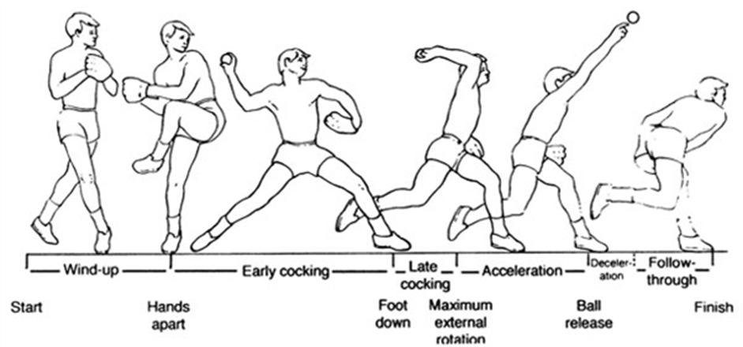
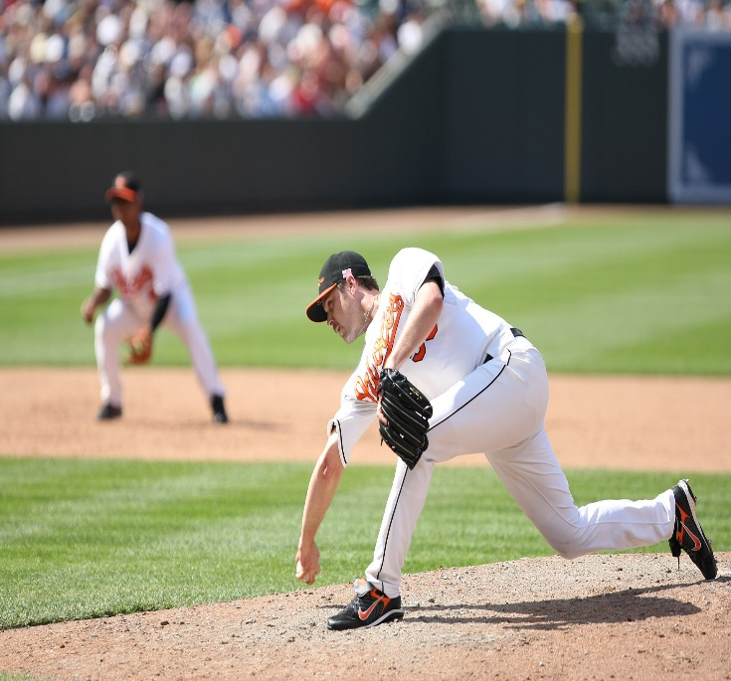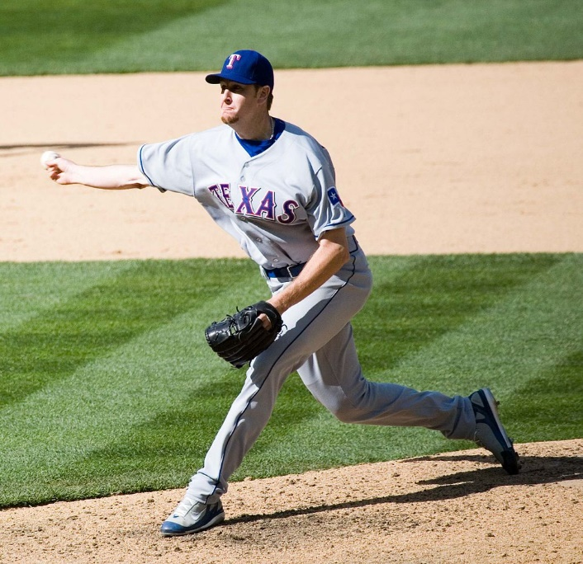
- At least 1 pitcher from each team must start warming up at least 10-20 minutes prior to the coin toss.
- A pitch counts as a strike if any of the following applies:
  - The ball travels though the strike sone & the batter doesn’t swing:
    - The strike zone is defined as the volume of space above home plate and between the batter's knees and the midpoint of their torso.
    - Whether a pitch passed through the zone or not is decided by an umpire, who is generally positioned behind the catcher.
  - The batter attempts to hit the pitch & missing regardless of the pitch travels through the strike zone or not.
  - The batter takes a swing at the ball, the umpire rules the pitch legal, and the batter decides to not run (i.e., the equivalent of a “foul ball”).
- A ball is a legal pitch that doesn't travel through the strike zone.
- A starting pitcher cannot pitch more than:
  - 70 pitches per game in the preseason (i.e., fall training).
  - 85 pitches per game in the regular-season
  - 100 pitches per game in the postseason
  - A pitcher can still finish a batter's plate appearance even if the limit is reached, but must come out after completing the plate appearance.
- A pitcher cannot pitch until:
  - A minimum of 4 days have passed since he last pitched, if he threw 50 or more pitches when he last pitched.
  - A minimum of 1 day has passed since he last pitched, if he threw 30 or more pitches when he last pitched.
  - A minimum of 1 day has passed since any second consecutive day on which the pitcher pitched.
  - These rules don’t apply during post season & spring training.
- All pitchers have pitch clocks in between pitches:
  - The play clock would start once the pitcher steps on the dirt portion of the mound with the baseball:
    - With no one on base = 15-second timer between pitches.
    - With at least 1 runner on base = 20-second timer between pitches.
    - There is a 35-second timer between batters.
  - If the pitcher does not deliver a pitch, make a pick-off throw to a base or step off the pitcher’s rubber before the clock expires, a ball will be assessed to the count.
  - Pitchers are allowed to "disengage" only 3 times during any given at-bat/plate appearance:
    - This includes stepping off the rubber, or even attempting to pick off a baserunner.
    - After a 4th step-off, the pitcher will be charged with a balk, unless at least one offensive player advances a base or an out is made on the ensuing play after the step off.
    - The disengagements rule resets if a runner or runners advance a base within the same plate appearance.
  - Catchers can throw down to any base as much as they want:
    - Catchers must be in the box and ready to catch with at least 9 seconds remaining on the clock.
    - The pitch clock then restarts as soon as the pitcher gets the ball back from an infielder.
    - Catchers cannot hold onto the ball longer to give a pitcher more time:
      - Any attempt -- or at least repeated attempt -- will result in a warning and/or violation being called. Umpires have discretion here.
  - Pitchers can ask for a new ball, but they must do so with at least eight seconds remaining on the clock. Repeated asks -- such as five in a row -- will result in a warning.
  - One clock would be placed along the boundary behind the home plate area, and the other would be located on the boundary behind the pitcher.
- Position players pitching:
  - The leading team must be up by at least 10 or more runs in order to pitch a position player.
  - The trailing team must be down by at least 8 or more runs in order to pitch a position player.
  - Exceptions will be made for injuries.
- All pitchers must face at least 3 batters unless they are injured or injure another player as a result of their actions (example = intentionally hitting a batter).
- The following penalties will occur if any player intentionally hits another player, regardless of the method:
  - 1st Offense = fined at least $1,000 and being suspended for at least 20 games.
  - 2nd Offense = fined at least $2,000 and being suspended for at least 40 games.
  - 3rd Offense = fined at least $4,000 and being suspended for the rest of the season (this includes the postseason).
  - If any player gets penalized at least 3 times in at least 2 consecutive seasons, then the player is banned from playing in the league for the rest of their life.
  - A batter cannot make a movement to intentionally be hit by a pitch:
    - A player who leans or sticks a portion of his body outside the batter’s box to be hit will have a strike awarded to the count.
- Pitchers will no longer be required to throw 4 pitches on intentional walks:
  - Instead, the defensive team can inform the umpire that it is walking the hitter (thus giving up 1 run).
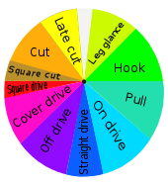
  - However, the pitcher must have paced at least 3 batters in order to do so.

Batting Rules:
- No foul balls:
  - The field has no foul area, so a ball can be legally hit (and scored off of) in any direction.
- Each batter has a max of 2 bunts per at-bat / plate appearance.
- Hit by pitch = awarded a walk (i.e. 1 run).
- All batters may take at most 2 practice swings before their 1st real attempt to hit the ball.
- Batters must be in the box and attentive to the pitcher with at least 9 seconds left on the timer.
- Batters will only get 1 timeout per plate appearance.
- If the batter is not ready to hit by the time the clock expires, a strike will be added to the count.
- If a batter steps out of the box between pitches, a strike will be added to the count.
- The batter has 3 strikes available during their turn at bat.
- Batters must be in the box and attentive to the pitcher with at least 8 seconds left on the timer.
  - If the batter is not ready to hit by the time the clock expires, a strike will be added to the count.
- Batters will only get 1 timeout per plate appearance:
  - A player, regardless of where he is standing, must indicate to an umpire that he is ready to resume play, at which point the umpire will tell the operator to wind the clock.
- The batter must keep at least 1 foot in the batter’s box throughout the at-bat / plate appearance, unless any of the following occurs:
  - The batter swings at a pitch
  - The batter is forced out of the batter’s box by a pitch.
  - A member of either team requests & is granted “time”.
  - A defensive player attempts to play a runner at any base.
  - The batter feints a bunt.
  - A wild pitch or ball occurs.
  - The pitcher leaves the dirt area of the pitching mound after receiving the ball.
  - The catcher leaves the catcher’s box to give defensive signals.
  - If the bat boy is too slow for whatever reason
  - However, the batter is still not allowed to leave the dirt area.
- If the batter hits the ball, they must do either of the following:
  - Attempt to run around the bases.
  - Take a strike in the B-S Count:
    - If a batter decides not to run and a fielder catches a pop fly, the batter is not out.
    - A fair hit does not require the batter to reach base.
    - Each batter will only get 2 chances to delay (i.e., a max of 2 strikes can be used before the batter must reach first base).

Baserunning Rules:
- Starting on homeplate, each offensive player attempts to earn the right to run (counterclockwise) to the next base (corner) of the diamond, then to touch the base at that corner, continuing on to each following base in order, and finally returning to home, whereupon a run (point) is scored.
- It is legal to lead off and steal bases:
  - Batters are now allowed to steal first base on any passed ball and/or wild pitch not caught cleanly (regardless of the count), similar to a dropped third strike.
  - A successful attempt will award 1 point to the baserunner.
  - Runners cannot use bats as an extension of their body while advancing the bases.
- How to advance the bases:
  - A player hits a fair ball that isn’t caught by a fielder before it touches the ground.
  - A player hits a fair ball that touches the ground and is caught by a fielder whose throw fails to beat the player to a base.
  - The umpire calls four pitches out of the strike zone during your at-bat.
  - A pitch in the strike zone hits a player without first touching your bat.
  - The catcher obstructs a player's swing.
  - A player hits a fair ball beyond the playing field (for a home run).
  - A player hits a fair, catchable ball, but the fielder drops the ball, throws it away, and so on.
  - A third strike skips past the catcher and a player beats the throw to first.

Types of Outs:
- Dismissal Procedure = automatic.
- Strikeout = 3 missed swings or bunts or any combination of missed swings and bunts that makes a total of 3 strikes:
  - With two strikes, the batter swings at a pitched ball and misses
  - With two strikes, they do not swing at a pitch that the umpire judges to be in the strike zone (and the catcher catches the ball and does not drop it)
  - With two strikes, the batter foul tips a pitch directly back into the catcher's mitt, and the catcher holds the ball and does not drop it
  - The third strike is pitched and caught in flight
  - On any third strike, if a baserunner is on first and there are fewer than two outs (even when not caught)
- Fly-out / Caught = a fielder catching the ball before landing:
  - A batted ball is caught in flight (fly out), but only after 2 strikes and/or a batter chooses to run.
  - They hit an infield popup while the infield fly rule applies
  - A fielder intentionally drops a line drive with fewer than two outs in a force situation (man on first, men on first and second, men on first and third, bases loaded) in an attempt to create a double play
- Force-out = tagging baserunner or base before baserunner touches base when a baserunner is forced to leave his base when the batter becomes a baserunner himself:
  - They are touched by a fair ball before the ball has touched or passed an infielder:
    - The ball is dead and no runner may score, nor runners advance, except runners forced to advance.
    - Exception: if a runner is touching their base when touched by an infield fly, they are not out, although the batter is out
  - They stray more than three feet (.91 meters) from their running baseline in attempting to avoid a tag.
  - They pass a base without touching it and a member of the defensive team properly executes a live ball appeal.
  - They pass a preceding runner who is not out.
- Tag-out / Run-out = tagging baserunner or base before baserunner touches base.
- Interference / Obstructing the Field = batter or baserunner intentionally interfering with the fielding side.
- Handled the ball = batter or baserunner (intentionally or not) touching the ball with hand, arm, or bat to change its course.
- Double Hit = where the batter or baserunner intentionally touches the ball twice.
- Timed out = batter not arriving within 35 seconds after previous one being dismissed or advanced to 1st base.
- Illegal Swing = a batter hits a pitch while one foot is entirely outside of the batter's box.
- They step from one batter's box to the other when the pitcher is ready to pitch.
- They are found to have committed a mockery of the game, for example, a stolen base of first from the second.
- They are found to be an illegal substitute.
- They are found to have used an altered bat.
- They intentionally abandon their effort to run the bases after touching first base; or
- They run the bases in reverse order in an attempt to confuse the defense or to make a travesty of the game.
- While they are attempting to reach home plate with fewer than two outs, the batter interferes with a fielder and such action hinders a potential tag out near home plate.

Scoring System:
- A player scores 1 point for every base reached after hitting the ball in addition to completing the circuit of all the bases:
  - i.e., the # of base runs after a hit = # of points:
    - Example: ground rule double = 2 pts.
  - However, they will not subsequently score when moving around the bases on another player's hit unless they manage to steal a base or reach home plate:
    - i.e., Players already on base cannot score by advancing to another base on another player's hit, but can score by either stealing a base or reaching home plate (1pt for either action).
    - Players can only attempt to steal a base a max of 3 times per game
- A home run scores either 4 or 6 points + the number of players on base (if any):
  - A home run scores 4 points if the ball is hit beyond the boundary and it bounces at least once before it leaves the field of play (or if it rolls along the ground & hits the boundary).
  - A home run scores 6 points if the ball is struck over the boundary without bouncing before it leaves the field.
  - When the ball is inside the boundary, it is live.
  - When the ball is either 1) touching the boundary, 2) grounded beyond the boundary, or 3) being touched by a fielder who is himself either touching the boundary or grounded beyond it, it is dead and the batting side usually scores for hitting the ball over the boundary.
  - Examples:
    - Major grand slam = 6 points + 3 base runners for a total of 9 points.
    - Minor grand slam = 4 points + 3 base runners for a total of 7 points.
- Extras = 1pt each:
  - Base on balls (4 balls per at-bat).
  - Bye (missed pitch and batter reaches a base).
- Example (Cincinnati Reds vs Chicago Cubs on August 10, 2019; still using 9-inning format):
- Reds:  - VanMeter doubled to deep left center (2), Votto scored (RBI-1) (3).  - Aquino homered to left (4)  - Senzel homered to left (4).  - Aquino homered to left (4).  - Barnhart singled to center (1)  - Peraza singled to right center, Barnhart to second. (1)  - Senzel singled to right center, Senzel safe at second on error by center fielder Almora Jr..(2)  - Barnhart singled to right center (1), Senzel scored (RBI-1) (2).  - Peraza hit a ground rule double to deep center, Barnhart to third (2)  - Gray singled to right (1), Barnhart scored and Peraza scored (RBI-2) (3).  - Winker doubled to left, Gray to third (2).  - Suárez homered to center (4).  - Aquino homered to left center (4).  - Winker walked (1)  - Farmer homered to left (4).  - Aquino walked (1)  - Senzel grounded into fielder’s choice at first, Aquino out at second (1).  - Barnhart walked, Senzel to second (1)  - Peraza hit by pitch, Barnhart to second, Senzel to third (1)  - Ogrady singled to left (1).  - Peraza singled to left (1). | - Cubs:  - Rizzo hit by pitch (1).  - Bote Walked (1).  - Rizzo Walked (1).  - Lucroy walked (1).  - Schwarber singled to right, Lucroy to second (1).  - Caratini walked (1)  - Kemp singled to right, Caratini to second (1).  - Castellanos grounded into fielder's choice to third, Mills out at second (1).  - Bote doubled to deep center (2).  - Mills singled to right, Bote to third (1).  - Kemp doubled to deep right (2).  - Schwarber homered into center (4).  - Bote singled to right (1).  - Total:  - Reds = 47.  - Cubs =18.

Defensive Shift Rules:
- At the time a pitch is thrown, all 4 infielders are required to be on the infield dirt (or infield grass) with at least 1 player on each side of 2nd base:
  - All initial shifts & shift changes must last for at least 3 at-bats / plate appearances.
  - Teams are still allowed to bring an outfielder in, either onto the infield or into the shallow outfield.
  - They are also allowed to employ a six-outfielder alignment by having the DH become an outfielder:
    - However, they can only do this once per inning, & it can only last a max of 3 plate appearances per inning.
- If the hitting team reaches base and runners advance on a ball hit under the violation, the game proceeds without penalties.
- If the play has any other consequence -- an out, a sacrifice, etc. -- the hitting team can decide either to accept the penalty -- which would add one ball to the hitter's count -- or decline it, and the play would stand.

Signals:
- Right hand and arm swept across the body = Home Run (four+ runs). This signal signifies that the ball has been hit all the way to & has hit the boundary, and a minimum of 4 runs has been scored.
- Both arms held above the head and index fingers outstretched = Home Run (six+ runs). The ball has been hit all the way or over the boundary. A minimum of 6 runs are awarded for this feat.
- Index finger raised towards the batsman = Out. The umpire has given the batsman or woman out and they have to leave the crease and take the long, lonely walk back to the pavilion.

Mound Visits:
- Mound visits will be limited to 6 per team per 3 regulation innings (i.e., 2 or 3 per inning):
  - Teams will receive an additional visit for every extra inning played.
  - Any manager, coach or player visit to the mound will count as a mound visit.
  - Visits to the mound to clean cleats in rainy weather, to check on an injury or potential injury or after the announcement of an offensive substitution are exempted.
  - Also, normal communication between player and pitcher that does not require either to vacate their position on the field does not count as a visit.
  - If a team is out of visits, the umpire will have discretion to grant a visit at the catcher's request if he believes there has been a cross-up between the pitcher and catcher.
  - Baserunners will not be allowed to leave the bases they are occupying during a defensive conference.

Coach’s Video Review Challenges:
- Coaches have 2 video review challenges per game where the technology is available:
  - Coaches have 30 seconds from the end of the play to issue a replay challenge.
  - Replay officials have 90 seconds to determine the ruling of any challenged play:
    - If they can’t determine an overrule within that time, then the call stands.
- The following plays will be reviewable by the crew chief at his discretion or with the use of a coach’s challenge:
  - Deciding if a batted ball is fair or foul. The ball must first touch the ground or a fielder beyond the initial position of the first or third baseman.
  - Deciding if a batted ball is either a ground-rule double or a home run.
  - Any catch or no-catch ruling in the outfield or foul territory.
  - A no-catch ruling in the infield in some instances. With runners on base, a no catch within the infield can be changed to a catch only if it results in a third out. With no runners on base, a no catch within the infield can be changed to a catch at any time.
  - Spectator interference.
  - Deciding scoring plays at home plate inclusive of collisions (illegal and/or malicious slides) or time plays.
- The following plays will be reviewable only by a coach’s challenge or at the crew chief’s discretion beginning in the last 2 innings of regulation and extra innings:
  - Force and tag-play calls at any base.
  - Calls involving whether a base runner passes a preceding runner; determining whether a base runner scored ahead of a third out; and upon an appropriate appeal by the defensive team, determining whether a base runner touched a base.
  - Plays involving hit by pitch.
  - Deciding if a runner failed to retouch a base after a fair or foul ball is legally caught.
  - The umpire’s placement of runners following a boundary call.
  - Deciding if interference occurred on a runner’s attempt to break up a double play.

