Roster Size:
- All NFL teams will employ 8 coaches, including the following:
  - A head coach.
  - An offensive and a defensive coordinator.
  - 4 position coaches.
  - 1 special teams coordinator.
  - Each team will also be assigned and limited to 8 football operations staff.
- Number System:
  - Quarterbacks & Kickers (Combination of Placekickers and Punters): 00–19, or 20-49 if all are taken.
  - Wide Receivers: 10–19 and 80–89, or 40–49 if all are taken.
  - Running Backs and Defensive Backs (including Designated Hitters): 20–49, or 00-19 if all are taken.
  - Offensive Linemen: 50–79 & 90–99.
  - Linebackers: 50–59 & 90–99, or 40–49 if all are taken.
  - Defensive Linemen: 50–79 & 90–99.
  - Tight Ends: 40–49 & 80–89, or 00-19 if all are taken.
- All NFL Teams can have no more than 53 total players on the roster during the regular season, with the rosters being made up in several ways:
  - All players are considered active.
  - All teams must have at least 2 quarterbacks & 2 kickers.
  - All NFL teams must have no more than 99 players during training camp & the pre-season.
  - All players signed from the Spring League can play in all preseason games.
- All NFL Teams may call up and assign a max of 5 NFL/NFDL players at once as many times as they choose, and veteran NFL players can be assigned with their consent:
  - Once the NFDL Season is over, the NFL player(s) will either be automatically called up back into their team's roster, or the NFDL player(s) will be assigned in their place and stay in their spot.
  - An NFL player on the disabled list may be sent to their minor league club for a "rehabilitation" assignment, allowing the player to face live competition (though not Major League level) as a means of working his way back into the regular lineup, prior to being returned to the team's roster.
  - All NFL teams are allowed a five-man roster expansion in December to a 58-man active roster from the current 53 to have 5 NFDL players come and practice with the squad, with the option of having them play in any game once the NFDL season is over (including the postseason). However, those players will still earn the same salary rate.
- The NFL Draft:
  - The NFL Draft is a 7-round draft:
    - The NFL Draft takes place in the final week of April.
    - The selection order is based on each team's win-loss record in the previous season and whether the team reached the playoffs. Teams that did not reach the playoffs the previous season are ranked in reverse order of their records (thus the team with the fewest wins is awarded the first selection).
  - All potential players must be at least 21 years old and meet the following requirements in order to become eligible to play in the NFL:
    - Options to skip the NFDL entirely:
      - Play at least 3 years of collegiate football (either in the US and/or Canada).
      - Play at least 3 years of professional football outside of the NFDL (for foreign players & domestic players skipping college only).
    - Options combining Collegiate & Professional Play:
      - At least 1 year of collegiate & 2 years of professional football either domestically (NFDL) and/or internationally.
      - At least 2 years of collegiate & 1 year of professional football either domestically (NFDL) and/or internationally.
      - Junior college players are eligible to be drafted once they complete their 2-year degrees, but they must play in the NFDL for at least 1 year.
    - All potential players must be at least 18 years old and have a high school diploma or GED to be eligible to play in the NFDL:
      - All players must spend at least 1-3 years in the NFDL and/or any other professional football league (i.e. the AFL, CFL, NGL, or Big 6) in order to be able to be moved up to the NFL.
      - All high school players can sign contracts to play at least 3 years of professional football inside the NFDL.
      - All players without college degrees must play the same number of years that they are skipping in college to play professionally either in 1) the NFDL or 2) an international football league (ex: a sophomore leaving college must play at least 1 year in the NFDL while being enrolled in an accredited accelerated education program).
    - All college players who declare for the draft and are not drafted remain eligible for college football unless and until they sign a professional contract.
  - Ties between teams with identical records are determined by the following tiebreakers (in order):
    - Strength of schedule:
      - Strength of schedule is defined as the combined win-loss record for all 18 of the team's opponents in the previous season.
      - Ties count as a half win and half loss).
    - The team with the lower strength of schedule (i.e. their opponents compiled fewer wins) is granted the earlier pick.
      - Teams with 6 wins or less participate in the first lottery for the top supplemental draft picks.
      - The second group consists of non-playoff teams and follows the same weighted system.
      - The third group consists of last season's 2 playoff teams and, again, follows the same lottery system.
      - The team that posted the worst record among that group is given a weighted advantage over the following team, with each team's "weight" being decreased on down the line until reaching the team with the best record in the group.
    - Record in common games against division opponents (if the teams are in the same division).
    - Record in common games against conference opponents (if the teams are in the same conference).
    - Coin flip(s), which occur(s) at the pre-draft NFL Combine.
  - Teams that reached the playoffs the previous season are then slotted in the order in which they were eliminated as indicated in the table below. Within each tier, the slotting is determined as above (i.e. worst record picks first and the same tiebreakers apply).
- All NFL Players must play at least 0-3 years in the NFDL, depending on how many years of college they have:
  - All NFL Teams are only able to recruit or call up players from their NFDL team or send players to their NFDL team.
  - All NFDL players are required to have playing time in every game unless an injury occurs.
  - After that 0-3 year span, all NFL teams can sign a player from any minor-league team if he has the minimum required years of minor-league service or more and is moved to the NFL team's 53-man roster.
  - All non-rookies and sophomores in the NFDL may be traded to another team by the NFL Parent Club.

Regular-Season Structure:
- "Mercy" Rule:
  - If a team has at least a 28-point lead at the start of the 4th quarter, the game is automatically called as a win for the team with the lead.
- Overtime Format:
  - If a game is tied after 4 quarters, the teams will play a max of 5 overtime periods similar in a format to a penalty shootout in soccer:
    - Teams will meet at the 50-yard line for another coin flip to determine the possession of the first extra period.
    - The visiting team picks heads or tails.
    - Whichever team has more points after 5 periods wins.
    - If it's still tied after 5 periods, the game will either end in a tie (regular-season) or continue playing until one team wins (post-season).
    - The NFL pre-season games will no longer have any overtime periods (i.e. be declared ties).
  - Each period consists of one play for each team, the order of which is decided by a pre-overtime coin toss:
    - The overtime period begins at the 2-yard line, and each team is given the opportunity to score a touchdown or field goal:
      - The offense can score a 'point' by converting in the end zone, while the defense can score a 'point' by forcing a turnover.
      - Neither team will score a point if the offense fails to convert in the end zone.
      - No field goals are allowed.
    - The game clock does not run, but the play clock is enforced.
    - Possessions end when the offensive team scores or turns the ball over.
    - To speed up the overtime process, both teams’ offense and defense will be on the field at the appropriate end zone.
      - After the first team completes its drive with a score or turnover, the opposing team has the same opportunity from the other 2-yard line (i.e. Once one team's offense has completed their round of the shootout, the other team's offense will play their round from the opposite end zone).
    - Each team has 1 timeout in overtime.
- Points System:
  - Points are now used to determine which teams will advance into the post season. Bonus points are being implemented in order to encourage aggressive play throughout a game and reward teams for "coming close" in losing efforts.
  - 4 points for winning a game in regulation.
  - 3 points for winning a game in overtime.
  - 2 points for drawing a game.
  - 0 points for losing a game.
  - 1 bonus point for losing by 8 points (or fewer) or in overtime.
  - 1 bonus point for scoring at least 4 touchdowns.
  - 1 bonus point for scoring at least 3 more touchdowns than the opponent.
  - All teams are allowed no more than 2 bonus points per game.
  - At the end of the regular-season, the team with the best regular-season record (i.e. highest point total) is awarded the Jim Thorpe Trophy:
    - For those who don't know, it echoes the practice of the top European soccer leagues in which the team with the best record is the champion, like the Supporter’s Shield in MLS.
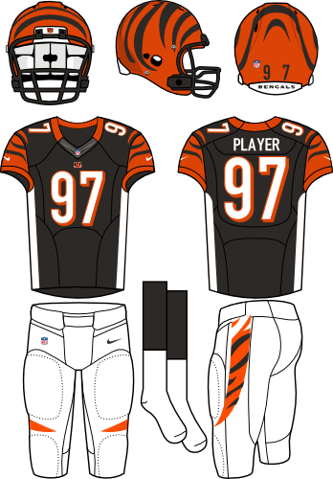
    - The Jim Thorpe Trophy winner is guaranteed home-field advantage in all rounds of the playoffs they compete in (excluding the wild-card round & the Super Bowl).
    - The Jim Thorpe Trophy can just be a certificate in a frame.
  - Tie-breaker - If only two teams are level on league points:
    - Most wins.
    - The team that won the head-to-head match (if applicable) is ranked first:
      - For divisional rivals, this becomes the teams with the higher aggregate score (i.e. The combined score from both games).
      - If this game was a draw, then the team with the more wins is ranked first.
    - Point difference (PD) = is the number of goals (or points) scored in all league matches minus the number of points conceded.
    - Points for (PF) = is the total number of points scored by a team over the course of the regular-season.
    - Points against (PA) = is the number of goals scored against them by their opponents over the course of the regular-season.
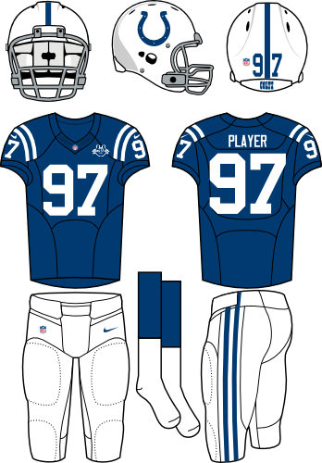
    - Fewest disciplinary actions.
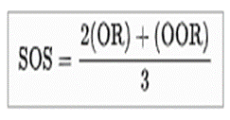
    - Strength of schedule = two-third (66 2/3%) for the opponent's record and one-third (33 1/3%) for the opponents' opponents record.
    - Total number of points scored on the road.
    - Road point difference.
    - Total number of points scored @ home.
    - Home point difference.
    - If still identical, a play-off is required.
    - Coin toss (2 teams) or drawing of lots (at least 3 teams).
- Uniform Rules:
  - Both teams must wear their dark color uniforms during games (similar to rugby or this NAL Championship Game) unless either of the following occurs (i.e. mandatory “Color Rush”):
    - The teams share similar colors.
    - If someone is colorblind (i.e. teams with red or green uniforms will not participate).
    - NFL Example: Indianapolis Colts vs Cincinnati Bengals.
  - If that is the case, the designated home team will wear their dark color uniforms and the away team will wear either of the following:
    - Their lighter color uniforms.
    - An alternative darker color uniform.
- The Pro Bowl Weekend:
  - There are two games - the regular Pro Bowl & the new Rising Stars Bowl:
    - The Rising Stars Bowl played the weekend before the Super Bowl, at least 3 hours before the regular Pro Bowl:
      - Anyone with a ticket to the Pro Bowl also has a free ticket to the Rising Stars Bowl.
    - All NFL & NFDL players are voted into the Pro Bowl & Rising Stars Bowl respectively by the coaches, the players themselves, and the fans.
    - Players from the two teams competing in the Super Bowl will not participate.
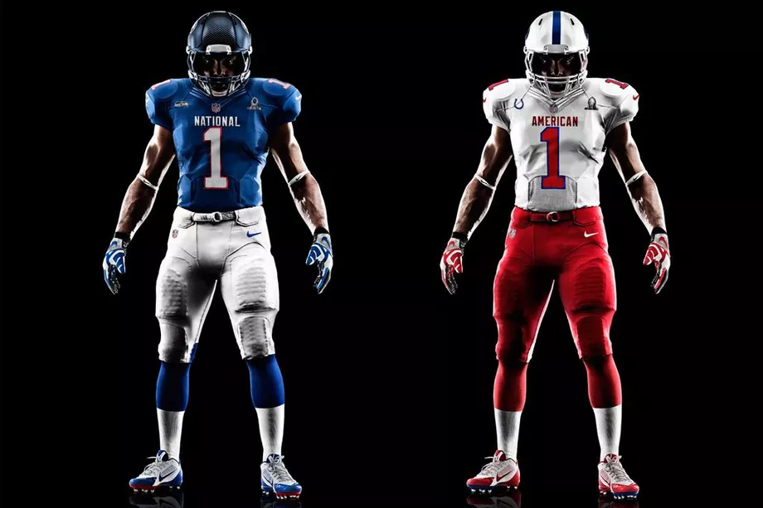
  - The Pro Bowl will be played the weekend before the Super Bowl:
    - The regular Pro Bowl uses the traditional NFC–AFC format in which jerseys/pants/socks are all one uniform color (red for the AFC, blue for the NFC).
    - The players each wear the helmet of their respective NFL team.
  - The Pro Bowl has different rules from other NFL games to make the game safer:
    - No motion or shifting by the offense.
    - Offense must have a running back and tight end in all formations.
    - Offense may have 1 or 2 receivers on the same side.
    - Intentional grounding is legal.
    - Defense must run a 4–3 at all times, though the Cover 2 and press coverage are allowed.
    - No blitz; DEs and tackles can rush on passing plays, provided they are on same side of ball.
    - No blindside or below the waist blocks.
    - Cannot rush punts, PATs or FG attempts.
    - 38-second play clock to run plays.
    - Deep middle safety must be aligned within hash marks.
    - No DH.
    - Replay reviews are allowed.
    - 44-player roster per team.
    - Coin toss determines who receives first; loser receives to start 3rd period.
    - Kickoffs are eliminated (including free kicks); Teams will start on their own 25-yard line after any score or at the start of each half/odd overtime.
  - Players are paid for participating in the game with the winning team receiving a larger payout:
    - NFL = $64,000 / $32,000.
  - The Pro Bowl Skills Challenge:
    - Epic Pro Bowl Dodgeball: Pro Bowlers will compete in a game of dodgeball (NFC vs AFC & EFC vs WFC).
    - Gridiron Gauntlet: 5 team members will compete in a timed relay race
or Power Relay Challenge: 4 team members will compete in a timed relay race
    - Precision Passing: 2 players on each team (NFC & AFC) will battle it out, trying to hit moving targets of varying size and distance.
    - Best Hands: Quarterback and wide receiver duos from each team will show off their skills, connecting on as many pass attempts as possible before time runs out (1 NFC & 1 AFC duo only).
    - Drone Drop: A drone flies high into the air, and drops a football for a receiver to catch (2 receivers from each conference).
    - Kick-Tac-Toe: 1 player from each team gets 6 kicks (2 45yd kicks, then 2 35yd kicks, and then 2 25yd kicks; NFC vs AFC).
    - Dodgeball is worth 3 points to the winner, & all of the other events are worth 1-3 team bonus points each (i.e. 1st place = 3 points, 2nd place = 2 points, etc.).
- All NFL games are played on Sundays, with a Monday night game typically held at least once a week and Saturday night games occurring on most weeks as well once the college football season is over:
  - There will be no Thursday games for all NFL teams.
  - All teams are required to have an off day after a game.
- The NFL preseason begins with the NFL's Hall of Fame Weekend, specifically the Hall of Fame Game between the previous season's Super Bowl contestants:
  - Each team plays 2 preseason games (1h/1a) beginning on the second Thursday of August and ending one week later (i.e. the Super Bowl Champion & Runner-up will play 3 preseason games):
    - Teams can only play against the following (example = New England Patriots):
      - The divisional teams (i.e. AFC East).
      - The team from the division of the same name in the other conference (i.e. NFC East).
      - Their designated rival (i.e. Denver Broncos).
  - The Hall of Fame Game will be played at Tom Benson Hall of Fame Stadium (23,000), & will take place on the 1st Sunday of August.
- Each team plays a 21-week season beginning on the fourth Sunday of August and ending on the Monday after the 2nd Sunday of January the following calendar year with 18 games (9h/9a) & 3 bye weeks (2019 Example = August 25, 2019 – January 13, 2020):
AFC East: | AFC North: | AFC South: | AFC West:
Baltimore Ravens | Cincinnati Bengals | Houston Texans | Denver Broncos
Buffalo Bills | Cleveland Browns | Jacksonville Jaguars | Kansas City Chiefs
New England Patriots | Indianapolis Colts | Miami Dolphins | Los Angeles Chargers
New York Jets | Pittsburgh Steelers | Tennessee Titans | Oakland / Las Vegas Raiders
NFC East: | NFC North: | NFC South: | NFC West:
Carolina Panthers | Chicago Bears | Atlanta Falcons | Arizona Cardinals
New York Giants | Detroit Lions | Dallas Cowboys | Los Angeles Rams
Philadelphia Eagles | Green Bay Packers | New Orleans Saints | San Francisco 49ers
Washington Federals | Minnesota Vikings | Tampa Bay Buccaneers | Seattle Seahawks

  - The NFL will have no more games on Thanksgiving.
  - Each team plays 2 games (1h/1a) against each of the other 3 teams in its division, with everyone’s divisional games in the first & last 3 weeks of the regular-season (6 Games).
  - Each team plays 1 game (2h/2a) against each of the four teams from another division within its own conference, with the assigned division based on a three-year rotation (4 Games).
  - Each team plays 1 game (1h/1a) against one team from each of the remaining two divisions within its conference, based on the final division standings from the prior season (2 Games).
  - Each team plays 1 game (2h/2a) against each of the four teams from a division in the other conference, with the assigned division based on a four-year rotation (4 Games).

  - Each team plays 1 game (1h, 1a, or 1n) against 1 team from the division of the same name in the other conference based on the final division standings from the prior season (i.e. AFC East #1 plays NFC East #1, etc.) (1 Game). These games will either be played at any of the following:
    - One of the team's stadiums.
    - A neutral site in the US with no professional football team with 700 mi of either franchise (especially for testing new cities for an expansion franchise in either the NFL or NFDL).
    - An approved international stadium for the NFL International Series.
  - Each team plays 1 game (1h, 1a, or 1n) against their designated rival (1 Game). These games will either be played at any of the following:
    - One of the team's stadiums.
    - A neutral site in the US with no professional football team with 700 mi of either franchise (especially for testing new cities for an expansion franchise in either the NFL or NFDL).
    - An approved international stadium for the NFL International Series.
- The NFL International Series:
  - The NFL International Series is a series of NFL regular-season games being held internationally across the world.
  - Sites:
    - Wembley Stadium (86,000) in London, England.
    - Twickenham Stadium (82,000) in London, England.
    - Northumberland Development Project (62,062) in London, England.
    - Croke Park (82,300) in Dublin, Ireland.
    - Aviva Stadium (49,000) in Dublin, Ireland.
    - Estadio Azteca (87,000) in Mexico City, Mexico.
    - Millennium Stadium (74,500) in Cardiff, Wales.
    - Murrayfield Stadium (67,144) in Edinburgh, Scotland.
    - Rogers Center (54,000) in Toronto, Ontario (only after the Grey Cup).
    - Olympiastadion (74,475) in Berlin, Germany.
    - Volksparkstadion (57,000) in Hamburg, Germany.
    - RheinEnergieStadion (49,698) in Cologne, Germany.
    - Merkur Spiel-Arena (54,600) in Düsseldorf, Germany.
    - Estadi Olímpic Lluís Companys (55,926) in Barcelona, Spain.
    - Shanghai Stadium (56,842) in Shanghai, China.
    - ANZ Stadium (83,500) in Sydney, Australia.
    - Salt Lake Stadium (85,000) in Kolkata, India
    - Estádio do Morumbi (67,011) in São Paulo, Brazil.
- Playoffs - the post-season is a 12-team single-elimination tournament:
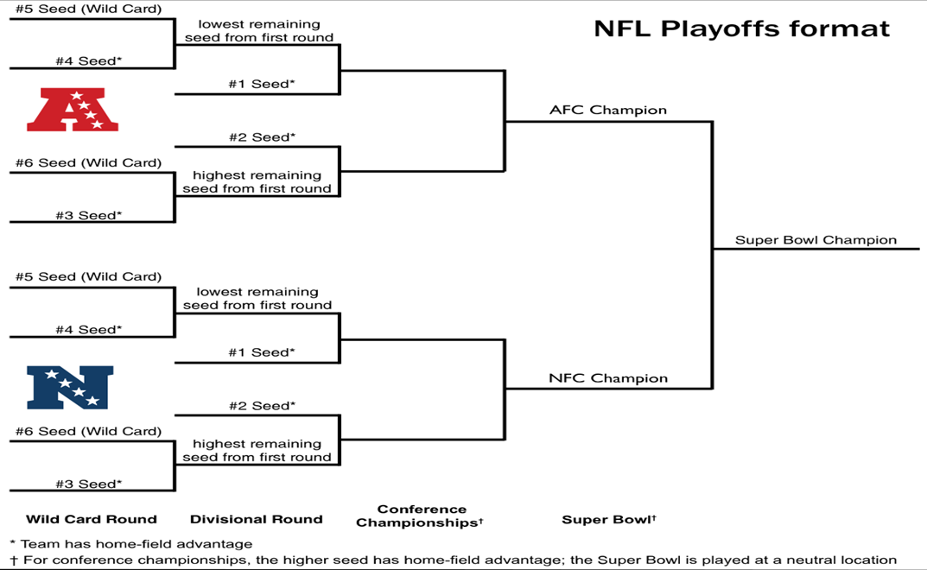
  - The NFL post-season will begin on the 3rd Sunday of January, & will end on the 2nd Sunday of February with the Super Bowl (2019 example = Jan 19-Feb 9, 2020).
  - 6 teams from each of the league's two conferences qualify for the playoffs based on total points earned using the bonus points system:
    - The 4 division champions & 2 wild card qualifiers from each conference will be selected.
    - All 12 teams will be seated 1 through 6 per conference based on the number of bonus points that they have, & will never be reseeded.
    - 1st Round (Conference Quarterfinals) = 3v6 & 4v5; #1 & #2 seeds get byes.
    - 2nd Round (Conference Semifinals) = 1 vs the lowest remaining seed from the 1st round & 2 vs the highest remaining seed.
    - 3rd Round (Conference Championship).
    - 4th Round = Super Bowl.
  - All playoff games will be played at the higher ranked team’s stadium, except for the Super Bowl:
    - The location of the Super Bowl is chosen by the NFL 3-5 years before the game.
    - Any NFL or Division 1 college team with a stadium capacity of at least 70,000 (including club and fixed suite seating) can host the Super Bowl:
      - Stadiums may include temporary seating for Super Bowls, but seating must be approved by the league.
      - Stadiums where the average game day temperature is below 50° Fahrenheit must either have a roof or a waiver given by the league.
      - There must be a minimum of 35,000 parking spaces within one mile of the stadium.
      - The host stadium must have space for the Gameday Experience, a large pregame entertainment area, within walking distance of the stadium.
      - The host city must have space for the NFL Experience, the interactive football theme park which is operated the week prior to the Super Bowl. An indoor venue for the event must have a minimum of 850,000 square feet, and an outdoor venue must have a minimum of 1,000,000 square feet.
      - Additionally, there must be space nearby for the Media Center, and space for all other events involved in the Super Bowl week, including golf courses and bowling alleys.
      - The necessary infrastructure must be in place around the stadium and other Super Bowl facilities, including parking, security, electrical needs, media needs, communication needs, and transportation needs.
      - There must be a minimum number of hotel spaces within one hour's drive of the stadium equaling 35% of the stadium's capacity, along with hotels for the teams, officials, media, and other dignitaries.
      - There must be practice space of equal and comparable quality for both teams within a 20-minute drive of the team hotels, and rehearsal space for all events within a reasonable distance to the stadium.
      - The practice facilities must have one grass field and at least one field of the same surface as the host stadium.

New Gameplay Rules:
- 11/12 players on the field during a play.
- It shall be the responsibility of the home team to have a qualified physician in attendance 15 minutes before, during and available after the game.
- All coaches must remain on the field in the coaching area during the conduct of the game. No phones are permitted for use.
- Equipment Rules:
  - The chain crews' equipment (including vests, yardage "sticks", down markers, and endzone pylons) will be bright orange.
  - A one-way radio into all offensive players' helmets to allow the offensive coordinator to run a no-huddle offense and call plays directly to all of the players from the sidelines.
  - The single-bar face mask is only allowed for kickers.
  - All players are required to wear knee pads and pants that cover the knees.
  - All players are allowed to wear custom cleats as long as they don’t say anything discriminatory:
    - i.e. racism, sexism, homophobia, ableism, etc.
  - Mouthguards are mandatory for all players.
  - All players must also wear either of the following:
    - Sensors designed to detect hard hits in their helmets, and any player that receives the beep must come out for at least 1 play while the medical staff examines them for concussions.
    - Helmets designed to crumple upon impact.
    - The single-bar face mask is now allowed for all players.
- Having full-contact practices twice in the same day is prohibited during the preseason, regular-season, & postseason:
  - All teams are allowed no more than 1 full-contact practices each week during the regular season & post-season:
    - While players still wear helmets, they no longer wear shoulder pads and other protective gear in in non-contact practices.
    - There are no limits for practices with robotic tackling dummies
  - All teams can still have 2-a-days, but the extra session has to be either film study, weight lifting, or a walkthrough.
  - No conditioning can take place at the walkthrough, and players can’t be in helmets or shoulder pads unless the tackling involves robotic tacking dummies.
- All players must weigh no more than 300lb / 136.078 kg at any time during the regular & post season:
  - There is a $2,000 fine for anyone over the weight limit for every week they are overweight.
- 4 downs to make 10 yards.
- Four 15-minute quarters with a 15-minute period at half-time & 2-minute periods between quarters:
  - The official time clock runs continuously unless stopped by any of the following:
    - Plays in which a touchdown or safety is scored (which must be automatically reviewed).
    - When a time out is called by either team.
    - Official reviews of penalties (including coaches challenges; instant replay reviews will be limited to 30 seconds).
    - PAT conversion plays after a touchdown.
    - The referee stops play to allow opposing teams to align properly after a play.
    - The mandatory play stoppage with 2 minutes remaining in each half:
      - After the two-minute warning, the game clock is run only from the snap of the ball to when the referee declares that play dead (i.e. the clock stops after every play after the 2-minute warning).
  - An offense has 30 seconds from the referee's signal to begin a play (i.e. The play clock will be 30 seconds long measured from the end of the previous play).
  - All teams have no more than 2 timeouts per half.
- Kicking Rules:
  - The kicker & punter positions will be merged into one (i.e. having one player who kicks all of the field goals, punts, & kickoffs).
  - All kickoffs will be administered from the kicking team's 25-yard line, as to decrease touchbacks and increase coverage opportunities:
    - Kickoffs may be taken as either:
      - A place kick with a tee.
      - A free kick (as is done after scoring a safety; i.e. like a punt or drop kick).
      - The scoring team can also elect to run a play from its 35-yard line that must go at least 10 yards to retain possession in lieu of an onside kick regardless of their score; If the team fails, then the opposition will start their possession on their own 35-yd line.
    - Rules for the kicking team:
      - The kickoff team must have 5 players on each side of the ball (5x5 alignment).
      - At least 2 players must be lined up beyond the yard-line number and 2 players between the inbounds line and the yard-line number.
      - The kickoff team cannot be lined up more than 1 yard from the restraining line (i.e. the 24-yd line for the kickoff at the 25-yd line).
      - The kickoff team must remain still until the ball is kicked (with the exception of the kicker).
      - The ball must go at least 10 yards before it can be recovered by the kicking team (i.e. the ball can be recovered by anyone on the kicking team after the 35yd line).
    - Rules for the receiving team:
      - 8 players on the receiving team must line up in a 15-yard zone that begins 10 yards from the kickoff line and extends back (i.e. between the kicking team's 50-yard and 35-yard lines; the setup zone) for the possibility of decreasing "high-impact collisions"; only 3 players can remain outside of the setup zone.
      - Only single & 2-man wedge blocks are permitted; until the ball is touched or the ball hits the ground, no player on the receiving team may cross its restraining line, or initiate a block against the kicking team in the 15-yard area (i.e. blocks can take place anywhere on the field except in-between the 40-yd & 35-yd lines).
      - Until the ball is touched or the ball hits the ground, no player on the receiving team may cross its restraining line, or initiate a block against the kicking team in the 15-yard area (i.e. blocks can take place anywhere on the field except in-between the 40-yd & 35-yd lines).
  - All players are prohibited from leading with the crowns of their helmets.
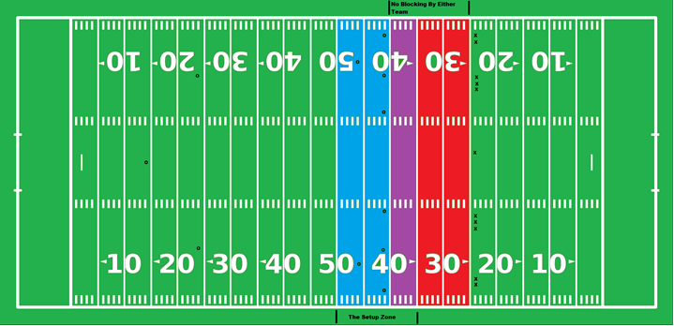
  - The No-Yards Rule (adopted from the CFL):
    - Like in the CFL, punts & kicks are allowed at any point of time in the game (i.e. any player can kick the ball at any time, including kickoffs).
    - All punt or kickoff coverage teams must give a 5-yard empty zone around the opposing receiver until he has received the ball.
      - Kick or punt receivers must field all kicks and punts, with no exceptions (i.e. Fair catches are not recognized).
      - All of the players offside at the time of the kick may neither touch the ball nor be within 5yds of the member of the receiving team who fields the kick.
      - The penalty for no-yards is 15yds (if the ball is in flight) or 5yds (if the ball has been grounded).
    - Any unhandled ball from any place kick or punt may be legally recovered by the kicker or any player behind the kicker at the time of the kick so long as the ball travels at least 10 yards:
      - The ball doesn't have to be touched by the receiving team in order for the possession to count.
      - In such a case, the kicker is exempt from the No-Yards rule. Thus, a player from Team A may punt or kick the ball 40 yards, chase the ball upfield, then recover an untouched ball for a Team A first down. Such instances are rare since the player would have to elude plenty of blocking to reach the ball. When it does happen, this play is highly exciting.
      - Examples = Montreal at Toronto - Wild Ending - October 29, 2010, Montreal Alouettes Perfect Fake Field Goal vs. Lions Wk. 11 2012.
    - The ball is live under almost all circumstances during a legal play within bounds at any time during the game (including if a punt or field goal attempt lands & stays in the end zone) except for incomplete forward passes & successful field goal attempts.
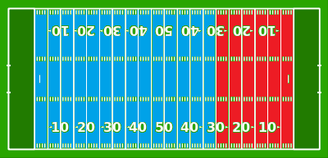
  - With the exception of a rouge/touchback, kicking/punting the ball out of bounds is a 10yd penalty.
  - All teams must do either of the following on 4th downs inside their opponent’s 30yd line:
    - Attempt to gain a 1st down.
    - Attempt to score (either a field goal or touchdown).
    - Punting on 4th down is not allowed inside the 30yd line unless the defense punts the ball out of desperation, similar to what happened in this CFL play.
    - However, teams may punt the ball if the ball is snapped from the 30yd line.
    - Key (diagram):
      - Blue = punting is allowed.
      - Red = punting is not allowed.
- Passing Rules:
  - A "defenseless player" now includes receivers tracking the quarterback or looking back for the ball, including inside the legal contact (10 yards from the line of scrimmage) zone:
    - Bump and run coverage (i.e. defensive backs being allowed to hit wide receivers any time before the quarterback releases the ball as long as the hit comes from the front and/or the side) is only allowed within the first 10yds from the line of scrimmage.
  - Teams are allowed to throw forward passes multiple times as long as each pass remains being the line of scrimmage:
    - All players behind the line of scrimmage will be eligible receivers, including those on the offensive line:
      - i.e. eliminating the "illegal touching of a forward pass" penalty at other levels of the game.
      - Offensive linemen would still be prohibited from advancing downfield before a forward pass that crosses the line of scrimmage is in the air.
  - No "Tuck Rule" = If a passer brings his arm forward in a passing motion and then loses possession of the ball as he is attempting to tuck it back toward his body, it is considered a fumble.
  - The defensive line can only hold up or block a receiver within 5 yards of the line of scrimmage.
  - No more than 6 (or 7 with the DH) with the defenders can rush the passer:
    - The penalty for violating this rule is illegal defense (signaled as unsportsmanlike conduct), with a 10-yard penalty and a first down.
    - Any player who aligns on the line of scrimmage either prior to or at the snap is designated as one of the five players regardless of whether he rushes.
  - Illegal contact on a receiver is still eligible to be a play coaches can challenge (and send to video review).
  - If a defender goes to press a receiver on the outside, and his hand happens to make its way up into the facemask of the offensive player, it’s a 5-yard penalty:
    - However, this will no longer result in an automatic first down.
  - Pass Interference Rules:
    - Team A’s ball at the spot of the foul, first down (if the foul occurs fewer than 10 yards beyond the previous spot).
    - Team A’s ball, first down, 10 yards from the previous spot (if the foul occurs 10 or more yards beyond the previous spot).
- Prior to the snap of the ball:
  - All offensive & defensive backfielders and receivers, except the quarterback & designated hitter, are allowed unlimited motion if they remain more than one yard behind the line of scrimmage, but all offensive & defensive linemen must not move.
  - There must be at least 5 players on the offensive line of scrimmage & 2 players on the defensive line of scrimmage:
    - Formations don’t need to include at least 1 eligible receiver on either side, but may do so.
    - Defensive linemen must line up immediately opposite the line of scrimmage (i.e. 11” away).
    - All offensive & defensive linemen (except for the center) must be in a 2-point stance for all plays where the offense must gain at least 5yds:
      - Otherwise, they may be in a 3-point or 4-point stance at the snap.
- Tackling & Contact Rules:
  - A 15yd penalty is awarded against the team who commits either of the following:
    - Both types of fouls are called “targeting” fouls:
      - Any “forcible contact” to the head or neck area of a “defenseless” opponent. Example of a “defenseless” player are players who:
        - are in the act of, or having just thrown, a pass (or has just thrown a pick).
        - are catching a pass or kick (or trying to) and hasn’t had time to become a “ball carrier.”
        - are in the act of kicking, or has just kicked.
        - are on the ground, or a player out of the play.
        - gets blocked from his blind side.
        - has the ball and has had his forward progress stopped.
        - has the ball and is sliding or giving himself up.
      - Leading with the crown of the helmet to make “forcible contact” anywhere (i.e. a head-down hit or spearing).
    - “Inadvertent” helmet contact won’t be treated as a penalty.
  - Defensive players are prohibited from leaping over or hurdling the offensive line in an attempt to block field goal or extra point attempts.
  - The nameplate area of the jersey has been added to the current horse-collar tackle rule.
  - When a runner now slides feet first, the runner is considered defenseless, and a hit on the runner will result in a targeting penalty (i.e. meaning a 15-yard personal foul will be enforced and the player will be ejected for at least the remainder of the game after the second offense).
  - Defenders can no longer trip the runner to bring him to the ground; however, this rule does not include defenders attempting to tackle a ball carrier below the waist.
  - All players who leave the tackle box are prohibited from blocking below the waist toward the initial position of the ball.
  - All players must practice tackling and blocking without their helmets at least once per week during the season, & at least once every 2 weeks during the offseason.
  - Players must sit at least 1 game after sustaining a concussion.
  - All illegal contact results in just a 5-yard penalty, not an automatic 1st down:
    - Within the area 10 yards beyond the line of scrimmage, a defensive player may chuck an eligible receiver in front of him. The defender is allowed to maintain continuous and unbroken contact within the five-yard zone, as long as the receiver has not moved beyond a point that is even with the defender.
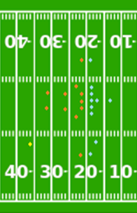
    - Beyond the 10-yard zone, if the player who receives the snap remains in the pocket with the ball, a defender cannot initiate contact with a receiver who is attempting to evade him. A defender may use his hands or arms only to defend or protect himself against impending contact caused by a receiver.
  - The Designated Hitter (DH) Rules:
    - The Designated Hitter (DH) is an extra defensive back that has to start the play at least 15 yards away from the line of scrimmage:
      - i.e. an additional 12th player on the field for the defense (the yellow player on the diagram).
      - The DH must be in either a 3-point or 4-point stance prior to the snap.
      - They are not allowed unlimited motion prior to the snap like the other offensive & defensive backfielders.
      - They can only blitz the QB unless they pass and/or hand off the ball to another player.
      - Only defensive backs (i.e. safeties & cornerbacks) can be designated as the DH.
    - They can only be played on 3rd downs, & no one’s allowed to block them until any of the following occurs:
      - They reach the original line of scrimmage.
      - The QB leaves the pocket.
      - The QB passes and/or hands off the ball to another player.
      - The QB fumbles the ball.
- All players (both offensive & defensive) get a max of 4 fouls (i.e. flags) per game:
  - Referees are required to announce how many penalties each player has committed, & keep notes on which players have committed fouls (preferably on a little notebook):
    - Example = “Pass Interference. Defense, #40. That is his 1st/2nd/3rd/4th foul. The ball will be placed at the spot of the foul, automatic first down”.
  - 1st = warning (Blue Card).
  - 2nd = sent off the field for the next 4 plays with a substitute (Yellow Card).
  - 3rd = sent off the field for the next 8 plays with a substitute (Black Card).
  - 4th = sent off the field for the rest of the game with a substitute (Red Card):
    - All players sent off the field are still eligible to start in the next game, unless the player either a) committed a targeting foul and/or b) has 3 straight games of receiving red cards:
      - In such a case of committing a targeting foul, such players are ineligible to start the first half of the next game regardless of whether they got ejected for targeting before or after halftime.
      - In such a case of having 3 straight games of receiving red cards, then the player must be sent down to the NFDL for at least 1 week while an NFDL player takes their spot on the NFL roster.
    - All targeting fouls (see above) are still automatic ejections (i.e. red cards) in addition to the 15yd penalty:
      - All targeting penalties must be subject to video review. If the hit is not deemed to be targeting by the video review, the player must be allowed to stay in the game and the yardage penalties will not be enforced.
- Coaching Challenges:
  - Each team gets 1 challenge per half.
  - Coaches can challenge anything, including penalties.
  - However, coaches will have unlimited challenges if they keep winning them.
  - The only time he loses the right to challenge a play is if they get one of their challenges wrong.
- Scoring System:
  - 6 points for a touchdown (TD).
  - Conversions or Points After Touchdown (C or PAT):
    - 1 point for a kicked convert (or PAT) kicked from the 15yd line (i.e. 25yds out).
    - 2 points for a passed or rushed conversion (2yds).
    - 3 points for a passed or rushed conversion (5yds).
    - All teams can waive "unnecessary" extra point attempts at the end of the game.
    - All defensive players are prohibited from leaping or hurdling over offensive linemen on field goal or PAT attempts.
    - On a convert attempt after a touchdown, the defending team may return a missed kick convert to the kicking team's end zone for 1 point, or if the convert was a rush or pass play may return a fumble or interception for 2 points.
    - The team being awarded the touchdown has the option of either:
      - Scrimmaging from their own 35-yard line (but must gain at least 10yds to retain possession), or
      - Kicking the ball off from their own 25-yard line (can punt, drop kick, or place kick the ball).
  - Field Goals (FG):
    - 3 points for a field goal under 50 yards.
    - 4 points for a field goal 50 yards and longer (the 33yd line must be painted dark gray to symbolize a 4-point line).
    - If the field goal is missed, but the ball is not returnable after crossing the end line, then it constitutes a rouge/single as long as the attempt was at least 50yds.
    - On a field goal attempt, the defending team may return a missed field goal to the kicking team's end zone for a Touchdown.
    - Any punt that goes through the uprights will also count as a field goal.
  - 2 for a Safety Touch (St):
    - A safety is scored when any of the following conditions occur:
      - The ball becomes dead in the goal area of the team in possession of the ball, except for an incomplete forward pass. (Examples = ball-carrier runs out of bounds, ball-carrier is tackled/takes a knee, & the ball is fumbled out of bounds).
      - The ball touches or crosses the dead line or a sideline in goal after having been directed from the field of play into the Goal Area by the team scored against or as the direct result of a blocked scrimmage kick.
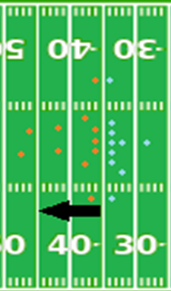
      - The offense commits a foul in its own end zone (examples = the ball carrier is penalized for intentional grounding or an offside pass in his own goal area).
    - The team being awarded the 2 points has the option of either:
      - Scrimmaging from their own 25-yard line, or
      - Kicking the ball off from their own 25-yard line (can punt, drop kick, or place kick the ball), or
      - Having the opposing team kick off the ball from their own 20-yard line (can punt, drop kick, or place kick the ball).
    - However, the team that conceded the safety also has the option of running an option play from their own 35yd line that must go at least 10 yards to retain possession, but only under the following circumstances:
      - If they are down by at least 10 points.
      - In the last 5 minutes of the game.
      - If the play succeeds, then the next possession starts on the 45yd line.
      - If the play fails, then the opposition will start their possession on their own 35-yd line.
    - This is different from a Rouge/Single (see below) in that the team scored against begins with possession of the ball & loses possession after the score occurs.
  - 1 for a Rouge or Single (Ro or Si):
    - A rouge is awarded to a kicking or punting team (Team A) if an opposing player (Team B) either:
      - Catches or recovers a punt or missed field goal in their own end zone but is prevented by Team A from returning the ball back out onto the field of play,
      - Elects to drop to one knee while still in the end zone before having returned the ball to the field of play, or
      - Elects to run with the ball from the end zone out of bounds rather than enter the field of play.
    - A rouge is also awarded to a kicking or punting team when any of the following scenarios occurs:
      - A field goal attempt at least 50yds or longer that goes out of the end zone through the endline.
      - A punt at least 50yds or longer that goes out of the end zone through the endline.
      - A kickoff goes that either a) goes through the uprights, b) lands in and bounces out of the end-zone, or c) goes out of the end zone on the full regardless of whether it is touched or not.
    - A rouge is also awarded to a defense (Team A) if they either:
      - Force an interception,
      - Recover a fumble,
      - Block a field goal, or
      - Force a turnover on downs (unless the turnover happens inside the 20yd line).
    - A rouge is not awarded in the following situations:
      - If a ball is downed in the end zone after being intercepted in the end zone.
      - If a ball is fumbled outside the end zone.
      - If the kicked ball hits the goalposts.
      - Kicks that pass out the sidelines of the end zone (punts & field goal attempts only).
    - After a rouge, the team conceding the score is given possession of the ball on their 25-yard line (i.e. the touchback rule).
    - This is different from a Safety (see above) in that team scored against receives possession of the ball after the score.

The NFL Preseason:
- If a player enters and leaves, from the moment he leaves the player is considered "dead" and cannot return to play until the designated time is served, or if a player is injured.
  - “Dead time” is 2 possessions (1 offensive & 1 defensive):
    - Exception: a "dead" player may participate on kickoffs and conversions, or as long snapper or holder.
  - All players are required to play in every game unless an injury occurs:
    - Each player must play a minimum of 2 possessions (or 8 plays).

Salary:
- All NFL Teams will have a hard salary cap of 2017 US$167 million for both players & coaches:
  - All NFL players will make a base salary of $16,000-166,666 per week, for a total of $288,000-3,000,000 in the regular season.
  - All NFDL transfer players (playing in NFDL last season and now a new permanent NFL player) must be paid at least the NFL Minimum Rookie Salary ($288,000).
  - These rates must be annually adjusted for inflation.
- A veteran NFL player will continue to be paid his NFL salary and will continue to be included on his NFL team’s roster on the inactive list while playing in the NFDL, and vice versa.

Ticket Pricing Minimums:
Type: | Individual: | Season:
Upper Sections (Yellow) | Endzones = $10 per person  Other sections = $15 per person | Endzones = $80 per person  Other sections = $125 per person
Middle Sections (Red) | Endzones = $20 per person  Other sections = $30 per person | Endzones = $170 per person  Other sections = $260 per person
Lower Sections (Blue) | Endzones = $30 per person  Other sections = $45 per person | Endzones = $260 per person  Other sections = $395 per person
Club & Suites (White) | $100 (NFL) or $75 (NFDL) per person | $800 (NFL) or $515 (NFDL) per person
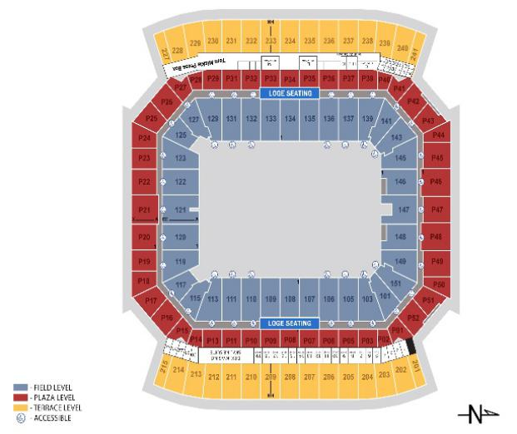

Broadcasting & Miscellaneous Rules:
- Game-day inactive players must be announced at the same time for all NFL games regardless of when they kick off, unless an injury occurs during practice.
- Player Celebrations:
  - All player celebrations (individual or group) for scoring are permitted only in the end zones or the bench areas:
    - However, the ball cannot be thrown or spiked into the fans as a celebration of a score because the ball is embedded with RFID tracking chips, allowing fans to “discover the speed, spin rate and trajectory” of the football.
    - Doing so will result in a 15yd unsportsmanlike conduct penalty.
  - Referees can no longer penalize players for celebrations as long as the following rules are adhered to:
    - Celebrations are not excessively long (i.e. more than 2 minutes in the end zone; no restrictions for bench areas).
    - Celebrations are not obscene in any manner (examples = overtly racist, flashing genitals, etc.).
    - So if a player like Antonio Brown wants to twerk, let him. If Tajae Sharpe pretends to sleep, allow it. If Josh Norman wants to shoot a bow and arrow after a pick, allow it.
- Each end zone and 50-yard line will be decorated with either of the following:
  - The team logo.
  - The NFL logo (preferably for teams that share stadiums).
- National Anthem Policy:
  - Personnel who choose not to stand for the Anthem may stay in the locker room or in a similar location off the field until after the Anthem has been performed.
  - All players and team personnel present on the sideline “shall stand and show respect for the flag and the Anthem.”
  - Each franchise may develop its own work rules, consistent with the above principles, regarding its personnel who do not stand and show respect for the flag and the Anthem.
  - All NFL teams must donate at least 2017 $16 million & $6 million respectively toward local social justice initiatives every fiscal year:
    - Half of the donation must come from the owners, with the other half coming from the players.
    - If any player kneels during the national anthem while on the field, each individual player involved must donate at least another $10,000 toward local social justice initiatives for each offense committed.
    - These rates must be adjusted for inflation every year.
  - The leagues have the power to fine any player & their respective franchise that has representatives who do not stand or "show respect" while present on the sideline for the anthem:
    - NFL = The minimum fine is 2017 USD $10,000 player & $25,000 for per franchise which will double for each offense.
    - Each individual player(s) will no longer eligible to play in any games after their 4th offense, but they will still be paid.
    - These rates must be annually adjusted for inflation.
- All cities can have no more than 2 professional football teams within their entire Metropolitan Statistical Area (MSA):
  - Examples of Metropolitan Statistical Areas = Dallas–Fort Worth metroplex, Norfolk-Virginia Beach (Hampton Roads), Riverside–San Bernardino (Inland Empire) or Minneapolis–Saint Paul (Twin Cities).
- All tickets for NFL preseason games must be no less than 15% but no more than 50% of the price for all regular-season games.
- The selection process for the NFL Pro Football Hall of Fame should be broadcast on both TV & online.

