Rink Dimensions:
- Rink Length & Width = 200' x 85' (61m x 26m), with a corner radius of 28’ (8.5m).
- Each goal line is 11’ (3.4m) from the end boards. UHL blue lines are 75’ (23m) from the end boards and 50’ (15m) apart.
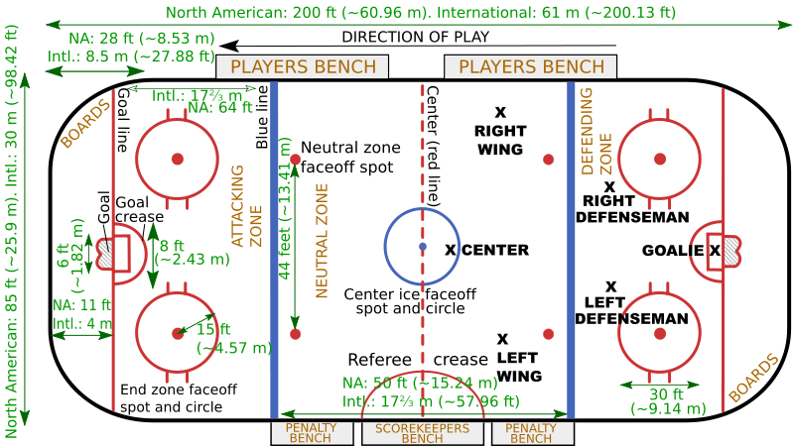

Timing Rules:
- The duration of the game is 3 20-minute periods.
- Overtime periods:
  - There are no overtime periods during the preseason.
  - There is a max of 2 overtime periods per game during the regular-season:
    - The 1st period is a 3v3 (2 field players & 1 goalie) 7 minutes in duration.
    - The 2nd period is a penalty shootout with 5 players on each team each getting 1 shot:
      - Teams will attempt 5 alternating penalty shots from the center circle.
      - A coin toss (called by the visiting team) will determine which team will go on offense or defense first.
      - Whichever team has the most points after the 5 tries, or after one team gains an insurmountable lead, will be the winner.
      - If the teams are still tied after 5 attempts, teams play multiple rounds until one team scores, which wins it.
  - There are no limits for overtime periods during the postseason.
- The length of the intermission periods is 18 minutes.

Timeout & Challenge Rules:
- Each team gets 2 time-outs per regulation period, and 1 per extra period:
  - All time-outs are 60 seconds in duration, & they do not accumulate.
- All timeouts can only be called by the head coach at the scorer’s table during dead-puck situations.
- The time-out will be granted on next play stoppage or, if requested in time, after the next field goal scored against the team that requested the time-out.
- No time-outs are allowed once a set of free throws has started (puck at disposal of free thrower for first or only free throw).
- All MiLH teams have 2 official challenges per game:
  - If the coach's challenge is successful -- that is, the ruling on the court is overturned -- then his team isn't charged with a timeout. However, if the second challenge is successful, the team retains its timeout but no longer has a challenge.
  - If it's unsuccessful, it costs the team a timeout. A coach can't challenge any ruling if he doesn't have at least one timeout remaining.
  - An unused challenge carries over from regulation to overtime and from one overtime period to the next overtime period, but a team out of challenges at the end of regulation does not gain a new or additional challenge.
  - Within these time constraints, a team’s head coach may challenge the following select NBA replay triggers:
    - Not reasonably certain whether a successful field goal was released or a called foul was committed prior to the expiration of the 24-second shot clock.
    - Not reasonably certain as to which team should be awarded possession after a puck goes out-of-bounds or whether an out-of-bounds in fact occurred.
    - Not reasonably certain whether a called common foul or called clear path foul met the criteria of a clear-path-to-the-basket foul.
    - Not reasonably certain as to which player should attempt free throws on a called foul.
    - Not reasonably certain as to whether the defender was inside or outside the restricted area (after the referees called a block or charge foul in the vicinity of the restricted area).
    - Not reasonably certain whether a goaltending or basket interference violation was called correctly.
    - Not reasonably certain whether an off-puck foul occurred prior to any of the following:
      - an offensive player beginning his shooting motion on a successful field goal if the off-puck foul is committed by a defensive player.
      - a defensive foul committed prior to the puck being released on a throw-in.
      - the puck being released on a successful field goal or a double-foul if the off-puck foul is committed by an offensive player.
    - Not reasonably certain whether a team had an improper number of players on the court while the puck is in play.
  - Referees will possess the sole and exclusive ability to initiate the following replay triggers at any point during the game:
    - Player altercation.
    - Not reasonably certain whether a called foul met the criteria of a flagrant foul.
    - A field goal is made with no time remaining on the clock at the end of any period.
    - A foul is called with no time remaining on the clock at the end of any period.
    - A play concludes (i) with no time remaining on the clock (0:00) at the end of any period or (ii) at a point when the referees believe that actual time may have expired in any period; and the referees are reasonably certain that the game clock malfunctioned during the play.
  - Referees will possess the sole and exclusive ability to initiate the following replay triggers during the final two minutes of the fourth period and at any point during overtime:
    - Not reasonably certain whether a successful field goal was scored correctly as a 2-point or 3-point field goal, or in the case of a called shooting foul, whether the player was attempting a 2-point or 3-point field goal; and
    - Not reasonably certain whether the puck touched the rim and thus whether the shot clock should be adjusted.
- Procedures to Initiate a Challenge:
  - To initiate a challenge, the head coach must call a legal timeout in a timely manner:
    - For a timeout to be considered “timely”, the challenging coach must call the timeout prior to live play resuming including, for example, prior to a referee handing the puck to the thrower-in, a referee handing the puck to a free throw shooter, or a referee tossing a jump puck.
    - Once these windows of opportunity have closed, any subsequent timeout no longer will be considered timely for purposes of triggering a challenge; and, as a result, a team is no longer permitted to challenge a previous event.
  - Immediately after calling a timeout to initiate a challenge:
    - The coach shall press a button that will illuminate a blinking light positioned at the end of the scorer’s table closest to the challenging team’s bench; and
    - After the referee approaches the head coach following the stoppage in play, the coach shall explain to the referee the specific event that he/she would like to challenge.
    - If a team calls a timeout to challenge an event that may not be challenged, it will retain its challenge but will be charged with the timeout.
    - If a team calls a timeout to challenge an event but does not have any timeouts remaining, it will be charged an excessive timeout, resulting in a technical foul, and no challenge review will take place.
  - Standard of Review:
    - The Replay Center will help facilitate the review, but the on-court referees will make the final determination on all reviews.
    - For each reviewable matter (regardless of whether it is triggered by a head coach or referee), the current reviewable matters as set forth by UHL rules will apply.
    - To overturn the call on the floor via a challenge, the visual evidence available on replay must be clear and conclusive. If the video is inconclusive, the challenge will be deemed unsuccessful.
    - If the replay equipment is not functional or the challenged event is not captured on video, the call on the floor will stand and the challenging team will retain its challenge and timeout.
​Substitution Rules:
- A "substitution opportunity" begins when the clock is stopped and the puck is dead (i.e. after a whistle or after a field goal in the last two minutes). It ends when the puck is placed at the disposal of a player making a throw-in, or placed at the disposal of a free throw shooter for the first or only free throw. One major effect of this is to prevent substitutions during free throws.
- Either team may sub on any foul, violation, alternating possession situation or time-out.
- Referee’s stoppages are included as substitution opportunities.

Season Structure:
- Uniform Rules:
  - Both teams must wear their dark color uniforms during games (similar to rugby or this NAL Championship Game) unless either of the following occurs (i.e. mandatory “Color Rush”):
    - The teams share similar colors.
    - If someone is colorblind (i.e. teams with red or green uniforms will not participate).
    - MiLH Example: Indy Fuel vs Orlando Solar Bears.
  - If that is the case, the designated home team will wear their dark color uniforms and the away team will wear either of the following:
    - Their lighter color uniforms.
    - An alternative darker color uniform.
- Each team will receive premier points for entry into the postseason:
  - 3 points for winning a game in regulation.
  - 2 points for winning a game in overtime or a shootout.
  - 1.5 points for drawing a game.
  - 1 point for losing a game in overtime or a shootout.
  - 0 points for losing a game in regulation.
  - .5 bonus points for losing by 3 points (or fewer) and/or in overtime.
  - .5 bonus points for scoring at least 4 points.
- At the end of the regular season, the team with the best regular-season record (i.e. highest point total) is awarded the either the Macgregor Kilpatrick Trophy (MiLH League 1) or the Brabham Cup (MiLH League 2):
  - For those who don't know, it echoes the practice of the top European soccer leagues in which the team with the best regular-season record is the champion, similar to the Supporter’s Shield in MLS.
  - The Macgregor Kilpatrick Trophy (MiLH League 1) or the Brabham Cup (MiLH League 2) winners are guaranteed home-court advantage in all rounds of the playoffs they compete in, including the MiLH championships (i.e. The League 1 Calder Cup & the League 2 Kelly Cup).
  - However, the award can just be a certificate in a frame.
  - Tiebreaker criteria when competitors are level on points:
    - The team that won the head-to-head match (if applicable) is ranked first.
    - If this game was a draw, then the team with the more wins is ranked first.
    - Point difference (PD) = is the number of points scored in all league matches minus the number of points conceded.
    - Points for (PF) = is the total number of points scored by a team over the course of the regular-season.
    - Points against (PA) = is the number of goals scored against them by their opponents over the course of the regular-season.
    - Fewest disciplinary actions.
    - Strength of schedule = two-third (66 2/3%) for the opponent's record and one-third (33 1/3%) for the opponents' opponents record.
    - Total number of points scored on the road.
    - Road point difference.
    - Total number of points scored @ home.
    - Home point difference.
    - If still identical, a play-off is required.
    - Coin toss (2 teams) or drawing of lots (at least 3 teams).
- The 4-game (2h/2a) preseason is a domestic exhibition series that starts in the first week of October and ends in mid-October:
  - All MiLH affiliate players must play in at least 2 games during the preseason/international exhibition games at home before the start of the regular season.
  - There must be a 2-day break in between games, and another 3-day break between the end of the preseason & start of the regular-season.
  - All preseason tickets (including national team exhibitions) must not cost more than 2017 US$25 (must be adjusted for inflation).
- The regular-season is a 56-game (28h/28a) season that starts in late October and ends in mid-March:
  - Each team plays 8 games (4h/4a) against all of the other 7 teams in their division (56 Games).
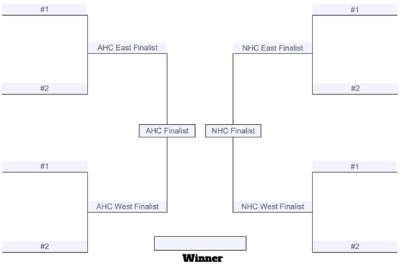
- The post-season is an 8-team Best-of-Series tournament per level:
  - There must be a 2-day break in-between the end of the regular-season and the start of the postseason.
  - The 8 teams that enter the tournament are the 4 divisional champions & runner-ups.
  - The format for the first round of the playoffs is 1v4 & 2v3 in each conference bracket.
  - The second-round format for the playoffs is (1/4) v (2/3).
  - All rounds in the MiLH postseason will use the following Formats:
    - Rounds #1-2 = single-elimination.
    - Championship = a best 2-of-3 series with a 1-1-1 format.
- Order of Season (# of Games):
  - MiLH Preseason (4).
  - MILH Regular Season (56).
  - MiLH Postseason (3-5).
  - Total Games = 63-65.
- Promotion & Relegation:
  - The top 4 teams in each division in MiLH League 2 will be promoted to League 1.
  - The bottom 4 teams in each division in MilH League 1 will be relegated to MiLH League 2.
  - All of the MiLH teams are eligible to be promoted and/or relegated.

Roster & Salary:
- All MiLH teams must have at least 20 players, but no more than 27 players (& all players are considered active):
  - No more than 15 must be MiLH-specific players and at least 5 must be UHL assignment players.
  - Each team also has local tryouts in early September, and at least one player from the tryouts is assigned to the team.
  - Examples of UHL assignment players:
    - Players picked in the UHL Draft (only includes the first 3 years of professional career; excluding international experience).
    - First-year or second-year players who are under a standard NBA contract (excludes MiLH players recently drafted by UHL teams; only players with actual UHL experience).
  - Examples of MiLH specific players:
    - Players picked in the UHL Draft (at least 4 years of experience; excluding international experience).
    - Players selected in a tryout.
- All players with 2-way contracts are exempt from the UHL & MiLH roster limits.
- The Salary Cap:
  - All MiLH teams have a hard salary cap of $20 million per season similar to the NFL for all 20-27 players on the roster:
    - The minimum salary for all players drafted from college and/or international leagues not in 2-way contracts is $25,500 per season.
    - The minimum salary for all players drafted straight from high school not in 2-way contracts is $41,000 per season.
    - The minimum salary for all players in two-way contracts is $95,000 per season:
      - These players will spend the majority of their time on a team's MiLH roster, but can freely move to their respective UHL team for up to 45 days in the regular-season. However, they can spend an unlimited amount of time with their UHL team during the preseason & postseason.
      - Only players with 4 years of UHL experience or less are eligible for two-way contracts.
      - All MiLH players can only be called up by their contracted UHL team.
    - All MiLH players will be paid by their UHL parent clubs.
  - A hard salary cap means that all contracts which cause a team to violate a hard cap are subject to major sanctions, including any of the following while breaching salary cap rules:
    - 1st offense = reduction of 1 million in their salary cap for the next season.
    - 2nd offense = reduction of another $3 million in their salary cap for the next season in addition to the previous reduction.
    - 3rd offense = reduction of another $3 million in their salary cap for the next season in addition to the previous reductions & the voiding of violating contracts.
    - 4th offense = reduction of another $4 million in their salary cap for the next season in addition to the previous reductions, the voiding of violating contracts, & the stripping of championships won.
﻿

