How to start a franchise in the GLA:
- The costs to join the GLA is a one-time USD $4,000,000 franchise fee.
- However, only the following ownership types are acceptable for GLA teams:
  - A group of no more than 32 people per franchise, with one holding a minimum 30% stake (may be a religious group and/or non-profit organization).
  - A publicly owned, non-profit corporation with a 7-member committee (mostly) appointed by the board of directors:
    - No one is allowed to hold more than 200,000 shares.
    - A share must cost at least $75 but no more than $350 2020 US dollars.
    - All stocks do not include an equity interest, do not pay dividends, cannot be traded, and has no protection under securities law.
    - Shareholders receive nothing more than the following:
      - Voting rights:
        - i.e., electing at least 1 member of the board of directors and the team president that leads a 7-member committee & represents the team at league meetings.
        - Only the president gets paid for his services, the other 6 committee members sits gratis.
      - An invitation to the corporation's annual meeting.
      - An opportunity to purchase exclusive shareholder-only merchandise.
      - Some season-ticket purchasing privileges in the form of a 10% discount on all plans.
      - Inheritance rights to any dependent, if the shareholder dies.
      - A souvenir certificate to hang up on the wall.
      - The chance to buy exclusive shareholders-only merchandise.
      - Flexible payment plan options for all season ticket plans.
      - 1st Right of Refusal on Next Seasons Tickets
      - The same ticket exchange program used by season ticket holders.
      - Early access to the I/GLA’s Football advisory Network.
      - Priority status for playoff tickets & season ticket renewal.
      - Free tickets to the following:
        - 1 team tryout session during the preseason.
        - The preseason game(s).
        - One live practice (date determined by the team)
        - 1 VIP field pass for one home game.
        - An invite to the annual shareholders meeting during training camp.
        - 1 preseason / kickoff party only accessible to shareholders & season ticket holders.
        - Access to exclusive team events & player meet-and-greets only accessible to shareholders & season ticket holders, such as the end of season party with the team & the Pregame Talks with Head Coach
      - A 10% discount on the following:
        - Regular team merchandise.
        - Tickets for individual game(s).
        - All parking adjacent to the stadium.
        - All season ticket plans (both full & partial); will be the same seat for each home game.
        - This will double for at least every 10 shares that the shareholder buys in additions to the 1st one.
      - All shareholder benefits will be directly provided by the team (or the closest team geographically to the shareholder)
      - However, the shareholder may also designate a specific team they would like during the application process as well.
  - A City and/or County Government as a 501(c)(6) mutual-benefit nonprofit corporation:
    - A City and/or County Government that owns a GLA team must also sell shares/stocks to anyone in the Combined Statistical Area (CSA) in order to raise funds for the team.
    - The same rules for shares/stocks listed above for publicly owned/non-profit corporations will also apply, except that the governmental entity will appoint 1 member each to the 1) board of directors & 2) the 7-member committee that does the following:
      - Directs corporate management.
      - Approves major capital expenditures.
      - Establishes board policy.
      - Monitors the performance of management in conducting the business and affairs of the corporation.
    - All excess revenue that is left after paying all of the players, coaches, & staff must go to funding local government agencies/programs (example = police/fire departments, public transportation, etc.)
  - The federal government (for the following military teams only – Air Force, Army, Coast Guard, & Navy).
  - People are allowed to invest in the league itself in order to help bailout teams if they cannot support themselves financially:
    - As a result, all teams may have no more than 25% of the ownership rights go to the league.
  - All teams are required to release their financial balance sheet every year.
- In addition, all GLA teams must have a stadium with all of the following:
  - At least 3,000 total seating capacity.
  - A Combined Statistical Area (CSA) or Metropolitan Statistical Area (MSA) of at least 300,000.
  - Locker rooms with showers for both teams and officials.
  - PA system and scoreboard.
  - The ability to sell tickets and concession.
  - Turf is not required, but it is encouraged.
  - Properly lined field if not turf.
  - The home team is also responsible for providing water and food for the visiting team, ensuring there is a trainer or doctor on-site for the match, and paying the referees fees at the end of each game.
- All cities can have no more than 2 GLA teams within their entire Metropolitan Statistical Area (MSA) or Combined Statistical Area (CSA):
  - Examples of Metropolitan Statistical Areas = Dallas–Fort Worth metroplex, Norfolk-Virginia Beach (Hampton Roads), Riverside–San Bernardino (Inland Empire) or Minneapolis–Saint Paul (Twin Cities).

Roster & Salary:
- 15 players on the field per team - 1 goalie, 6 defensemen, 2 midfielders, and 6 attackmen.
  - Attack = attempt to score as many goals as possible.
  - Midfield = contribute offensively and defensively and may roam the entire playing area
  - Defense = assist the goalkeeper in preventing the opposing team from scoring.
  - Goal = prevent the opposition from scoring by directly defending the 12-foot x 7-foot-tall goal.
- All teams can only have a max of 30 total players:
  - All teams must dress 26 players for each game.
  - Numbering System for GLA Players:
    - Full Forwards = 0, 00, 1-14
    - Half Forwards = 15-31
    - Midfielders = 32-48
    - Halfbacks = 49-65
    - Fullbacks = 66-82
    - Goalies = 83-99
- Each team only gets 5 substitutions per half.
- The New GLA salary cap for civilian teams is USD $41,500 per season:
  - Rookies & Practice Squad: USD $1,208
  - Second-year players: USD $1,219-$1,663
  - Veteran minimum: USD $1,516
  - Veteran maximum: USD $3,013
  - Franchise player: USD $3,766
  - Like the PLL, the GLA will also open-sources its highlights, allowing players to freely use them to build their own personal brands.

Season Structure:

Preseason:
- All teams must host an open 1-week tryout no more than 1 week prior to the start of fall training camp:
    - A max of 150 potential players in addition to all of the players from the previous year are allowed (i.e., a max of 186 total players).
    - The tryout for rookies & free agent signings will start on the 1st Monday of May for all ALA teams.
    - Players will be tested on the following:
      - 40yd Dash
      - 3 Cone
      - Triple Broad Jump
      - Position-Specific Drills
      - One-On-One Drills
    - All positions will be evaluated in tryouts.
- Registration fees:
  - A $58 pre-registration fee for the following types of players listed below can be applied no more than 1 day before the start of the tryouts/preseason.
  - All of the registration fees listed above are in 2020 USD; both fees must be adjusted for inflation at least once every 5 years.
- Each team plays 1 preseason scrimmage (1h) one week before the season begins.

Regular-Season:
- Bonus Points System:
  - 4 points for winning a game in regulation.
  - 3 points for winning a game in overtime.
  - 2 points for drawing a game (i.e., 2 points for both teams).
  - 0 points for losing a game.
  - 1 bonus point for losing by 8 points (or fewer) and/or in overtime.
  - 1 bonus point for scoring at least four 2-point goals (regardless of whether they win, lose, or tie).
  - 1 bonus point for scoring at least three more 2-point goals than the opponent.
  - All teams are allowed no more than 2 bonus points per game.
  - At the end of the regular-season, the team with the best regular-season record (i.e. highest point total) at each level regardless of conference is awarded the GLA Supporter’s Trophy:
    - For those who don't know, it echoes the practice of the top European soccer leagues in which the team with the best record is the champion, like the Supporter’s Shield in MLS.
    - The Trophy winners are guaranteed home-field advantage in all rounds of the playoffs they compete in (excluding the GLA Championship).
    - The Supporter’s Trophy can just be a certificate in a frame.
    - Regular-season rankings will be based on the amount of bonus points that each team has.
  - Tie-breaker - If only two teams are level on league points:
    - Most wins.
    - The team that won the head-to-head match (if applicable) is ranked first:
      - For divisional rivals, this becomes the teams with the higher aggregate score (i.e. The combined score from both games).
      - If this game was a draw, then the team with the more wins is ranked first.
    - Point difference (PD) = is the number of goals (or points) scored in all league matches minus the number of points conceded.
    - Points for (PF) = is the total number of points scored by a team over the course of the regular-season.
    - Points against (PA) = is the number of goals scored against them by their opponents over the course of the regular-season.
    - Fewest disciplinary actions.
    - Strength of schedule = two-third (66 2/3%) for the opponent's record and one-third (33 1/3%) for the opponents' opponents record.
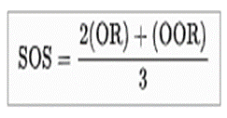
    - Total number of points scored on the road.
    - Road point difference.
    - Total number of points scored @ home.
    - Home point difference.
    - If still identical, a play-off is required.
    - Coin toss (2 teams) or drawing of lots (at least 3 teams).
- The regular season will start on the 1st Saturday of April & will end in the 1st or 2nd Sunday of May.
- Each team plays all 6 other teams once (3h/3a) during the season (6 games).
- All GLA games must be scheduled on the following:
  - Saturday & Sunday afternoons & evenings.
  - All teams can have no more than 1 game per week.
  - All teams are required to have an off day after a game.
- The GLA Ticket Prices:
  - Endzones = at least USD $15.35 / AUD $22.85 per person at least 1 week prior to the game.
  - Sidelines = at least USD $30.85 / AUD $45.93 per person at least 1 week prior to the game.
  - All tickets will increase by at least 20% the Monday before a game.

Postseason:
- The postseason runs from the on the 2nd or 3rd Saturday of May, & will end on the 3rd or last Sunday of May:
  - The top 4 teams qualify for the playoffs based on total points earned using the bonus points system.
  - 1st round = the GLA Semifinals (#1 vs #4 & #2 vs #3).
  - 2nd round = the GLA Championship:
    - The GLA Championship will be held in Croke Park in Dublin (82,300) (53,343) in Melbourne, like how the AFL Grand Final is hosted at Melbourne Cricket Ground.

Equipment:
- The ball is either of the following:
  - A standard lacrosse ball
  - A size 4 sliotar
- Each player carries a lacrosse stick:
  - A short stick measures between 40 and 42 inches (100 and 110 cm) long and is used by attackmen and midfielders.
  - A maximum of 7 players on the field per team (excluding the goalie) may carry a long stick which is between 52 and 72 inches (130 and 180 cm) long and is used by the 6 defensemen and sometimes one defensive midfielder.
  - The goalie uses a stick with a head as wide as 12-15 inches (30-38 cm) that can be between 40 and 72 inches (100 and 180 cm) long.
- Instead of shoulder pads and elbow pads, the goalkeeper wears a chest protector. He also wears special "goalie gloves" that have extra padding on the thumb to protect from shots.
- Both teams must wear their dark color uniforms during games (similar to rugby or this NAL Championship Game) unless either of the following occurs (i.e. mandatory “Color Rush”):
  - The teams share similar colors.
  - If someone is colorblind (i.e., teams with red or green uniforms will not participate).

Gameplay Rules:
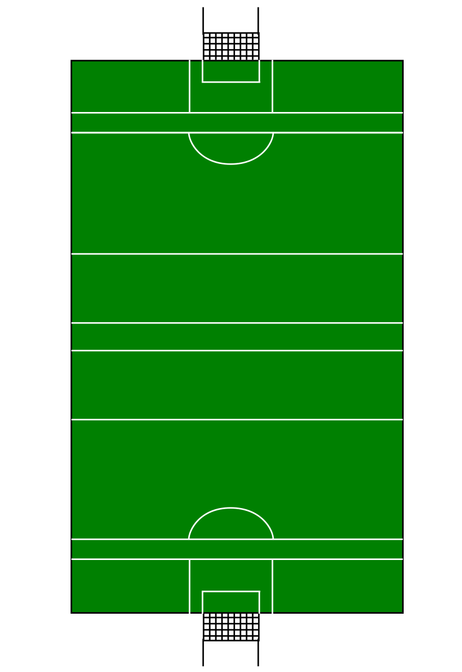
- The Field:
  - Length = 130m-145m (140yd-160yd).
  - Width = 80m-90m (90yd-100yd).
  - Large Goal Area/Crease = 19m x 13m (21yds x 14yds)
  - Small Goal Area/Crease = 14m x 4.5m (15.3 yds x 5yds)
  - Penalty Arc = 13m (14yd) from the 20m line.
  - Lines are marked at distances of 13m (14yds), 20m (22yds), 45m (49yds), and 65m (71yds) from each end-line
  - Goals = There are H-shaped goalposts at each end, formed by two posts, which are usually 6–7m (20–23ft) high, set 6.5m (21ft) apart, and connected 2.5 m (8ft 2in) above the ground by a crossbar.
- Two 35-minute halves with a 15-minute halftime:
  - Championship matches have a 30-minute intermission.
- Play is started at the beginning of each quarter and after each goal with a face-off:
  - During a face-off, two players lay their sticks on the ground parallel to the mid-line inside the center circle, the two heads of their sticks on opposite sides of the ball.
  - At the whistle, the face-off-men scrap for the ball, often by "clamping" it under their stick and flicking it out to their teammates.
  - All 4 midfielders must be in between the 65m lines, with all other field players being behind the 45m lines.
- Restarting play:
  - After an attacker has scored a point or put the ball wide of the goals, the goalkeeper may take a "puckout" from the hand at the edge of the small square. All players must be beyond the 20 m line.
  - After a defender has put the ball wide of the goals, an attacker may take a "65" from the 65 m line level with where the ball went wide. It must be taken by lifting and striking. However, the ball must not be taken into the hand but struck whilst the ball is lifted.
  - After a player has put the ball over the sideline, the other team may take a 'sideline cut' at the point where the ball left the pitch. It must be taken from the ground.
  - After a player has committed a foul, the other team may take a 'free' at the point where the foul was committed. It must be taken by lifting and striking in the same style as the "65".
  - After a defender has committed a foul inside the square (large rectangle), the other team may take a "penalty" from the ground from behind the 20 m line. Only the goalkeeper may guard the goals. It must be taken by lifting and striking and the sliotar must be struck on or behind the 20m line (The penalty rule was amended in 2015 due to safety concerns. Before this the ball merely had to start at the 20m line but could be struck beyond it. To balance this advantage the two additional defenders previously allowed on the line have been removed).
  - If many players are struggling for the ball and no side is able to capitalize or gain control of it the referee may choose to throw the ball in between two opposing players. This is also known as a "throw in".
- Officials
  - A Gaelic Lacrosse match is watched over by 8 officials:
    - The referee (on field)
    - Two linesmen (sideline)
    - Sideline official/standby linesman
    - Four umpires (two at each end)
- Contact rules:
  - Shoulder-to-shoulder contact is allowed
  - Checking:
    - stick checking is when a defending player uses his or her stick to lift or poke another player’s stick (on the head and/or shaft) in order to dislodge the ball.
- Penalties:
  - Personal foul penalties:
    - Cross-Check = Contact made when a player has his hands spread apart on his stick and uses his shaft to push another player instead of using his hands.
    - Illegal Body Checking – There are numerous variations of this penalty but they focus on illegal body hits (i.e. a player using their body to strike an opposing player’s back).
    - Illegal stick = Examples include pockets that are too deep (because it is harder to dislodge a ball from an illegal deep pocket), sticks that are too short (because it is easier to protect the ball in an illegally short stick), etc.
    - Slashing = Illegal stick check to the body of a player
    - Tripping = Impeding an opponent at or below the waist (with either the feet and/or a stick), and causing him to fall.
    - Warding – When a player moves his arm to block an opposing player’s stick check.
    - Blows to the head,
    - Late hit,
    - Sliding tackles
    - Pulling an opponent's jersey
    - Using threatening and/or abusive language to an opposing player, a teammate or an official
    - Throwing the lacrosse stick in a dangerous manner
    - Attempts to strike any player or official with a lacrosse stick, elbow, fist, head or kick.
    - Spitting at an opponent
    - Unnecessary Roughness – When a player uses excessive force.
    - Pushing an opponent
    - Abusive language to refs
    - Intentionally moving the goal
    - To challenge the authority of a referee, umpire, linesman, or sideline official.
    - To fail to comply with a referee's instruction to use an orifice guard.
    - To refuse to leave the field of play, on the instruction of the referee, for attention, after an injury involving bleeding.
    - To show dissent with the referee's decision to award a penalty shot to the opposing team.
    - To refuse to leave the field of play when ordered off (red card) or rejoin the game after being ordered off.
    - A team or player(s) leaving the field without the referee's permission or refusing to continue playing
    - Always timeserving (1:00-3:00).
  - Technical foul penalties:
    - Off-Sides:
      - Picking the ball directly off the ground (instead it must be scooped up with the lacrosse stick)
      - Throwing the ball with one’s arm instead of the stick
      - Going more than four steps with the ball in the hand (it may be carried indefinitely in the stick)
      - The 6 offensive & 6 defensive players may not cross their 65m lines at any point.
      - The goalie may leave the goal area but cannot leave the penalty/restraining area at any point.
      - No more than 8 offensive players (i.e., 6 attackers & 2 midfielders) & 9 defensive players (i.e., 6 defenders, 2 midfielders, & the goalie) on either side of the 65m lines at any given time.
      - Zones:
        - Goalkeeper = Gold
        - Fullbacks = Dark Blue
        - Half Backs = Light Blue
        - Midfielders = Purple
        - Half-Forwards = Orange
        - Full Forwards = Red
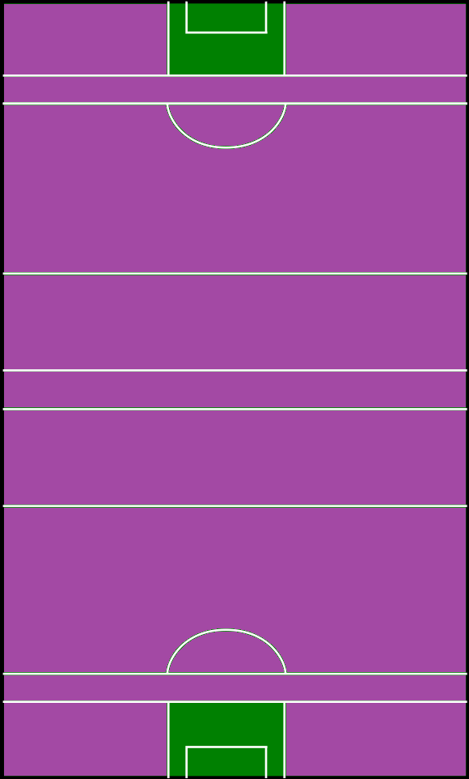
    - Crease Violation:
      - All offensive players or their sticks may not enter the small goal area at any time while the goalie is in the area. Once a goalkeeper leaves the small crease, he loses these privileges.
      - Defensive players with or without the ball may pass through the crease but are not allowed to attempt to block a shot from within the crease.
    - Holding = when one player keeps another player from getting to where he wants to go by using their arms, stick, or feet.
    - Grabbing an opposing player’s stick
    - Illegal Pick – A pick which usually knocks an opponent down
    - Too many men on the field.
    - Illegal procedure
    - All are change of possession fouls unless the team that is fouled has possession.
    - If the team that commits the foul has possession have to serve a 30 second penalty.
  - Yellow Card:
    - 3rd offense for all technical fouls
    - 1st offense for most personal fouls
    - 2-minute power play:
      - i.e., players must serve at least 2 minutes in the penalty box while their team plays with 1 player down.
      - The player may return after either a) the 2-minute penalty has been served, b) a goal has been scored, or c) 3 points have been scores
  - Black Card:
    - 4th offense for all technical fouls
    - 2nd offense for most personal fouls
    - 1st offense for the following:
      - Abusive language to refs
      - Intentionally moving the goal
      - To challenge the authority of a referee, umpire, linesman, or sideline official.
      - To fail to comply with a referee's instruction to use an orifice guard.
      - To refuse to leave the field of play, on the instruction of the referee, for attention, after an injury involving bleeding.
      - To show dissent with the referee's decision to award a penalty shot to the opposing team.
    - 5-minute power play:
      - i.e., players must serve at least 5 minutes in the penalty box while their team plays with 1 player down.
      - The player may return after either a) the 5-minute penalty has been served, b) at least 3 goals has been scored, or c) 9 points have been scores
  - Red Card:
    - 5-minute power play:
      - i.e., players must serve at least 3 minutes in the penalty box while their team plays with 1 player down.
      - The player may not return to the game; however, a substitute may come in only after 5-minute penalty has been served.
    - 5th offense for all technical fouls
    - 3rd offense for most personal fouls
    - 1st offense for the following:
      - To refuse to leave the field of play when ordered off (red card) or rejoin the game after being ordered off.
      - A team or player(s) leaving the field without the referee's permission or refusing to continue playing
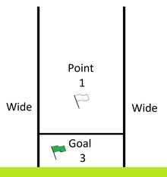
- Scoring Rules:
  - There is no shot clock due to the size of the field.
  - Scoring is achieved by sending the ball between the opposition's goal posts. The posts, which are at each end of the field, are H posts as in rugby football but with a net under the crossbar as in football.
  - If the ball goes over the crossbar, a point is scored and a white flag is raised by an umpire. If the ball goes below the crossbar, a goal, worth three points, is scored, and a green flag is raised by an umpire.
  - A goal must be scored by a throwing motion with a stick.
  - Scores are recorded in the format {goal total} – {point total}:.
    - For example, the 1997 All-Ireland final finished: Dublin 0–20 Belfast 2–13. Thus Dublin won by one point (2–13 being worth nineteen points).
    - In speech, a score consisting of at least one goal and one point is read as simply the two numbers, so Belfast's 2–13 is read "two thirteen"; the words "goals" and "points" invariably omitted. Goals are never "converted" into points; it is incorrect to describe a score of 2–13 as "nineteen". 2–0 would be referred to as "two goals", never "two zero".
    - Likewise, 0–10 would be referred to as "ten points", never "zero ten". 0–0 is said "no score". So the Dublin/Belfast match score would be read as "Dublin twenty points, Belfast two thirteen".
- In the event of a tie, the teams play an overtime session that uses elements penalty shootouts used in soccer and ice hockey:
  - A coin toss (called by the visiting team) will determine which team will go on offense or defense first, and which end zone will be used (both offenses will attack the same end zone, just as soccer shootouts are attempted at the same goal).
  - Teams will attempt at least 3 but no more than 5, alternating attempts from the penalty mark.
  - Successful scores will be worth 3 points each.
  - Whichever team has the most points after the 3-5 tries, or after one team gains an insurmountable lead, will be the winner.

