Season Structure:
- The 6-game (3h/3a) preseason is an international exhibition series that starts in late September and ends in mid-October:
  - EuroLeague teams will play games against the eastern conference teams of the National Basketball Association (NBA) teams with one long tour in Europe (for American franchises) and one long American tour (for European franchises) in an alternating cycle.
  - All EuroLeague players must play in at least 3 games during the preseason/international exhibition games before the start of the regular season.
  - There must be a 2-day break in between games during each tour, a 3-day break in-between tours, and another 3-day break between the end of the preseason & start of the regular-season.
  - Every year when the EuroBasket or FIBA Basketball World Cup are not held, the national teams will hold a series of 4 exhibition games (2 of which must be in their home country) around the world during August & September:
    - All of the national teams can play in any basketball arena with a total seating capacity of at least 10,000 seating capacity.
    - All of the national team players will complete fall training with their national team.
    - All of the national team players must be paid during the preseason while they are playing with their national team.
  - All preseason tickets (including national team exhibitions) must not cost more than 2017 US$35 (must be adjusted for inflation).
- The regular-season is a 68-game (34h/34a) season that starts in late October and ends in mid-March:
  - Each team plays 4 games (2h/2a) against all of the other 17 teams in the league.
  - Each team will receive premier points for entry into the post season:
    - Points are now used to determine which teams will advance into the postseason. Points are being implemented in order to encourage attacking play throughout a game and to reward teams for "coming close" in losing efforts.
    - 3 points for a win.
    - 2 points for winning a game in overtime.
    - 1.5 points for drawing a game.
    - 0 points for losing a game.
    - .5 bonus point for losing by 10 points (or fewer) or in overtime.
    - .5 bonus point for scoring at least 100 points.
    - All teams can only have a max of 2 bonus points per game.
  - At the end of the regular-season, the team with the best regular season record is awarded the Supporters' Shield (It echoes the practice of the top European soccer leagues in which the team with the best record is the champion).
  - Order of Season (# of Games):
    - EuroLeague preseason / international crossover (6)
    - EuroLeague RegularSeason (66)
    - EuroLeague Postseason (9-15)
    - FIBA Intercontinental Cup (5)
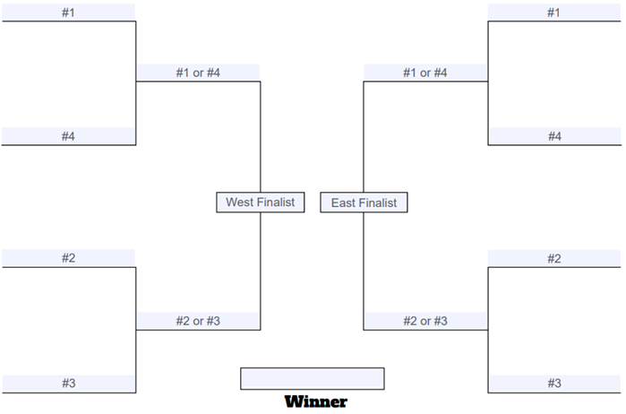
    - Total Games = 86-92.
- The post-season is an 8-team Best-of-Series tournament:
  - The 8 teams that enter the tournament are the 3 division champions and 1 wild card per conference.
  - There must be a 3-day break in-between the end of the regular-season and the start of the postseason.
  - The 1st Round (Conference Semifinals):
    - The first-round format is 1v4 & 2v3.
    - The first round is a 2-of-3 series in a 1-1-1 format.
  - The 2nd Round (Conference Finals):
    - The second round is a 3-of-5 series in a 2-2-1 format.
  - The EuroLeague Championship:
    - The final round is a 4-of-7 series in a 2-2-1-1-1 format.
    - The team that won the coin toss hosts the first 2 games.
    - The other team hosts the second 2 games, and the teams alternate between the final 3 games.
- A coin toss will determine which team gets more home games during each series, unless they win the rights to more games twice in a row:
  - Team #1 = more home games / Team #2 = less home games.
  - 2-of-3 & 3-of-5 = Both Teams alternate between hosting games, starting with Team #1.
  - 4-of-7 = Team #1 hosts 2 consecutive games, Team #2 hosts 2 consecutive games, then both teams alternate for the final 3 games starting with Team #1.
- 1 week after the NBA Championship is the revised FIBA Intercontinental Cup in which the club champions of each of the following leagues takes part of each year:
  - Teams = NBA G-League, Euroleague, NBL Australia, FIBA Africa Clubs Champions Cup, FIBA Asia Champions Cup, and FIBA Americas League.
  - Each team plays all other teams once in a round-robin tournament (5 games) while the tournament is hosted by one of the 6 leagues each year in a 6-year rotating format; all teams must have a 2-day break in between games.
  - All host teams can play their games in their respective areas (example: Real Madrid playing all 5 games in WiZink Center) while the other 4 teams must rotate their games among some, if not all, of the host league's arenas.

