- All teams are allowed a max of 30 players on the roster:
  - All 30 players are eligible to be selected to the 18-player game-day squad for all regular season and the playoff game.
- The league follows the same rules and standards used by the International Football Association Board (FIFA) with the following exceptions.

Season Structure:
- The regular season is a 28-game season starting on the Second Friday of August and ending on the Third Sunday of February:
  - All games will be played on Saturday and Sunday afternoons with the occasional Friday evenings.
  - All teams will play the other 26 teams (13h/13a) in their conference once (26 Games) & 1 random team from the other conference twice (1h/1a) (2 games).
  - Each team is awarded the following bonus points:
    - 3 points for winning a game in regulation.
    - 2 points for winning a game in overtime (in either in the two 15-min periods or the penalty shootout).
    - 1.5 points for drawing a game.
    - 0 points for losing a game in regulation.
    - 1 bonus point for losing a game in overtime (in either in the two 15-min periods or the penalty shootout).
    - 1 bonus point for scoring at least 3 goals.
  - In the event of an end-of-season tie in total accumulated points, the following tie-breakers will be used:
    - The team that won the head-to-head match (if applicable) is ranked first.
    - If this game was a draw, then the team with the more wins is ranked first
    - Goal difference (GD) = is the number of goals scored in all league matches minus the number of points conceded.
    - Goals for (GF) = is the total number of goals scored by a team over the course of the regular-season.
    - Goal against (GA) = is the number of goals scored against them by their opponents over the course of the regular-season.
    - Fewest disciplinary actions.
    - Strength of schedule = two-third (66 2/3%) for the opponent's record and one-third (33 1/3%) for the opponents' opponents record.
    - Total number of goals scored on the road.
    - Road goal difference.
    - Total number of goals scored @ home.
    - Home goal difference.
    - If still identical, a play-off is required.
    - Coin toss (2 teams) or drawing of lots (at least 3 teams).
  - There must be a 1-week break into between the regular-season & the playoffs.
  - If there is a tie for the championship, for relegation, or for qualification to other competitions, a play-off match at a neutral venue decides rank.
- The post-season (i.e. EPFL Playoffs) is a 32-team 2-stage tournament in March-May between the top 16 teams from each conference (similar to the Rugby World Cup):
  - The location of the EPFL Championship Game is chosen in a manner similar to the NFL's Super Bowl, but the game must be rotated between each conference every single year:
    - Any European team with a stadium capacity of at least 70,000 (including club and fixed suite seating) can host the EPFL Championship Game.
    - Stadiums may include temporary seating for the Championship Game, but seating must be approved by UEFA
    - Stadiums where the average game day temperature is below 10° Celsius must either have a roof or a waiver given by UEFA.
    - There must be a minimum of 35,000 parking spaces within 3km of the stadium.
    - The host stadium must have space for the Gameday Experience, a large pregame entertainment area, within walking distance of the stadium.
    - The host city must have space for the European Soccer Experience, the interactive football/soccer theme park which is operated the week prior to the Championship Game. An indoor venue for the event must have a minimum of 850,000 square feet, and an outdoor venue must have a minimum of 1,000,000 square feet.
    - Additionally, there must be space nearby for the Media Center, and space for all other events involved in the Championship Game week, including golf courses and bowling alleys.
    - The necessary infrastructure must be in place around the stadium and other Championship Game facilities, including parking, security, electrical needs, media needs, communication needs, and transportation needs.
    - There must be a minimum number of hotel spaces within one hour's drive of the stadium equaling 35% of the stadium's capacity, along with hotels for the teams, officials, media, and other dignitaries.
    - There must be practice space of equal and comparable quality for both teams within a 20-minute drive of the team hotels, and rehearsal space for all events within a reasonable distance to the stadium.
    - The practice facilities must have at least 2 grass fields.
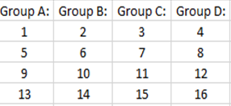
  - The 1st stage is a group stage/pool play where there are 4 groups of 4 teams each per conference, with each team playing 3 games (1 per week):
    - The #1-4 seeds each get their own pool, with #5-16 seeds being assigned by adding 4 to each of the previous team’s rank.
    - The top seed in a four-team group gets to host all three of its group games; the No. 2 seed hosts two of its three group games; the No. 3 seed hosts one, and the No. 4 seed goes on the road for all three group games.
  - The 2nd stage is a 16-team single-elimination tournament where the top 2 teams from each of the 8 groups will compete. The format is 1v8, 2v7, 3v6, & 4v5 in each conference.
  - There are four off-days between each group matchday for both stages.
  - The winner of this competition plays as in the FIFA Club World Cup as the representative of the UEFA confederation, instead of the UEFA Champions League winner.
  - Times for playoff games (always in Central European time):
    - Europe = Tuesday or Wednesday at 20:45.
    - Georgia, Russia, Armenia, & Azerbaijan = Tuesday or Wednesday at 18:00
    - Kazakhstan = Tuesday or Wednesday at 15:00.
    - Turkey = Tuesday or Wednesday at 18:45.
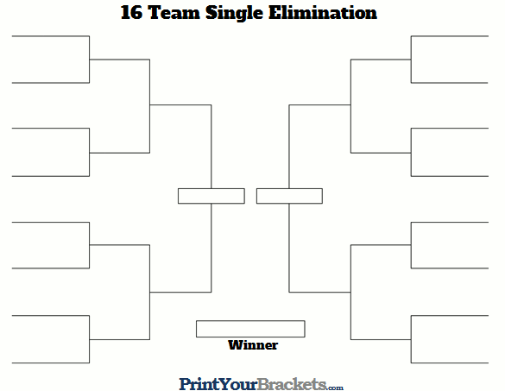

Team Selection:
- The European Premiership Football League is at the top the promotion & regulation pyramid in which the top teams compete for a max of 1 season:
  - A total of 54 teams from the 54 UEFA member associations participated in the 2015–16 UEFA Champions League (the exception being Liechtenstein, which does not organize a domestic league):
  - All associations will each have one team qualify (i.e. the association's top domestic league's champion):
    - The process repeats every single year with the top team from each association's domestic league playing against the other top European professional teams for a single season before being replaced by the next season's teams:
      - i.e. The teams from the previous season will be demoted back to their domestic leagues, & the winners of the domestic leagues will be promoted to the EPFL.
      - Example = FC Barcelona winning the 2017-18 La Liga Season, playing in the EPFL in 2018-19 season, & returning to La Liga for the 2019-20 season with Atlético Madrid replacing them in the EPFL.
- The EPFL is operated as a corporation and is owned by the 54 member associations:
  - Each association is a shareholder, with one vote each on issues such as rule changes and contracts.
  - The associations select a chairman, chief executive, and board of directors to oversee the daily operations of the league.
- All UEFA-based teams can compete in the UEFA Champions & Europa Leagues:
  - Both leagues are played from June to August.
  - Champions League allotment:
    - Associations ranked 1–4 each have 4 teams qualify.
    - Associations ranked 5–6 each have 3 teams qualify.
    - Associations ranked 7–15 each have 2 teams qualify.
    - Associations ranked 16–55 (except Liechtenstein) each have 1 team qualify.
  - Europa League allotment:
    - Associations ranked 1–51 each have 3 teams qualify.
    - Associations ranked 52–54 each have 2 teams qualify.
    - Associations ranked 55 each have 1 team qualify.
  - Associations are represented in both leagues on the following basis:
    - All EPFL teams can only compete in the Champions League.
    - One representative: winner of the top domestic league championship.
    - Two representatives: winner of the top domestic league championship & the qualifying member of the EPFL from the previous season (example = 2018-19 EPFL season for the 2018-19 UEFA leagues).
    - Three representatives: winner & runner-up in the top domestic league championship & the qualifying member of the EPFL.
    - Four representatives: winner, runner-up, third-placed clubs in the top domestic league championship & the qualifying member of the EPFL.

