Roster & Salary Rules:
- Each CPL club is allowed up to 30 players on its first team roster; all 30 players are eligible for selection to each 18-player game-day squad during the regular season and playoffs.
- CPL has two transfer windows—the primary pre-season transfer window lasts three months from mid-February until mid-May, and the secondary mid-season transfer window runs one month from early July to early August.
- There are 3 types of contracts in CPL:
  - The salary cap is CAN$15 million per team for all players on the roster:
    - CPL Players occupying roster spots #1-19 at least $60,000 per year.
    - CPL Players occupying roster spots #20-24 will earn at least $50,000.
    - CPL Players occupying roster spots #25-30 will earn at least $40,000.
    - However, homegrown players do not count toward a team’s overall salary cap regardless of what spot they hold on the roster.
- CPL now has a luxury tax (i.e. a surcharge put on the aggregate payroll of a team to the extent to which it exceeds a predetermined guideline level set by the league):
  - All transfer fees would be subject to the luxury tax, as would salaries for players over their cap hit.
  - 150% for amounts up to CAN$1 million over the threshold (worse than the previous 100 percent rate, mind you).
  - 175% from CAN$2 million.
  - 250% from CAN $3 million.
  - 325% from CAN$4 million.
  - 375% at CAN$5 million.
  - 425% at CAN$6 million.
- When an CPL club sells one of its players overseas, the club and the league split the transfer revenues, with the club retaining from 33% to 75% depending on the player's status and tenure.
- Each team should carry at least 3 Homegrown-signed players on their game day rosters:
  - Any team that cannot comply with this will be fined each game that they do not follow this gameday rule.
  - In the event that a team cannot meet this requirement due to injuries, a fine will not be placed on the team.
  - If CPL teams play their young players (i.e. Homegrown Players and U-23 college draftees) up to at least 10,000 minutes a season per player, then those teams will receive at least $300,000 in allocation:
    - If a team plays their HGP and draftees half as many minutes, they receive half as much money,
    - However, all homegrown players drafted out of college will phase out of this program once they turn 23.

Regular Season Structure:
- Bonus Points System:
  - 3 points for winning a game in regulation.
  - 2 points for winning a game in overtime (in either in the two 15-min periods or the penalty shootout).
  - 1.5 points for drawing a game.
  - 0 points for losing a game in regulation.
  - 1 bonus point for losing a game in overtime (in either in the two 15-min periods or the penalty shootout).
  - 1 bonus point for scoring at least 3 goals.
  - At the end of the regular season, the team with the best regular season record (i.e. highest point total) is awarded the CPL Supporters' Shield:
- For those who don't know, it echoes the practice of the top European soccer leagues in which the team with the best regular-season record is the champion.
- The CPL Supporter’s Shield winners are guaranteed home-field advantage in all rounds of the playoffs they compete in, including the championship.
  - In the event of an end-of-season tie in total accumulated points, the following tie-breakers will be used:
    - The team that won the head-to-head match (if applicable) is ranked first.
    - If this game was a draw, then the team with the more wins is ranked first
    - Goal difference (GD) = is the number of goals scored in all league matches minus the number of points conceded.
    - Goals for (GF) = is the total number of goals scored by a team over the course of the regular-season.
    - Goal against (GA) = is the number of goals scored against them by their opponents over the course of the regular-season.
    - Fewest disciplinary actions.
    - Strength of schedule = two-third (66 2/3%) for the opponent's record and one-third (33 1/3%) for the opponents' opponents record.
    - Total number of goals scored on the road.
    - Road goal difference.
    - Total number of goals scored @ home.
    - Home goal difference.
    - If still identical, a play-off is required.
    - Coin toss (2 teams) or drawing of lots (at least 3 teams).
- Each team plays 2 preseason games (1h/1a) with any combination of domestic and/or international teams beginning in early March:
  - These teams should preferably be from the following:
    - Sister cities (both domestic & international).
    - reserve/affiliate clubs.
    - Local college teams.
    - Events such as the Carolina Challenge Cup or the international Pacific Rim Cup.
  - Teams can play more preseason games if they qualified for other events such as the CONCACAF Champions League.
- The CPL now uses a split-season schedule, Similar to the modern (now defunct) North American Soccer League (NASL) & Liga MX:
  - The regular-season runs from early April to late October with its teams playing 28 games (14h/14a) in a balanced schedule (excluding all of the exhibitions with European teams):
    - The 13-week “spring” season begins in early April and ends in late June (2019 Example = April 3-June 29), followed by a 4-week break in July:
      - The Canadian national team must play a game against any other national team on Canada Day (July 1st).
    - The 13-week “fall” season begins in early August & ends in late October (2019 Example = August 3-October 26).
    - Each team plays 2 games (1h/1a) against the remaining 14 teams in the league in a double round-robin format.
    - Each team can have no more than 2 games per week.
    - Regular-season rivalry cups are contested by at least two teams, with each trophy being awarded to the team with the better (or best for rivalry cups with 3 teams) regular-season record in games involving the contesting teams.
  - All teams will no longer break for the annual All-Star Game, a friendly game between the league's finest players and a major club from a different league.
  - Each CPL team plays 1 game (2h/2a) against 4 random international soccer teams in other leagues during the 4-week break in July midway through the season (4 games):
    - A break in July that coincides with the international transfer window allows teams to acquire (or sell) players during the summer, providing ample time for new players to compete acquainted with their new club and league.
    - All CPL teams can use this break to generate additional revenue by hosting international friendlies (4h), going on tour (4a), or any combination of both (1h/3a, 2h/2a, or 3h/1a).
    - These games will technically act as “preseason” games for the international clubs, but both teams can only have 6 substitutions per game.
    - Examples = MLS, English Premier League, Mexican Liga MX, and German Bundesliga.
    - These teams should preferably be from sister cities, but they don’t have to be:
      - Toronto FC examples = Chicago Fire, Milan, Eintracht Frankfurt, etc.
- The Post-Season:
  - Unlike European soccer leagues, the CPL regular season is followed by a 4-team CPL Cup Playoffs in November, ending with the CPL Cup championship final in late November
    - The post-season is a 4-team single-elimination bracket:
      - All 12 teams will be seated 1 through 4 based on the number of bonus points that they have, & will never be reseeded.
      - 1st Round = (CPL Semifinals) = 1v4 & 2v3.
      - 2nd Round = CPL Cup.
    - The teams that make it are the following:
      - The “spring” season champion (i.e. the team with the largest amount of points from the 1st half of the entire CPL season).
      - The “fall” season champion (i.e. the team with the largest amount of points from the 2nd half of the entire CPL season).
      - The 2 clubs with the next best overall records from both seasons combined.
      - If the same club won both “seasons”, the clubs with the second, third and fourth best overall records from both seasons combined will qualify.
    - The post-season must take place after the FIFA November window.
    - The playoff extra time structure follows IFAB standards: two full 15-minute periods, followed by a penalty shootout if necessary.
    - In addition, the tournament winner qualifies for the group stage of the CONCACAF Champions League.
    - There must be at least 4 off-days between each group matchday (2019 example listed below):
      - Saturday, November 16: Two Semifinal Games.
      - Thursday, November 21: CPL Cup Final (hosted by finalist with better regular-season record)
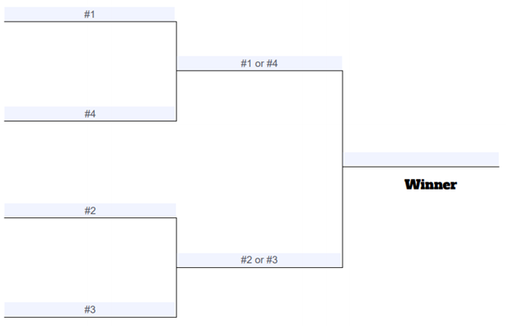
- CPL SuperDraft:
  - The SuperDraft is held in January & lasts 2 rounds.
  - Any college player that goes undrafted may return to college (assuming that they still have eligibility left).
  - Any expansion teams receive the first picks.
  - Non-playoff clubs receive the next picks in reverse order of prior season finish.
  - Teams that make the CPL Cup Playoffs are then ordered by which round of the playoffs they were eliminated.
  - The winner of the CPL Cup are given the last selection, and the loser the penultimate selection.

