Roster & Salary:

CFL:
- All CFL teams will employ no more than 8 coaches, including the following:
  - A head coach.
  - An offensive and a defensive coordinator.
  - 4 position coaches.
  - 1 special teams coordinator.
  - Each team will also be assigned and limited to 8 football operations staff as well.
- Each team must have no more than 56 total players:
  - 46 players on the active roster.
  - 10 players on the inactive roster / practice squad in accordance with the following terms and conditions:
    - At least 1 place on the practice roster shall be filled by a national player (other than a national player who was a candidate in the current year CFL Canadian Draft, who is not the property of another CFL club);
    - If 10 places are used by a member club on it’s practice roster, at least 1 place on the practice roster shall also be filled by a national player who was a candidate in the current year CFL Canadian Draft, who is not the property of another CFL club.;
    - Expands practice rosters from 10 to 12 players per team and, come the Fall, from 12 to 15 players.
- Each team must abide by the national/international ratio rule, which requires teams to keep at least 18 national players, with the other 38 players allowed to originate from any country:
  - A national player for Canadian teams is defined as "a Canadian citizen at the time of signing his first contract, was classified as a non-import prior to May 31, 2014, or was physically resident in Canada for an aggregate period of 5 years prior to reaching the age of 18.")​
  - A national player for American teams is defined as "an American citizen at the time of signing his first contract, was classified as a non-import prior to May 31, 2014, or was physically resident in the US for an aggregate period of 5 years prior to reaching the age of 18.")​
  - Quarterbacks, of which a team can carry only three on a roster, cannot be counted toward the national player requirement.
- The CFL salary cap will be set at 2017 CAD$4,550,000-5,150,000 (USD$3,639,854-4,119,835) per season with a minimum salary of CAD$53,000 (USD$42,398) per player; all rates must be adjusted for inflation.
- Each team elects two players to the CFLPA Board of Player Representatives, which meets once per year. Every two years, it elects an executive Board of Directors.
- The CFL Draft:
  - The CFL Draft is a 7-round draft:
    - The CFL Draft takes place approximately six weeks prior to the start of the upcoming season.
    - The first two rounds of the draft are usually shown live on TSN.
    - The selection order is based on each team's win-loss record in the previous season and whether the team reached the playoffs. Teams that did not reach the playoffs the previous season are ranked in reverse order of their records (thus the team with the fewest wins is awarded the first selection).
  - All potential players must be at least 21 years old and meet the following requirements in order to become eligible to play in the CFL:
    - Play at least 3 years of collegiate football (either in the US, Mexico, or Canada).
    - At least 1 year of collegiate & 2 years of either CJFL/QJFL junior football and/or professional football internationally.
    - At least 2 years of collegiate & 1 year of CJFL/QJFL junior football or professional football internationally.
    - Example of professional leagues include the NFL & LFA.
    - All college players who declare for the draft and are not drafted remain eligible for college football unless and until they sign a professional contract.
  - Ties between teams with identical records are determined by the following tiebreakers (in order):
    - Strength of schedule:
      - Strength of schedule is defined as the combined win-loss record for all 18 of the team's opponents in the previous season.
      - Ties count as a half win and half loss).
    - The team with the lower strength of schedule (i.e. their opponents compiled fewer wins) is granted the earlier pick.
      - Teams with 6 wins or less participate in the first lottery for the top supplemental draft picks.
      - The second group consists of non-playoff teams and follows the same weighted system.
      - The third group consists of last season's 2 playoff teams and, again, follows the same lottery system.
      - The team that posted the worst record among that group is given a weighted advantage over the following team, with each team's "weight" being decreased on down the line until reaching the team with the best record in the group.
    - Record in common games against division opponents (if the teams are in the same division).
    - Record in common games against conference opponents (if the teams are in the same conference).
    - Coin flip(s), which occur(s) at the pre-draft NFL Combine.
  - Teams that reached the playoffs the previous season are then slotted in the order in which they were eliminated as indicated in the table below. Within each tier, the slotting is determined as above (i.e. worst record picks first and the same tiebreakers apply).

Season Structure:

Both:
- "Mercy" Rule:
  - If a team has at least a 28-point lead at the start of the 4th quarter, the game is automatically called as a win for the team with the lead.
- Overtime Format:
  - If a game is tied after 4 quarters, the teams will play a max of 3 extra periods:
    - Teams will meet at the 55-yard line for another coin flip to determine the possession of the first extra period.
    - The visiting team picks heads or tails.
    - Whichever team has more points in the first extra period wins.
    - If it's still tied after one period, they play up to 2 more (regular-season) or until one team wins (post-season).
    - The CFL pre-season games will no longer have any overtime periods.
  - Each period consists of one possession for each team, the order of which is decided by a pre-overtime coin toss:
    - The overtime period begins at the 35-yard line, and each team is given the opportunity to score a touchdown or field goal:
      - This is moved up to the 10yd line starting with the 4th overtime period in post-season games.
      - No field goals are allowed starting with the 4th overtime period.
    - The game clock does not run, but the play clock is enforced.
    - Possessions end when the offensive team scores, misses a field goal, or turns the ball over
    - After the first team completes its drive with a score or turnover, the opposing team has the same opportunity from the other 30-yard line.
    - The defensive team to score after gaining possession on a turnover can advance the ball upon gaining possession; if it scores a touchdown, it will satisfy the condition of each team having a chance to score and thus end the game.
    - After each period, the order of possession flips.
    - Teams can no longer kick extra points after touchdowns and must instead attempt a 2-point, 3-point, or 4-point conversion.
    - Each team has 1 timeout per overtime period.
- Uniform Rules:
  - Both teams must wear their dark color uniforms during games (similar to rugby or this NAL Championship Game) unless either of the following occurs (i.e. mandatory “Color Rush”):
    - The teams share similar colors.
    - If someone is colorblind (i.e. teams with red or green uniforms will not participate).
    - CFL Example = BC Lions vs Winnipeg Blue Bombers.
- Bonus Points System:
  - 4 points for winning a game
  - 2 points for drawing a game
  - 0 points for losing a game
  - 1 bonus point for losing by 8 points (or fewer) or in overtime.
  - 1 bonus point for scoring at least 4 touchdowns.
  - Tie-breaker - If only two teams are level on league points:
    - Most wins.
    - The team that won the head-to-head matches (i.e. The higher aggregate score, or combined score from both games, if applicable) is ranked first:
      - If this game was a draw, then the team with the more wins is ranked first.
    - Point difference (PD) = is the number of goals (or points) scored in all league matches minus the number of points conceded.
    - Points for (PF) = is the total number of points scored by a team over the course of the regular-season.
    - Points against (PA) = is the number of goals scored against them by their opponents over the course of the regular-season.
    - Fewest disciplinary actions.
    - Strength of schedule = two-third (66 2/3%) for the opponent's record and one-third (33 1/3%) for the opponents' opponents record.
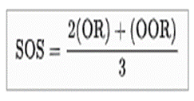
    - Total number of points scored on the road.
    - Road point difference.
    - Total number of points scored @ home.
    - Home point difference.
    - If still identical, a play-off is required.
    - Coin toss (2 teams) or drawing of lots (at least 3 teams).

CFL:
- All CFL players will attend their club's training camp once it starts 28 days prior to the first regular season game of the season; a camp solely devoted to first year players is allowed the 3 days before the main camp opens.
- The preseason is a 2-game, 3-week exhibition season in mid-June.
- Each team plays a 21-week regular-season that starts on the weekend before Canada Day weekend and ends in early November with 18 games & 3 bye weeks:
  - i.e. Home-and-Away series with the other 9 teams (or double round-robin).
  - There are no conferences/divisions
- The playoff is a 6-team single-elimination tournament starting one week after the regular season:
  - The teams selected will be the 6 teams with the highest point totals.
  - 1st Round:
    - #3 plays #5 & #4 plays #6.
    - The #1-2 seeds earn 1st round byes.
  - 2nd Round:
    - #1 plays #3/5 & #2 plays #4/6.
  - 3rd Round (Grey Cup):
    - #1/3/5 play #2/4/6.
- At the end of the regular-season, the team with the best regular-season record (i.e. highest point total) is awarded the CFC Trophy:
  - For those who don't know, it echoes the practice of the top European soccer leagues in which the team with the best record is the champion, similar to the Supporter’s Shield in MLS.
  - The CFC Trophy winner is guaranteed home-field advantage in both the second round of the playoffs & the Grey Cup (excluding the wild-card round).
- The CFL All-Star Game is a flag football game played 1 week after the Grey Cup between a team of Canadian citizens (Team Canada-Canucks) & a team of imported players (Team International-Panthers). The game is rotated between the following sites:
  - Rogers Centre (52,230) in Toronto, ON.
  - Olympic Stadium (66,308) in Montreal, QC.
  - BC Place (54,000) in Vancouver, BC.
- A CFL player is eligible to participate for Team Canada during the CFL All-Star Game if at least one of the following criteria is met:
  - The player is a citizen of Canada.
  - The player is qualified for citizenship or to hold a passport under the laws of Canada, but has not been granted citizenship or been issued a passport:
    - In this case, the player may be made eligible by CFL upon petition by the player or team.
  - The player is a permanent legal resident of Canada.
  - The player was born in Canada.
  - The player has one parent who is, or if deceased was, a citizen of Canada.
  - The player has one parent who was born in Canada.
  - The player has lived in Canada seven years prior to their 15th birthday.
- The CFL Combine & Draft:
  - Eligible Canadian citizens/nationals, & American non-imports (usually from U Sports football or American college football) are drafted by teams in the annual CFL Draft which takes place in May and consists of 8 rounds. The first two rounds of the draft are usually shown live on TSN.
  - The CFL Combine is a 3-day program in late March similar to the NFL Combine in which athletes from both American & Canadian universities are scouted by general managers, coaches and scouts of the CFL.
  - A junior player in the locale of a team may be claimed as a territorial exemption and sign with that team before beginning collegiate play (one recent example is when the BC Lions claimed Andrew Harris). Teams maintain "negotiation lists" of players they wish to sign as free agents.
  - The selection order of the draft is based on a combination of the regular season standings and post-season results from the previous season, with Non-Grey Cup participants being ranked in reverse order of the previous season's standings with the team with the league-worst record being awarded the first overall pick. Any ties between teams in different conferences are decided the same way as tied division opponents: first by season series, then by other tie-breaking formulas. The losing team in the previous year's Grey Cup game selects second-last while the winner of the previous year's Grey Cup selects last in each round. The order remains the same in each round.
  - Teams are permitted to trade draft picks before and during the draft for either another team's draft picks or players. This is a common practice resulting in some teams having multiple selections in one round while other teams may have none. Teams may also trade conditional draft picks, meaning the transaction will only occur if a condition is fulfilled (for example, if a traded player plays enough games or signs a contract extension with his new team).
  - A club holds a player’s rights for as long as he is in school or playing in another professional football league. Once a player is no longer in school or playing professional football, a team loses his rights one full calendar year following his graduation. For example, a player who graduates in April 29, 2018 and doesn’t remain in school or play professional football would become a free agent April 29, 2020.

New Gameplay Rules:
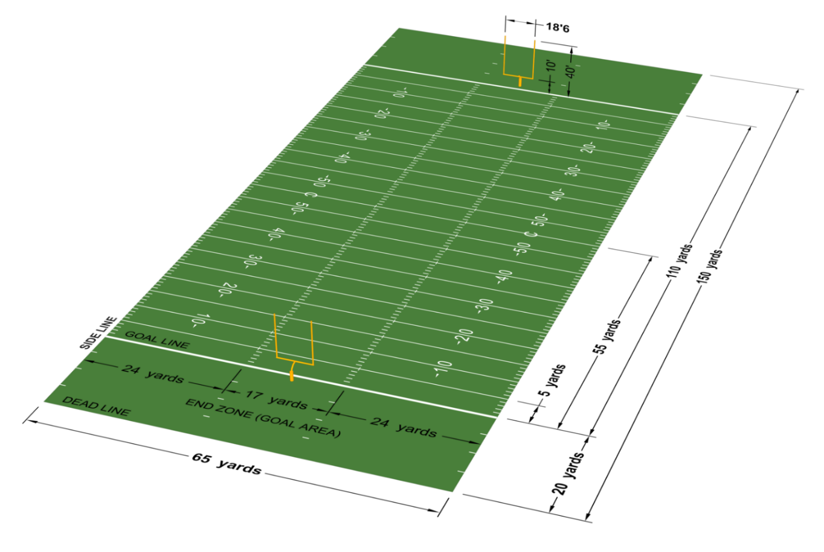
- It shall be the responsibility of the home team to have a qualified physician in attendance 15 minutes before, during and available after the game.
- 3 downs to make 10 yards.
- Full-contact padded practices will be discontinued during the regular-season.
- All teams must attempt either of the following on 3rd & 1 (and shorter):
  - Score (i.e. touchdown, field goal or rouge).
  - Attempt to gain a first down.
- Equipment Rules:
  - All players are required to wear knee pads and pants that cover the knees.
  - All players are allowed to wear custom cleats as long as they don’t say anything discriminatory:
    - i.e. racism, sexism, homophobia, ableism, etc.
  - Mouthguards are mandatory for all players.
  - All players must also wear either of the following:
    - Sensors designed to detect hard hits in their helmets, and any player that receives the beep must come out for at least 1 play while the medical staff examines them for concussions.
    - Helmets designed to crumple upon impact.
    - The single-bar face mask is now allowed for all players.
- Four 15-minute quarters with a 15-minute period at half-time & 2-minute periods between quarters:
  - The official time clock runs continuously unless stopped by any of the following:
    - Plays in which a touchdown or safety is scored (which must be automatically reviewed).
    - When a time out is called by either team.
    - Official reviews of penalties (including coaches challenges; instant replay reviews will be limited to 30 seconds).
    - PAT conversion plays after a touchdown.
    - The referee stops play to allow opposing teams to align properly after a play.
    - The mandatory play stoppage with 3 minutes remaining in each half:
      - After the three-minute warning, the game clock is run only from the snap of the ball to when the referee declares that play dead.
  - An offense has 20 seconds from the referee's signal to begin a play.
- Prior to the snap of the ball:
  - All offensive & defensive backfielders and receivers, except the quarterback, are allowed unlimited motion provided that they remain more than one yard behind the line of scrimmage, but all offensive & defensive linemen must not move.
- Kicking Rules:
  - The kicker & punter positions will be merged into one (i.e. having one player who kicks all of the field goals, punts, & kickoffs).
  - All kickoffs will be administered from the kicking team's 35-yard line, as to decrease touchbacks and increase coverage opportunities:
    - Kickoffs may be taken as either:
      - A place kick with a tee.
      - A free kick (as is done after scoring a safety; i.e. like a punt or drop kick).
      - The scoring team can also elect to run a play from its 35-yard line that must go at least 10 yards to retain possession in lieu of an onside kick regardless of their score; If the team fails, then the opposition will start their possession on their own 35-yd line.
    - Rules for the kicking team:
      - The kickoff team must have 5 players on each side of the ball (5x5 alignment).
      - At least 2 players must be lined up beyond the yard-line number and 2 players between the inbounds line and the yard-line number.
      - The kickoff team cannot be lined up more than 1 yard from the restraining line (i.e. the 34-yd line for the kickoff at the 35-yd line).
      - The kickoff team must remain still until the ball is kicked (with the exception of the kicker).
      - The ball must go at least 10 yards before it can be recovered by the kicking team (i.e. the ball can be recovered by anyone on the kicking team anywhere in-between the 45yd & 55yd lines).
      - Once a kickoff passes the 55-yard line, fielding rules became similar to punts in that the kicking team is not allowed to recover and regain possession (except for the kicker & any players behind the kicker).
    - Rules for the receiving team:
      - 8 players on the receiving team must line up in a 15-yard zone that begins 10 yards from the kickoff line and extends back (i.e. between the kicking team's 50-yard and 35-yard lines; the setup zone) for the possibility of decreasing "high-impact collisions"; only 3 players can remain outside of the setup zone.
      - Only single & 2-man wedge blocks are permitted; until the ball is touched or the ball hits the ground, no player on the receiving team may cross its restraining line, or initiate a block against the kicking team in the 15-yard area (i.e. blocks can take place anywhere on the field except in-between the 40-yd & 35-yd lines).
      - Until the ball is touched or the ball hits the ground, no player on the receiving team may cross its restraining line, or initiate a block against the kicking team in the 15-yard area (i.e. blocks can take place anywhere on the field except in-between the 40-yd & 35-yd lines).
  - The ball must go at least 10 yards before it can be recovered by the kicking team.
  - All players are prohibited from leading with the crowns of their helmets.
  - The No-Yards Rule:
    - Fair catches are not recognized.
    - Punts & kicks are allowed at any point of time in the game (i.e. any player can kick the ball at any time).
    - All punt or kick coverage teams must give a 5-yard empty zone around the opposing receiver until he has received the ball. Kick or punt receivers must field all kicks and punts, with no exceptions:
      - All of the players offside at the time of the kick may neither touch the ball nor be within 5yds of the member of the receiving team who fields the kick.
      - The penalty for no yards is 15yds I regardless of whether the kick is in flight or if it has been grounded.
    - Any unhandled ball from a place kick or punt may be legally recovered by the kicker or any player behind the kicker at the time of the kick so long as the ball travels at least 10 yards:
      - The ball doesn't have to be touched by the receiving team in order for the possession to count.
      - In such a case, the kicker is exempt from the No-Yards rule. Thus, a player from Team A may punt or kick the ball 40 yards, chase the ball upfield, then recover an untouched ball for a Team A first down. Such instances are rare since the player would have to elude plenty of blocking to reach the ball. When it does happen, this play is highly exciting.
      - Examples = Montreal at Toronto - Wild Ending - October 29, 2010, Montreal Alouettes Perfect Fake Field Goal vs. Lions Wk. 11 2012.
    - The ball is live under almost all circumstances during a legal play within bounds at any time during the game (including if a punt or field goal attempt lands & stays in the end zone) except for incomplete forward passes.
    - With the exception of a rouge/touchback, punting out of bounds is a 10yd penalty.
- Scoring System:
  - 6 points for a touchdown or major (TD/M).
  - Conversions or Points After Touchdown (C or PAT):
    - 1 for a kicked convert (or PAT); In the NCFL, all extra points will be attempted from 35 yards out.
    - 2 for a passed or rushed convert (2yds).
    - 3 for a passed or rushed convert (5yds).
    - All defensive players are prohibited from leaping or hurdling over offensive linemen on field goal or PAT attempts.
    - On a convert attempt after a touchdown, the defending team may return a missed kick convert to the kicking team's end zone for 1 point, or if the convert was a rush or pass play may return a fumble or interception for 2 points.
  - Field Goals (FG):
    - 3 for a field goal under 50 yards.
    - 4 for a field goal 50 yards and longer (the 33yd line must be painted dark gray to symbolize a 4-point line).
    - On a field goal attempt, the defending team may return a missed field goal to the kicking team's end zone for a Touchdown.
  - 2 for a Safety Touch (St); the team being awarded the 2 points has the option of either:
    - Scrimmaging from their own 25-yard line, or
    - Kicking the ball off from their own 25-yard line, or
    - Having the opposing team kick off the ball from their own 20-yard line.
  - 1 for a Rouge or Single (Ro or Si):
    - A rouge is awarded to a kicking or punting team (Team A) if an opposing player (Team B) either:
      - Catches or recovers a punt or missed field goal in their own end zone but is prevented by Team A from returning the ball back out onto the field of play,
      - Elects to drop to one knee while still in the end zone before having returned the ball to the field of play, or
      - Elects to run with the ball from the end zone out of bounds rather than enter the field of play.
    - A rouge is also awarded to a kicking or punting team when any of the following scenarios occurs:
      - A field goal attempt 50yds or longer that goes out of the end zone.
      - A punt 50yds or longer that goes out of the end zone (a punt that goes through the upright will count as a field goal).
      - A kickoff goes that goes either 1) through the uprights or 2) out of the end zone.
    - A rouge is also awarded to a defense (Team A) if they either:
      - Force an interception,
      - Recover a fumble,
      - Block a field goal, or
      - Force a turnover on downs (unless the turnover happens on a 4th & 1 play).

Ticket Pricing (CFL minimums):
Type: | Individual: | Season:
Adults (ages 18-64) | $15 per person | $135 per person
Children (ages up to 17) | $10 per person | $90 per person
Seniors (ages 65 & up) | $5 per person. | $45 per person

Broadcasting & Miscellaneous Rules:
- All tickets for CFL preseason games must be no less than 15% but no more than 50% of the price for all regular season games.
- Player celebrations (individual or group) are permitted only in the end zones or the bench areas.
- No "Tuck Rule" = In the CFL, if a passer brings his arm forward in a passing motion and then loses possession of the ball as he is attempting to tuck it back toward his body, it is considered a fumble.

