General Rules:
- How to start a franchise in the AFFL:
  - The costs to join the league are a one-time $15,000 franchise fee and a $5,250 annual league fee.
  - All teams are required to have a stadium that meets the following requirements:
    - At least 300 total seating capacity, but not more than 20,000.
    - A scoreboard.
    - Locker rooms with showers for both teams and officials.
- Games are played 7-on-7:
  - All teams must have a 12-man roster:
    - All professional teams have a weekly salary cap of 2017 US$3,600:
      - Professional players must be paid at least $200 per game before taxes. No other benefits are provided.
      - Both rates must be adjusted for inflation annually.
    - All professional teams are required to have at least 3 players that originate from within a 120-mile radius of the team's home town. Eligibility requirements include the following:
      - Being born inside the aforementioned limit.
      - Residing in the aforementioned limit for at least 5 years.
      - Playing professional football in other leagues (i.e. NFL, NFDL, AFL, Spring League, etc.) and/or college football inside the aforementioned limit for at least 1 season.
  - All players must be at least 18, but can be no older than 55 at the start of the season.
  - All players must play on both offense & defense:
    - If a player enters and leaves, from the moment he leaves the player is considered "dead" and cannot return to play until the designated time is served, or if a player is injured/ejected.
    - “Dead Time” is 4 possessions (2 offensive & 2 defensive or at least 16 total plays).
    - Exception: a "dead" player may participate on conversions.
- Timing Rules:
  - Games consist of two 30-minute halves instead of four 15-minute quarters (similar to rugby):
    - The game clock only stops for the following:
      - Scoring play.
      - Incomplete passes.
      - Out of bounds plays.
      - Penalties.
      - Every play after the 3-minute warning.
  - The play clock is 25 seconds.
  - "Mercy" Rule:
    - If a team has at least a 48-point lead at the start of the 2nd half or any point after, the game is automatically called as a win for the team with the lead.
  - Overtime Format:
    - If a game is tied after 2 halves, the teams will play a max of 3 extra periods (no limits for postseason games):
      - Teams will meet at the 50-yard line for another coin flip to determine the possession of the first extra period.
      - The visiting team picks heads or tails.
      - Whichever team has more points in the first extra period wins.
      - If it's still tied after one period, they play up to 2 more (regular-season) or until one team wins (post-season).
      - The AFFL pre-season games will no longer have any overtime periods.
    - Each period consists of one possession for each team, the order of which is decided by a pre-overtime coin toss:
      - The overtime period begins at the 30-yard line, and each team is given the opportunity to score a touchdown.
      - The game clock does not run, but the play clock is enforced.
      - Possessions end when the offensive team scores or turns the ball over.
      - After the first team completes its drive with a score or turnover, the opposing team has the same opportunity from the other 30-yard line.
      - The defensive team to score after gaining possession on a turnover can advance the ball upon gaining possession; if it scores a touchdown, it will satisfy the condition of each team having a chance to score and thus end the game.
      - After each period, the order of possession flips.
      - Each team has 1 timeout per overtime period.
- The field will be the same as the NFL field, but without the goalposts.
- The official football is the same size and weight as a National Football League ball, but with the proprietary American Flag Football League insignia.
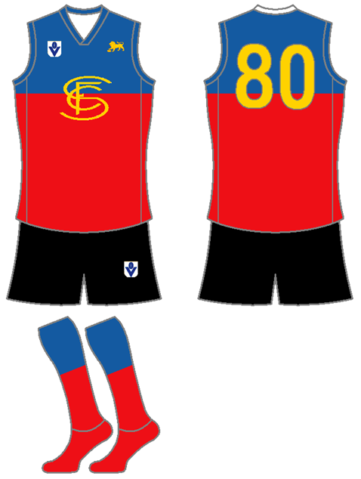
- Uniform Rules:
  - All players can wear any number that they want:
    - However, numbers cannot be shared.
    - Player uniforms must have logos on the front and numbers back of shirts.
  - Jerseys must have either of the following on the front:
    - The AFFL logo.
    - The respective team logo.
  - All jerseys must be Australian Football League (AFL) type uniforms.
  - All players can wear a nickname on the back of their jersey.
  - Jerseys & socks can be any color.
  - All players must wear solid black, white, or team color shorts with no pockets.
  - All clothing worn underneath shirts and shorts must be black or white.
  - Players can not wear face coverings but are allowed backwards official AFFL ballcaps and soft protective gear with no visible logos.
  - Long sleeves & pants must be worn in cold weather games.
- Scoring System:
  - Touchdown (TD):
    - 6 points for a touchdown under 50 yds.
    - 7 points for a touchdown 50yds or longer.
  - Conversions or Points After Touchdown (C or PAT):
    - 1 point for a passed or rushed conversion (2yds).
    - 2 points for a passed or rushed conversion (5yds).
    - 3 points for a passed or rushed conversion (10yds).
    - On a convert attempt after a touchdown, the defending team may return a fumble or interception for 1, 2, or 3 points.
  - 2 points for a Safety Touch (St):
    - A safety is scored when any of the following conditions occur:
      - The ball becomes dead in the goal area of the team in possession of the ball (Example = a defensive player managing to pull an offensive player’s flag in his own end zone while the offensive player has possession of the ball), with the exception of an incomplete forward pass.
      - The offense commits a foul in its own end zone (examples = the ball carrier is penalized for intentional grounding or an offside pass in his own goal area).
    - The team being awarded the 2 points has the option of either:
      - Scrimmaging from their own 25-yard line, or
      - Having the opposition scrimmage from their own 25-yard line
  - 1 point for Single/Rouge (Si/Ro):
    - A single is awarded to a team’s defense if they either forced an interception or recovered a fumble.

Gameplay Rules:
- Teams will be given 3 downs to make 10 yards:
  - Teams with the lead and possession of the ball have to gain positive yards on a play from scrimmage or the clock will be stopped until the next snap.
- Kicking & throw-offs are not permitted (i.e. teams are required to go for it on 3rd down).
- There will be no kickoffs:
  - All possessions will begin on each team’s 25-yard line.
- Prior to the snap of the ball:
  - All offensive & defensive backfielders and receivers, except the quarterback, are allowed unlimited motion if they remain more than 1 yard behind the offensive or defensive line of scrimmage:
    - However, all offensive & defensive linemen must not move.
    - Defensive players may not jump offside 3 times in any half; they risk ejection for the rest of the half if they do (this penalty is enforced in addition to the yardage penalty).
  - The offense must have at least 3 linemen, while the defense must only have 2:
    - Defensive linemen must line up at least 1 yard away from the offensive line of scrimmage.
    - All linemen can be in a 3-point or 4-point stance prior to the snap, but don’t have to be (except for the center).
  - At least 1 defensive player must line up at least 5 yards behind the defensive line of scrimmage:
    - However, this player can still roam freely prior to the snap if they maintain the aforementioned distance.
  - Only 7 players are allowed in both Defensive and Offensive huddles (except for timeouts):
    - If the Offense starts a play with more than 7 players on the field, the play is dead and the Offense loses the Down in addition to being penalized 5 yards.
    - If the Defense starts a play with more than 7 players on the field, the play continues as a free play, with the Offense having the option to take the result of the play or replay the Down with an additional 5 yards.
- Post-snap:
  - The QB must either 1) throw the ball, 2) hand the ball off to a teammate, or 3) run with the ball themselves within 4 seconds (i.e. (the GO clock):
    - A GO Clock violation is a loss of 5 yds & must replay the down.
  - Running Rules:
    - The quarterback can run whenever they choose.
    - North/South handoffs are not allowed but pitches and handoffs to runners running East/West are permitted.
    - The player to whom the ball is snapped cannot run the ball past the line of scrimmage; however, if the ball is tossed to another player, that player can run or throw the ball and the player to whom the ball was snapped is still an eligible receiver.
  - Passing Rules:
    - 6 players are eligible receivers downfield:
      - The one exception is the designated center on offense, who must stay on the spot to mark the line of scrimmage.
      - All forward passes to the offensive line must travel at least 1 yard (1 m) in flight.
    - Receivers must have at least one foot inbounds.
    - No "Tuck Rule" = If a passer brings his arm forward in a passing motion and then loses possession of the ball as he is attempting to tuck it back toward his body, it is considered a fumble.
    - Only 1 forward pass & 1 lateral are allowed per play.
  - Defensive Pursuit Rules:
    - Defensive rushers may charge into a blocker while in pursuit of the player in possession of the ball.
    - The defensive line can only hold up or block a receiver within 5 yards of the defensive scrimmage line (i.e. 6 total yards).
    - The defense can blitz as many times as they choose:
      - No more than 2 defenders can rush the passer; the penalty for violating this rule is illegal defense (signaled as unsportsmanlike conduct), with a 5-yard penalty and a repay of the current down.
      - All non-lineman can blitz at a time from any direction, but must be at least 5 yards off the defensive line of scrimmage/goal line prior to the snap.
      - Players do not have to announce their intention to blitz.
  - Blocking from the front & incidental contact are permitted:
    - Rules for blocking:
      - The arms of the blockers cannot be any of the following:
        - Crossed.
        - Fully extended.
        - Outside of the defender’s torso.
        - Any combination of the above.
      - The hand must be open, not closed (i.e. in a fist)
      - Contact can only be made inside of the front rectangular area of the torso.
    - Bump and run coverage (i.e. defensive backs being allowed to hit wide receivers any time before the quarterback releases the ball as long as the hit comes from the front and/or the side) is only allowed within the first 5yds from the line of scrimmage.
    - A blocker may use their body as a shield to impede a defender's pursuit of the player in possession of the ball, but only after a completion of a forward pass or a defensive interception.
    - All other types of contact are categorized as a 10-yard penalty & a replay of the current down.
- All players (both offensive & defensive) get a max of 3 fouls (i.e. flags):
  - 1st = warning (Yellow Card).
  - 2nd = sent off the field for at least 8 plays with a substitute (Black Card).
  - 3rd = sent off the field for the rest of the game without a substitute for the rest of the quarter (Red Card):
    - All players sent off the field are still eligible to start in the next game, unless the player has 3 straight games of receiving red cards.
    - Any form of contact that doesn’t involve blocking (excluding incidental, but including tacking) are automatic ejections (i.e. red cards).
- Coaching Challenges:
  - Each team gets at least 1 challenge per half:
    - However, coaches will have unlimited challenges if they keep winning them.
    - The only time he loses the right to challenge a play is if they get one of their challenges wrong.
  - Coaches can challenge anything, including uncalled penalties:
    - However, coaches are required to specifically call out the penalty and players involved when challenging uncalled penalties.

Season Structure:
- The AFFL uses a spring-to-fall season format, like the Arena Football League.
  - All teams must host an open 2-day tryout no more than 1 month prior to the start of the season:
    - A max of 100 potential players plus all of the players from the previous year are allowed.
    - Players will be tested on their 40-yard dash time and short shuttle with other position-specific drills and one-on-one drills to follow.
    - All positions will be evaluated in tryouts.
    - All tryouts must take place on Saturday & Sunday.
    - Registration fees:
      - A pre-registration fee of 2019 $65 can be applied no more than 1 day before the start of the tryouts/preseason.
      - Registration after that time and the day of will require an application fee of 2019 $80.
      - Both fees must be adjusted for inflation at least once every 5 years.
  - All team practices must occur after 5pm local time.
  - All teams must play 1 preseason scrimmage open to the public at least 2 weeks prior to April 1.
  - All teams play 20 total regular-season games (10h/10a):
    - The season runs from the first Friday of April until the second third Sunday of August.
    - The postseason runs from the Fourth Friday of August until the final Sunday of September.
    - All teams can have no more than 1 game per week.
    - All teams play the other 10 teams in their level twice (20 games).
    - All AFFL games must be scheduled on the following:
      - Friday evenings
      - Saturday afternoons & evenings.
      - Sunday afternoons.
  - Organizational Format:
    - All divisions will have no more than 11 teams.
    - This includes all of the teams being promoted (holding spots #8-11) & relegated (holding spots #1-4).
    - List of Divisions:
      - New England (Connecticut, Maine, Massachusetts, New Hampshire, Rhode Island, and Vermont)
      - North Atlantic (New Jersey, New York, and Pennsylvania).
      - East North Central (Illinois, Indiana, Michigan, Ohio, and Wisconsin).
      - West North Central (Iowa, Kansas, Minnesota, Missouri, Nebraska, North Dakota, and South Dakota).
      - Mid-Atlantic (Delaware, Maryland, Virginia, District of Columbia, and West Virginia).
      - South Atlantic (Florida, Georgia, North Carolina, and South Carolina).
      - East South Central (Alabama, Kentucky, Mississippi, and Tennessee).
      - West South Central (Arkansas, Louisiana, Oklahoma, and Texas).
      - Mountain (Arizona, Colorado, Montana, Nevada, New Mexico, Utah, and Wyoming).
      - Pacific (Alaska, California, Hawaii, Idaho, Oregon, and Washington).
- Bonus Points System:
  - 4 points for winning a game in regulation.
  - 3 points for winning a game in overtime.
  - 2 points for drawing a game
  - 0 points for losing a game
  - 1 bonus point for losing by 8 points (or fewer) or in overtime.
  - 1 bonus point for scoring at least 4 touchdowns.
  - 1 bonus point for winning while scoring at least 3 more touchdowns than the opponent.
  - At the end of the regular-season, the team with the best regular-season record (i.e. highest point total) at each level regardless of conference is awarded the Jeff Lewis Level-1/2/3 Trophy:
    - For those who don't know, it echoes the practice of the top European soccer leagues in which the team with the best record is the champion, like the Supporter’s Shield in MLS.
    - The Jeff Lewis Trophy winners are guaranteed home-field advantage in all rounds of the playoffs they compete in (excluding the AFFL 1/2/3 Championships).
    - Regular-season rankings will be based on the amount of bonus points that each team has.
  - Tie-breaker - If only two teams are level on league points:
    - Most wins.
    - The team that won the head-to-head match (if applicable) is ranked first:
      - For divisional rivals, this becomes the teams with the higher aggregate score (i.e. The combined score from both games).
      - If this game was a draw, then the team with the more wins is ranked first.
    - Point difference (PD) = is the number of goals (or points) scored in all league matches minus the number of points conceded.
    - Points for (PF) = is the total number of points scored by a team over the course of the regular-season.
    - Points against (PA) = is the number of goals scored against them by their opponents over the course of the regular-season.
    - Fewest disciplinary actions.
    - Strength of schedule = two-third (66 2/3%) for the opponent's record and one-third (33 1/3%) for the opponents' opponents record.
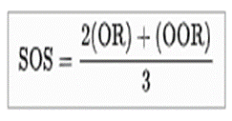
    - Total number of points scored on the road.
    - Road point difference.
    - Total number of points scored @ home.
    - Home point difference.
    - If still identical, a play-off is required.
    - Coin toss (2 teams) or drawing of lots (at least 3 teams).
- The Post-Season:
  - The post-season is a 20-team single-elimination tournament:
    - The 20 teams selected are the top 2 teams from each division:
      - These teams will play an elimination game to enter the national 10-team bracket.
    - The Eastern Bracket:
      - New England (Connecticut, Maine, Massachusetts, New Hampshire, Rhode Island, and Vermont)
      - North Atlantic (New Jersey, New York, and Pennsylvania).
      - Mid-Atlantic (Delaware, Maryland, Virginia, District of Columbia, and West Virginia).
      - South Atlantic (Delaware, Florida, Georgia, North Carolina, and South Carolina).
      - East North Central (Illinois, Indiana, Michigan, Ohio, and Wisconsin).
    - The Western Bracket:
      - West North Central (Iowa, Kansas, Minnesota, Missouri, Nebraska, North Dakota, and South Dakota).
      - East South Central (Alabama, Kentucky, Mississippi, and Tennessee).
      - West South Central (Arkansas, Louisiana, Oklahoma, and Texas).
      - Mountain (Arizona, Colorado, Montana, Nevada, New Mexico, Utah, and Wyoming).
      - Pacific (Alaska, California, Hawaii, Idaho, Oregon, and Washington).
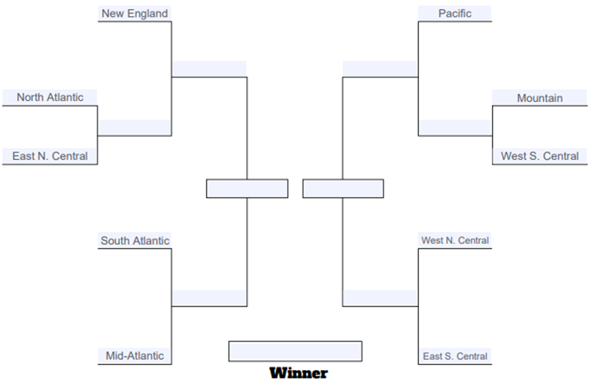
  - All playoff games will be played at the higher ranked team’s stadium, except for the AFFL 1/2/3 Championship Games:
    - The locations of the AFFL 1/2/3 Championship are chosen by the AFFL respectively 1-3 years before the game.
    - Any AFFL or college football team with a stadium capacity of at least 6,000 (including club and fixed suite seating) can host the AFFL 1/2/3 Championship Game:
      - Stadiums may include temporary seating for the AFFL Championships, but seating must be approved by the league.
      - Stadiums where the average game day temperature is below 50° Fahrenheit must either have a roof or a waiver given by the league.
      - There must be a minimum of 2,000 parking spots within one mile of the stadium.
      - The host stadium must have space for the Gameday Experience, a large pregame entertainment area, within walking distance of the stadium.
      - The host city must have space for the AFFL Experience, the interactive football theme park which is operated the week prior to the AFFL Championships. An indoor venue for the event must have a minimum of 850,000 square feet, and an outdoor venue must have a minimum of 1,000,000 square feet.
      - Additionally, there must be space nearby for the Media Center, and space for all other events involved in the Super Bowl week, including golf courses and bowling alleys.
      - The necessary infrastructure must be in place around the stadium and other Super Bowl facilities, including parking, security, electrical needs, media needs, communication needs, and transportation needs.
      - There must be a minimum number of hotel spaces within one hour's drive of the stadium equaling 35% of the stadium's capacity, along with hotels for the teams, officials, media, and other dignitaries.
      - There must be practice space of equal and comparable quality for both teams within a 20-minute drive of the team hotels, and rehearsal space for all events within a reasonable distance to the stadium.
      - The practice facilities must have one field (turf or grass) for each team.
- Promotion & Relegation (Pro/Rel):
  - The bottom 4 teams (2 per division) in AFFL1 (based on points) will be demoted to AFFL2.
  - The top 4 teams (2 per division) in AFFL2 (based on points) will be promoted to AFFL1.
  - The bottom 4 teams (2 per division) in AFFL2 (based on points) will be demoted to AFFL3.
  - The top 4 teams (2 per division) in AFFL3 (based on points) will be promoted to AFFL2.
- League 1 games will be broadcast live on the NFL Network.
- All cities can have no more than 2 professional football teams within their entire Metropolitan Statistical Area (MSA):
  - Examples of Metropolitan Statistical Areas = Dallas–Fort Worth metroplex, Norfolk-Virginia Beach (Hampton Roads), Riverside–San Bernardino (Inland Empire) or Minneapolis–Saint Paul (Twin Cities).
  - There are no limits for purely amateur teams.

Ticket Pricing Minimums:
Type: | Individual: | Full-Season: | Group (1 game):
Adults (18-64) | $8 per person | $35 per person | $5 per person
Children (5 to 17; 4 & under are free) | $5 per person | $20 per person | $3 per person
Seniors (ages 65 & up)
All ticket prices are in 2017 US$ & must be adjusted for inflation. | Includes only a single game | Includes only a single game | The group must include at least 5 people, regardless of their ages

