Positions:

Outdoor version:
- 11 players on the field per team - 1 goalie, 3 defensemen, 4 midfielders, and 3 attackmen.
  - Attack = attempt to score as many goals as possible.
  - Midfield = contribute offensively and defensively and may roam the entire playing area
  - Defense = assist the goalkeeper in preventing the opposing team from scoring.
  - Goalkeeper = prevent the opposition from scoring by directly defending the goal.
  - Max of 18 players on the active roster, & 30 total players.
  - Numbering System:
    - Forwards/ Attackers = 0, 00, 1-31
    - Midfielders = 32-64
    - Defenders & Goalkeepers = 65-99

Indoor Version:
- 6 players on the field per team - 1 goalie and 5 field players.
  - Field players = contribute offensively and defensively and may roam the entire playing area
  - Goalkeeper = prevent the opposition from scoring by directly defending the goal.
  - Max of 12 players on the active roster, & 18 total players.

Equipment:
- All players are allowed to wear the following:
  - Soccer Uniforms, though long sleeves & thermal pants may be worn in cold weather games.
  - Mouthguards
  - Soccer cleats & shin guards
  - American football gloves (field players only)
  - Soccer goalkeeper gloves (goalies only)

Gameplay Rules:

The Field/Court:

Outdoor Version:
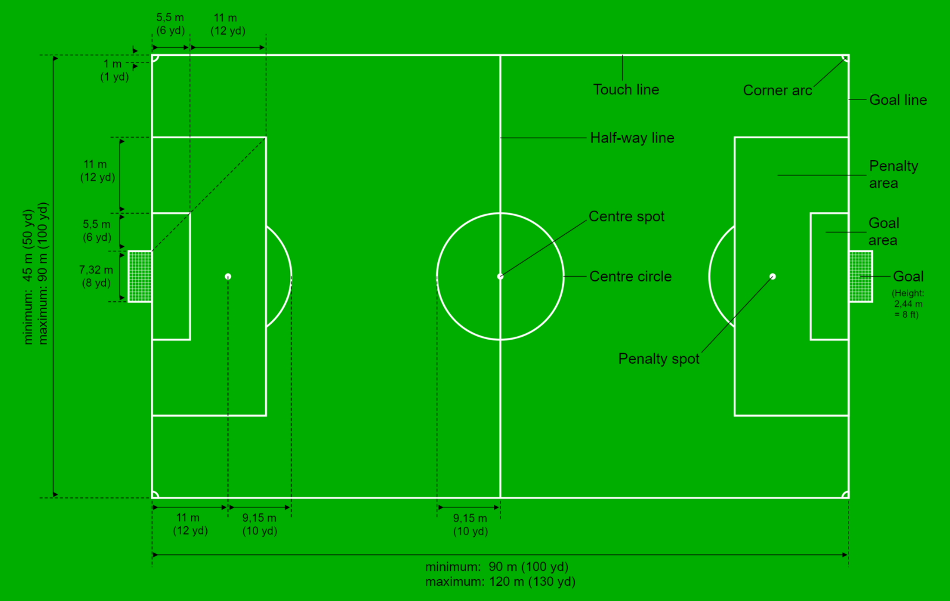
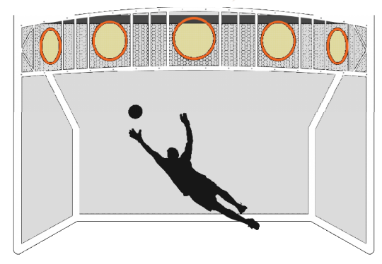
- Goals:
  - Option #1 (Soccer Goal) = 7.32m x 2.44m (8yds x 8ft) or 3m x 2m (9ft x 6ft).
  - Option #2 (Kronum Goal) = Chamber is (16ft x 8ft) & there are 5 crown rings 2’ in diameter.
- Length = 90m-120m (100yd-130yd).
- Width = 45m-90m (50yd-100yd).
- Goal Area = 18.3m x 5.5m (20yd x 6yd).
- Penalty/Restraining Area = 40.32m x 16.5m (44yd x 18yd).
- Penalty Mark = 11m (12yd) from goalline.
- Penalty Arc = (22yd) from the goalline.
- Center Circle = 9.15m (10yd) radius.

Indoor Version:
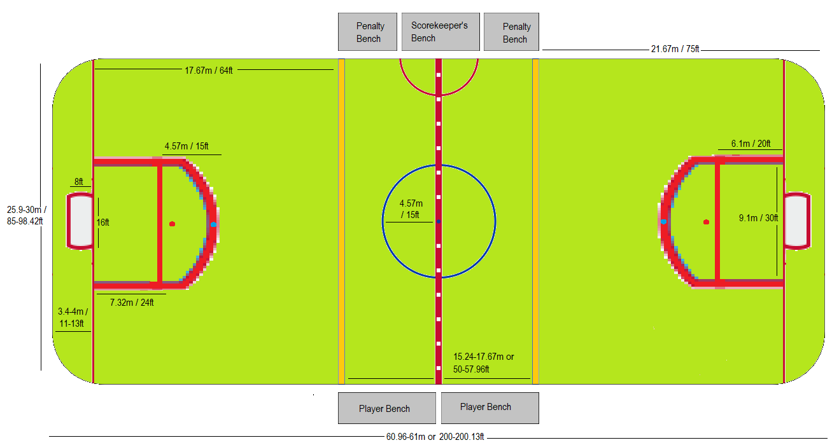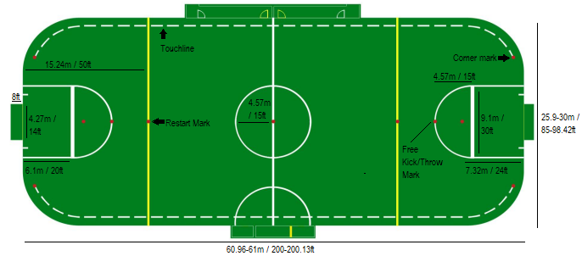
- Goals:
  - Option #1 (American Indoor Soccer Goal) = 4.27m x 2.44m (14ft x 8ft)
  - Option #1 (Futsal Goal) = 3m x 2m (10ft x 6ft).
  - Option #3 (Kronum Goal) = Chamber is (16ft x 8ft) & there are 5 crown rings 2’ in diameter.
- Length = 61m (200-200.13’).
- Width = 26m (85ft).
- Goal Area
- Penalty Area = 9.1m x 6.1m (30’ x 20’).
- Penalty Arc = 4.57m (15’) radius
- Penalty Mark = 7.32m (24’) from goalline.
- Free Kick Mark = placed at the top of each Penalty Area arc
- Center Circle = 4.57m (15’) radius.
- Neutral zone lines = yellow line marking shall be placed across the field (50’) from each goal line.
- A red corner mark 9” in diameter, shall be placed 3’ inside the perimeter wall 20’ from the inside of the nearest goal post
- Dasher boards, topped by plexiglass, surround the field. Player’s benches and the penalty boxes are behind the dasher boards at midfield.
- Penalty boxes for each team shall be adjacent to the Assistant Referee on the side of the field opposite the team benches. Penalty boxes shall be protected from spectator areas by suitable Plexiglas partitions

Timing Rules:
- Outdoor = Three 30-minute periods.
- Indoor = Three 20-minute periods.
- Each team is given a 10-minute break between the 1st and 2nd periods, & the 2nd and 3rd periods.
- There is a 60-second (outdoor) or 35-second (indoor) shot clock.
- Each team may announce 1 timeout per half consisting of 1 minute each.
- Timeouts are not to accumulate over the course of the game.
- Also, there is no added times for injuries, overtime, or stoppage time.
- The clock stops the final minute of each period, or official timeout.
- In the event of a tie, the teams play an overtime session that uses elements penalty shootouts used in soccer and ice hockey:
  - A coin toss (called by the visiting team) will determine which team will go on offense or defense first, and which end zone will be used (both offenses will attack the same end zone, just as soccer shootouts are attempted at the same goal).
  - Teams will attempt at least 3 but no more than 5, alternating one-point attempts from the penalty mark.
  - Whichever team has the most points after the 3-5 tries, or after one team gains an insurmountable lead, will be the winner.

Advancing The Ball:
- A player may stop, catch, throw, bounce or strike the ball in any manner and in any direction, using hands, fists, arms, head, body, thighs, knees, shins, or feet.
- The ball must be dribbled like in basketball or soccer:
  - Basketball dribbling = bouncing the ball on the floor continuously with one hand at a time.
  - Soccer dribbling = controlling/maneuvering the ball with one’s feet while walking and/or running.
  - Players can take up to 3 steps for up to 3 seconds at a time without dribbling, after this happens, the player must either pass the ball or begin dribbling the ball.
- Players must advance the ball over the mid-court line within 20 (Outdoor) or 12 (indoor) seconds to avoid a turnover.
- An offensive player must pass, shoot or dribble the ball within 5 seconds if being guarded by a defensive player who is within arm’s reach.
- Double dribbling is legal, but only when players stop to switch dribbling methods (i.e., basketball to soccer or vice versa).
- Indoor only:
  - The ball may be struck in such a way that it contacts one or more walls without penalty or stoppage.
  - If the ball flies over the walls or contacts the ceiling, play is stopped and the team opposing the one that most recently touched the ball is awarded a free kick at the location where the ball left the arena or made contact with the ceiling.

Starting & Restarting Play:
- Tip-off (from basketball in the center circle) = following a goal by the opposing team, or to begin each period of play.
- Throw-in = when the ball has crossed the touchline; awarded to the opposing team to that which last touched the ball.
- Goal kick/throw = when the ball has wholly crossed the goal line without a goal having been scored and having last been touched by a player of the attacking team; awarded to defending team.
- Corner kick/throw = when the ball has wholly crossed the goal line without a goal having been scored and having last been touched by a player of the defending team; awarded to attacking team.
- Indirect free kick/throw = awarded to the opposing team following "non-penal" fouls, certain technical infringements, or when play is stopped to caution or dismiss an opponent without a specific foul having occurred such as the following below:
  - When the 1st or 2nd technical fouls for players occurs.
  - When the 1st or 2nd personal fouls (most of them) for players occurs.
  - A goal may not be scored directly (without the ball first touching another player) from an indirect free kick/throw.
  - Indirect free kicks/throws are taken from the place where the offense occurred, even if it was inside the offending player's penalty area. If the offence took place inside their goal area, the indirect free kick/throw is taken from the nearest point on the goal area line which runs parallel to the goal line
- Direct free kick/throw: awarded to fouled team following certain listed "penal" fouls:
  - When a blue, yellow and/or red card is awarded.
  - When a player commits a shooting foul, regardless of whether a player has been wared a card or not.
  - A goal may be scored directly from a direct free kick.
- Penalty shot = awarded to the fouled team following a foul usually punishable by a direct free kick/throw but that has occurred within their opponent's penalty area, or after a team’s 6th foul.
- Dropped-ball = occurs when the referee has stopped play for any other reason, such as a serious injury to a player, interference by an external party, or a ball becoming defective.
- The free kick/throw is awarded from the spot of the foul, except in the case where it took place in the opponent's penalty box:
  - In that case, a penalty kick/throw will automatically be awarded.

Contact Rules:
- Slide tacking is legal:
  - Just like in soccer, the tackle must be made from the front & contact must be made with the ball first.
  - Slide tackles cannot be made if the players are dribbling the ball like in basketball.
  - Slide are banned in the indoor version since painful burns and/or cuts can occur.
- A screen is an attempt by an offensive player to stop a defender from guarding the ball-carrier:
  - Screens/picks, like in basketball, must be performed in a standstill manner.
- Hand checking is legal, but only when defending from the font.
- Hitting a player above the neck is not allowed.
- When going after a loose ball, players may hip check or create shoulder contact with the player nearest the ball.
- Boxing/shielding a player like in basketball is also allowed.
- Players can reach in to steal the ball, but they cannot make contact with the player while doing so.
- Players cannot pull the ball out another player’s hands.
- If 2 players both leave the ground & collide in a neutral vertical plane, then neither player commits a foul.
- Players cannot make contact with a player while they are attempting to shoot the ball.

Penalties:
- Referees:
  - The staff must consist of the following:
    - 1 Basketball or Olympic Handball ref
    - 1 Soccer ref
    - 1-2 sideline refs.
- There are 2 main categories for fouls/penalties:
  - Player foul = a foul against the offending player during the game. A player who accumulates 5 total fouls (both personal & technical) will foul out.
  - Team foul = a foul against the offending player's team during the current period. A team that accumulates 6 fouls in that period enters the penalty situation and puts the other team into the "bonus." these fouls reset every period.
- Personal foul penalties:
  - Kicking an opponent
  - Tripping an opponent
  - Jumping into an opponent (like when you are going for a header)
  - Jumping up with one knee forward as to intentionally hit a player.
  - Lifting or jumping onto a teammate to gain a height advantage
  - Pushing an opponent
  - Tackling from behind
  - Tackling an opponent and you make contact with the player prior to making contact with the ball.
  - Holding an opponent
  - Fighting or threatening to fight
  - Rugby-style tackling an opponent and/or the referee(s).
  - Hand check = When a player continually uses their hands on an opposing player on the side or back of a player.
  - Elbowing = When a player excessively swings their elbows and hits another player.
  - Shooting foul = making contact with a player while they are attempting to shoot the ball.
  - Dissent by word or action
  - When a player impedes the progress of an opponent without any contact being made
  - Illegal or “moving” pick/screen = When a player fails to maintain a set position while setting a screen or pick. Screens must be performed in a standstill manner.
  - When a player prevents the goalkeeper from releasing the ball from their hands or kicks or attempts to kick the ball when the goalkeeper is in the process of releasing it
  - When a player initiates a deliberate trick for the ball to be passed (including from a free kick/throw or goal kick/throw) to the goalkeeper with the head, chest, knee etc. to circumvent the back-pass rule, whether or not the goalkeeper touches the ball with their hands; the goalkeeper is penalized if responsible for initiating the deliberate trick
  - Charging into an opponent = When an offensive player makes contact with a defender who has established position in front of an offensive player with or without the basketball and is not moving. Generally, the ball-carrier committed a charge if all of the following are true:
    - The defender was still, or moving sideways or backward but not forward, when contact occurred.
    - The defender took a legal guarding position before the contact, that is, one with both feet on the floor.
    - The defender was hit on the torso (as opposed to the arm or leg).
  - There are also 2 offenses which apply in matches using the video assistant referee system:
    - Entering the referee review area
    - Excessively using the "review" (TV screen) hand gesture
  - Always timeserving (2:00-5:00).
- Technical foul penalties:
  - Handballs from soccer will no longer count as a foul.
  - Palming = When a player dribbles the basketball in a manner that has their palm underneath the basketball.
  - Failure to respect the required distance when play is restarted with a corner kick, throw-in or free kick/throw.
  - Allowing players to lock arms to restrict the movement of an opponent (usually a team technical)
  - If the coach leaves their box, especially to argue.
  - Baiting or taunting an opponent
  - Having too many players on the field, or too few (always a team technical)
  - Disrespectfully addressing or contacting an official or gesturing in such a manner as to indicate resentment
  - Faking being fouled (flopping)
  - Blocking a penalty shot, if not a goalkeeper.
  - Illegal substitution or entering the game at an impermissible time
  - Intentionally hanging on the basket at any time (except to prevent an injury)
  - Knowingly attempting a free kick/throw or accepting a foul to which the player was not entitled
  - Lifting or jumping onto a teammate to gain a height advantage
  - Remaining out of bounds to gain an advantage
  - Removing the jersey or pants within the visual confines of the playing area
  - Failure to supply the scorer with names and numbers of team players prior to the start of the scheduled contest.
  - Held ball = When two players gain possession of the ball and a brief battle for the basketball occurs. The referee will award possession to one team, alternating which team gets the ball each subsequent time it occurs.
  - Illegal double dribbling = When a player picks up their dribble to establish their position and then restarts their dribble, or when a player dribbles the basketball with two hands at the same time.
  - Backcourt or “over & back” = When an offensive player brings the ball over the midfield line and then retreats back over mid court during their possession.
  - Traveling = When a player either 1) takes more than 3 steps between dribbles or without dribbling the ball. Traveling can also occur when a player who has picked up the dribble switches their pivot foot.
  - 12/20-Second Violation = when a team in possession of the ball fails to advance the ball over the midfield line within 20 (outdoor) or 12 (indoor) seconds.
  - 5-Second Violations:
    - Inbounding = when a player fails inbound the ball within five seconds after the referee hands it to them to avoid a turnover.
    - Offensive = when an offensive player fails to either pass, shoot or dribble the basketball within five seconds if being guarded by a defensive player who is within arm’s reach.
  - If a goalkeeper, inside their penalty area, commits any of the following offences:
    - Controls the ball with their hands for more than 6 seconds before releasing it from possession
    - Touches the ball again with their hands after releasing it from possession and before it has touched another player
    - Touches the ball with their hands after it has been deliberately kicked/thrown to them by a team-mate, or thrown to them from a throw-in taken by a team-mate (the back-pass rule)
  - Yellow Line Violations (Indoor Only) = a forward pass crosses both yellow lines without being touched by another player.
  - Off-Sides:
    - Indoor Version:
      - No more than 4 offensive players and 4 defensive players (including the goalie) may be in the attacking zone at any time.
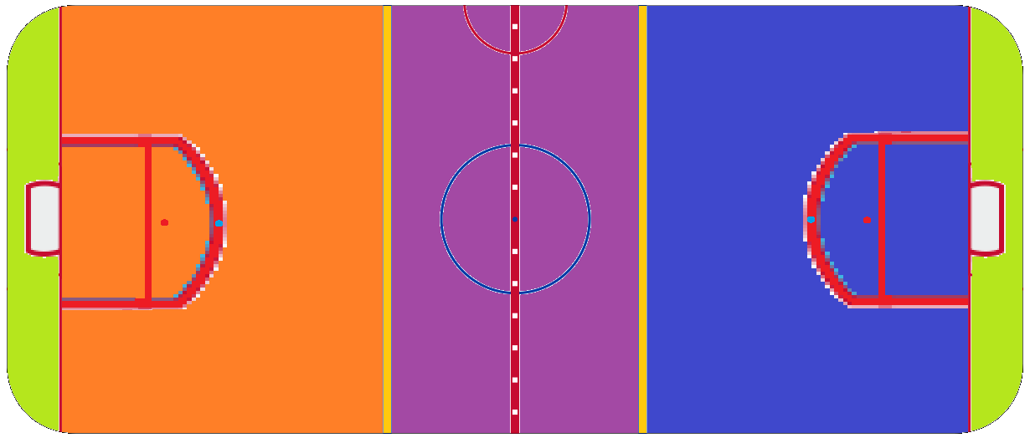
    - Outdoor Version:
      - The 3 offensive & 3 defensive players may not cross the midline at any point.
      - The goalie may leave the goal area but cannot leave the penalty/restraining area at any point.
      - No more than 7 offensive players (i.e., 3 attackers & 4 midfielders) & 8 defensive players (i.e., 3 defenders, 4 midfielders, & the goalie) may be on either side of the field at any given time.
      - No more than 4 offensive players and 4 defensive players (including the goalie) may be in the combined goal & penalty/restraining areas at any time.
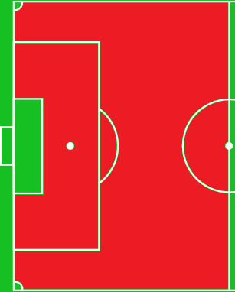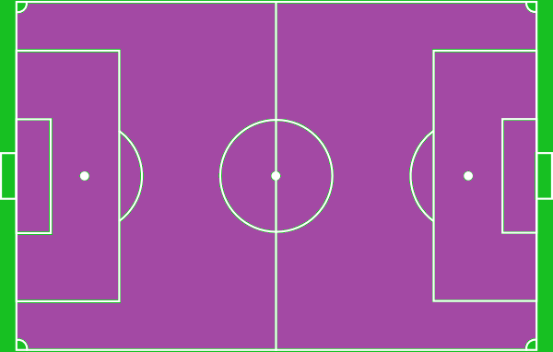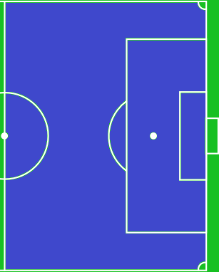
  - Goal Area Violation:
    - Only 1 offensive player may enter the goal area for a max if 3 seconds at any time while the goalie is in the area, & only while they have possession of the ball.
    - Defensive players with or without the ball may pass through the crease but are not allowed to attempt to block a shot from within the crease.
  - All are change of possession fouls unless the team that is fouled has possession.
  - If the team that commits the foul has possession have to serve a 30 second penalty.

Cards:
- Blue Card:
  - 4th offense for most technical fouls
  - 3rd offense for most personal fouls
  - 1st offense for the following personal & technical fouls:
    - Removing the jersey or pants within the visual confines of the playing area
    - Kicking an opponent
    - Tripping an opponent
    - Jumping into an opponent (like when you are going for a header)
    - Jumping up with one knee forward as to intentionally hit a player.
    - Pushing an opponent
    - Tackling from behind
    - Tackling an opponent and you make contact with the player prior to making contact with the ball.
    - Holding an opponent
    - Faking being fouled (flopping)
  - 2-minute power play to opposition:
    - The player being sent off may come back into the game, but only after the full 2 minutes has been served or the opposition has scored at least 3 points.
- Yellow Card:
  - 5th offense for most technical fouls
  - 4th offense for most personal fouls
  - 1st offense for the following personal & technical fouls:
    - Unsportsmanlike behavior (note that this includes trying to trick the referee)
    - Arguing with the referee
    - Delaying the game
    - Denying an obvious goalscoring opportunity with a foul
    - Failure to respect the required distance when play is restarted with a corner kick, throw-in or free kick
    - Knowingly attempting a free kick/throw or accepting a foul to which the player was not entitled
    - Entering or leaving the game without informing the referee
    - Entering the referee review area
    - Excessively using the "review" (TV screen) hand gesture
    - Throwing an object (other than the ball) at an opponent or match official
    - Threatening to fight
    - Using tobacco or smokeless tobacco
  - Receiving a 2nd blue card.
  - 5-minute power play to opposition:
    - The player being sent off may come back into the game, but only after the full 5 minutes has been served or the opposition has scored at least 6 points.
- Red Card:
  - 6th offense for most technical fouls
  - 5th offense for most personal fouls
  - 1st offense for the following personal & technical fouls:
    - Biting or spitting at other persons
    - Rugby-style tackling an opponent referee(s)
    - Fighting a player or the referee(s)
    - Damaging the goals and/or the field of play.
    - Using bad language
    - Use of television monitoring or replay equipment, computers, or electronics such as megaphones for coaching purposes during the game.
  - Receiving a 2nd yellow card or 3rd blue card.
  - 5-minute power play to opposition:
    - The player being sent off cannot return.
    - A substitute may come into the game, but only after the 5 minutes has been served.

Scoring Rules:

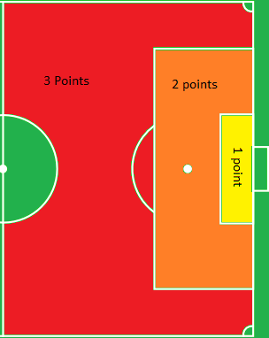
Outdoor Version:
- Option #1 = Soccer Goal:
  - All goals scored inside the goal area are worth 1 point.
  - All goals scored inside the penalty/restraining area are worth 2 points.
  - All goals scored outside the penalty/restraining area are worth 3 points.
  - However, goals scored inside the arc will also count as 3 points.
- Option #2 = Kronum Goal:
  - All goals scored inside the goal area:
    - Inside the chamber = 1 point.
    - Inside the crown rings = 2 points.
  - All goals scored inside the penalty/restraining area:
    - Inside the chamber = 2 points.
    - Inside the crown rings = 4 points.
  - All goals scored outside the penalty/restraining area:
    - Inside the chamber = 3 points.
    - Inside the crown rings = 6 points.
  - However, goals scored inside the arc will also count as 3/6 points.

Indoor Version:
- Options #1-2:
  - All goals scored inside the penalty area are worth 1 point.
  - All goals scored outside the penalty area are worth 2 points.
  - However, goals scored inside the arc will also count as 2 points.
- Option #3:
  - All goals scored inside the penalty area:
    - Inside the chamber = 1 point.
    - Inside the crown rings = 2 points.
  - All goals scored outside the penalty area:
    - Inside the chamber = 2 points.
    - Inside the crown rings = 4 points.

