How to start a franchise in the USFL:
- The costs to join the USFL is a one-time $34 million franchise fee.
- However, only the following ownership types are acceptable for USFL teams:
  - A group of no more than 32 people per franchise, with one holding a minimum 30% stake (may be a religious group and/or non-profit organization).
  - A publicly owned, non-profit corporation with a 3,5, or 7-member committee elected by the shareholders & appointed by the board of directors:
    - No one is allowed to hold more than 200,000 shares.
    - A share must cost at least $75 but no more than $350 2020 US dollars. all stocks do not include an equity interest, do not pay dividends, cannot be traded, and has no protection under securities law.
    - Shareholders receive nothing more than the following:
      - Voting rights (i.e. electing the board of directors and a 3/5/7-member executive committee that represents the team at league meetings).
      - An invitation to the corporation's annual meeting.
      - A 25% discount on official team merchandise & an opportunity to purchase exclusive shareholder-only merchandise.
      - Some season-ticket purchasing privileges in the form of a 10% discount on all plans.
  - A City and/or County Government as a 501(c)(6) mutual-benefit nonprofit corporation:
    - A City and/or County Government that owns a USFL team must also sell shares/stocks in order to raise funds for the team.
    - The same rules for shares/stocks listed above for publicly owned/non-profit corporations will also apply, except that the governmental entity will appoint 1 member each to the 1) board of directors & 2) 3/5/7-member executive committee that represents the team at league meetings.
    - All excess revenue that is left after paying all of the players, coaches, & staff must go to funding local government agencies/programs (example = police/fire departments, public transportation, etc.)
  - People are allowed to invest in the league itself in order to help bailout teams if they cannot support themselves financially:
    - As a result, all teams may have no more than 25% of the ownership rights go to the league.
  - All teams are required to release their financial balance sheet every year.
- In addition, all USFL teams must have a stadium with all of the following:
  - At least 20,000, but no more than 50,000 total seating capacity:
    - All stadiums with more than 50,000 total seating capacity & multiple decks will only open the lower bowl for USFL games.
  - A Combined Statistical Area (CSA) or Metropolitan Statistical Area (MSA) of at least 300,000.
  - Locker rooms with showers for both teams and officials.
  - PA system and scoreboard.
  - The ability to sell tickets and concession.
  - Turf is not required, but it is encouraged.
  - Properly lined field if not turf.
  - The home team is also responsible for providing water and food for the visiting team, ensuring there is a trainer or doctor on-site for the match, and paying the referees fees at the end of each game.
- All cities can have no more than 2 USFL teams within their entire Metropolitan Statistical Area (MSA) or Combined Statistical Area (CSA):
  - Examples of Metropolitan Statistical Areas = Dallas–Fort Worth metroplex, Norfolk-Virginia Beach (Hampton Roads), Riverside–San Bernardino (Inland Empire) or Minneapolis–Saint Paul (Twin Cities).

Roster & Salary Rules:
- All players in the USFL must be at least 18 years of age, but no more than 45.
- 9 players on the field at any one time.
- Min of 30 & max of 38-man active roster:
  - All USFL teams must have at least 2 quarterbacks & 2 kickers.
  - All USFL Teams are required to have at least 3 players that originated from within a 120mi / 193km radius of the team's home town. Eligibility requirements include the following:
    - Being born inside the aforementioned limit.
    - Residing in the aforementioned limit for at least 5 years after graduating from college.
    - Playing high school and/or semiprofessional football inside the aforementioned limit for at least 2 seasons.
    - Playing college and/or junior college football inside the aforementioned limit for at least 1 season.
- All USFL teams will employ 8 coaches, including the following:
  - A head coach (the head coach will also be the general manager).
  - An offensive and a defensive coordinator.
  - 4 position coaches.
  - 1 special teams coordinator.
  - Each team will also be assigned and limited to 8 football operations staff.
- Salary & Other Benefits:
  - All USFL players & coaches will have to do the following:
    - Find employment elsewhere during the offseason.
    - Pay for their own housing & health insurance.
  - All USFL teams cannot give guaranteed player contracts.
    - All 1-way (i.e., “Specialist”) active-roster players teams must be paid $645.83-1,776 per game, & $100 per bye & postseason week (i.e., a max of $7,849.96-21,712 per season).
    - All 2-way (i.e., “Iron Man”) players must earn $946.37-1,983 per regular season game, & $200 per bye & postseason week (i.e., a max of $11,456.44-24,596 per season).
    - The overall salary floor will be approximately $486,400 per team, while the salary cap will be $1.3 million.
    - These rates must be adjusted for inflation at least once every 5 years.
  - The overall salary cap for just coaches will be $1 million per team:
    - A minimum of $30,000 & a maximum of $75,000 per season for head coaches/general managers.
    - A minimum of $20,000 & a maximum of $50,000 per season for coordinators.
    - A minimum of $15,000 & a maximum of $25,000 per season for position coaches.
    - These rates must be annually adjusted for inflation.
  - All players are not paid during the preseason.
  - All contracts must be at least 1 year/season but no more than 6 years/seasons in length.
  - Signing bonuses = no more than $500.
- Player/Team Conduct & Equipment Rules:
  - All teams must use the official USFL football:
    - The football is the same size as an NFL football:
      - The ball is inflated to 12.5-13.5 psi (86-93 kPa) and weighs 14-15 oz (400-430g) beyond that, the exact dimensions vary slightly.
      - The ball has a long axis of 11-11.25” (28-29 cm), a long circumference of 28-28.5” (71-72cm), and a short circumference of 21-21.25” (53-54cm).
  - No spectators are permitted on the sideline:
    - Teams can only have rostered players (in uniform) and up to 5 staff members (18 or over) on their sideline.
    - Players & staff can yell but do not curse. Refs will call 15yd penalties for unsportsmanlike conduct every time it occurs.
    - Teams must keep their sidelines clear of garbage and personal belongings such as chairs, bags and other items. If your sideline is in violation at any point in the game the referee will flag your team 15yds for unsportsmanlike conduct. Multiple infractions could result in a forfeit.
  - Uniform Rules:
    - Regular jerseys will be used.
    - Numbering system:
      - QB & K = 0,00,1-19.
      - RB, DB, LB, & WR (including Tight Ends) = 10-49 & 80-89.
      - OL & DL = 0,00,50-79 & 90-99.
      - However, numbers cannot be shared.
      - Player uniforms must have numbers on the front and back of shirts.
      - The numbers used relate to the player's primary position when they are first assigned a number (i.e. an Iron Man player at the QB & LB positions may use 0,00,1-19, 40-59, or 90-99).
      - If they later change positions (or adding/dropping position, in the case of 2-way/ iron man players), they can keep their prior number, provided they have spent at least 1 season at their original position, unless it conflicts with the eligible receiver rule. This means that only players that change positions from an eligible position (such as receiver or back) to an ineligible position (such as an offensive lineman) are required to change numbers if they change position.
    - Any player can use any name or nickname on their jersey that they please (i.e., Rod Smart using “He Hate Me”) so long as it not “offensive” in any way.
    - All players are allowed to wear custom cleats and visors as long as they don’t say anything “offensive” in any way.
    - “Offensive” is defined as anything being discriminatory towards any race, gender, religion, political beliefs, sexual orientation, mental/physical disability, etc. in any way:
      - If a player’s choice of custom gear is offensive, the official has the right to ask that player(s) to remove their gear.
      - If the player refuses, that will result in an unsportsmanlike conduct penalty.
    - Mouthguards are mandatory for all players.
    - Long sleeves & pants must be worn in cold weather games.
    - All helmets must have a one-way radio in all offensive & defensive players' helmets to allow the offensive & defensive coordinator(s) to run a no-huddle offense/defense and call plays directly to all of the players from the sidelines
  - Both teams must wear their dark color uniforms during games (similar to rugby or this NAL Championship Game) unless either of the following occurs (i.e. mandatory “Color Rush”):
    - The teams share similar colors.
    - If someone is colorblind (i.e., teams with red or green uniforms will not participate).
  - 3 violations over the course of the season will result in a player being suspended:
    - This applies to anyone cutting up, cursing a ref, threatening to fight, a dirty hit, or ejection. Any pushing or shoving after the play is over or any vulgar trash talk is not permitted. After you get a warning you will get a 2-game suspension to be served immediately following the game you just played.
    - A punch will land you a season suspension for an entire year, even if you miss. Depending on your teams’ actions during this type of infraction the league can suspend or fine your entire team. If that same team has another member throw a punch again that season they will be removed from the schedule with no refund. We have zero tolerance for fighting.
- All players may play on both offense & defense, including the Quarterbacks (QB) & the Kickers (K):
  - If a 2-way player enters and leaves, from the moment he leaves the player is considered "dead" and cannot return to play until the designated time is served:
    - “Dead time” is 2 possessions (1 offensive & 1 defensive, or 8 total plays); Exception = a "dead" player may participate on kickoffs and conversions, or as long snapper or holder.
- The USFL Draft:
  - The USFL Draft is a 2-round draft:
    - The USFL Draft takes place in the final week of December.
    - The selection order is based on whether each team reached the playoffs:
      - The lowest level teams will draft first, with the highest-level teams drafting last.
      - All 8 teams that did not reach the playoffs the previous season will draft first, & their picks will be randomly assigned in a lottery similar to the NBA (i.e. 8 ping pong balls will be placed in a lottery machine, the balls being mixed for 20 seconds, picking one ball randomly, etc.).
      - All 6 teams that participated in the playoffs will draft last & their picks are ranked in reverse order of their records, regardless of what level they participated in.
  - All potential players must be at least 18 years old and meet the following requirements in order to become eligible to play in the USFL:
    - Options to meet the playing requirements:
      - Play at least 1 year of collegiate football (either in the US and/or Canada).
      - Play at least 3 years of HS football outside of the USFL
    - All HS & college players who declare for the draft and are not drafted remain eligible for college football unless and until they sign a professional contract.
  - Ties between teams with identical records are determined by the following tiebreakers (in order):
    - Strength of schedule:
      - Strength of schedule is defined as the combined win-loss record for all 18 of the team's opponents in the previous season.
      - Ties count as a half win and half loss).
    - The team with the lower strength of schedule (i.e. their opponents compiled fewer wins) is granted the earlier pick:
      - Teams with 6 wins or less participate in the first lottery for the top supplemental draft picks.
      - The second group consists of non-playoff teams and follows the same weighted system.
      - The third group consists of last season's 2 playoff teams and, again, follows the same lottery system.
      - The team that posted the worst record among that group is given a weighted advantage over the following team, with each team's "weight" being decreased on down the line until reaching the team with the best record in the group.
    - Record in common games against division opponents (if the teams are in the same division).
    - Record in common games against conference opponents (if the teams are in the same conference).
    - Coin flip(s), which occur(s) at the pre-draft USFL Combine.
  - Teams that reached the playoffs the previous season are then slotted in the order in which they were eliminated as indicated in the table below. Within each tier, the slotting is determined as above (i.e. worst record picks first and the same tiebreakers apply).
  - The USFL Draft uses a territorial system:
    - All teams can only draft players that are born in and/or played college football (regardless of division) in their respective zones:
      - Example = Oklahoma Hitmen being only able to draft players south of Kentucky’s southern border (except for California & Nevada) AND west of the Mississippi River (i.e. the blue area on the map below).
      - All international players (including Canadian players & American players who have played abroad) can be drafted by any team.
    - Key for the map below:
      - Red = Northeast (Connecticut, Illinois, Indiana, Maine, Maryland, Massachusetts, Michigan, New Hampshire, New Jersey, New York, Ohio, Pennsylvania, Rhode Island, Vermont, West Virginia, & Wisconsin).
      - Green = Southeast (Alabama, Florida, Georgia, Kentucky, Mississippi, North Carolina, Puerto Rico, South Carolina, Tennessee, Virginia, the Virgin Islands, & Washington DC).
      - Blue = Southwest (American Samoa, southern Arizona, Arkansas, California, Guam, Hawaii, Louisiana, Nevada, New Mexico, Oklahoma, & Texas).
      - Purple = Northwest (Alaska, Colorado, Idaho, Iowa, Kansas, Minnesota, Missouri, Montana, Nebraska, North Dakota, Oregon, South Dakota, Utah, Washington State & Wyoming)
    - However, all teams can trade players that they have already drafted to other teams outside of their respective zones in exchange for players outside of their respective zones (in addition to being able to trade draft picks).
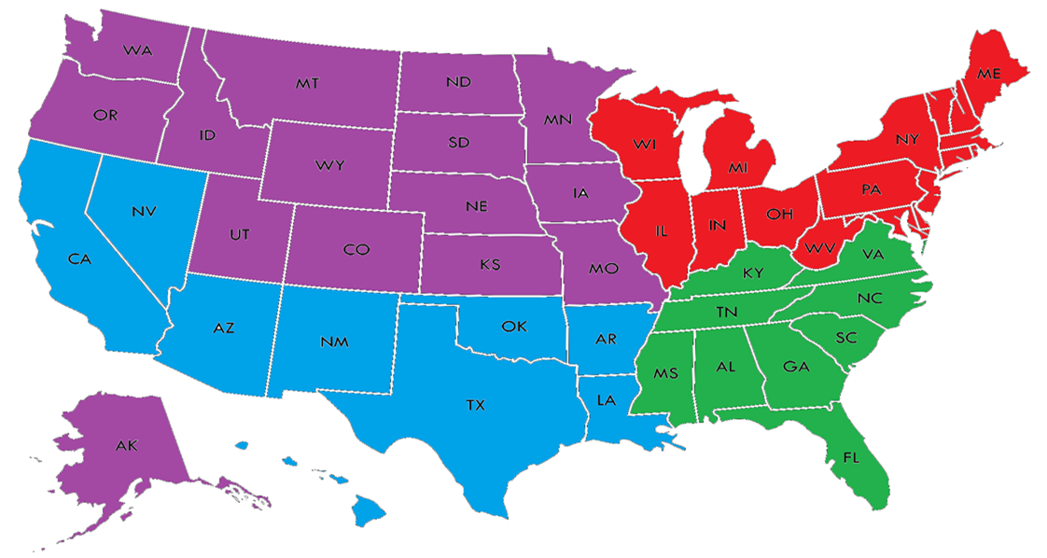

Season Structure:
- The USFL uses a spring-to-summer season format, similar to the Arena Football League (AFL):
  - Each team plays 1 preseason game (1h or 1a) beginning on the 1st Sunday of March, and ending one week later:
    - The preseason games will take place on the 1st Sunday of March.
    - If a player enters and leaves, from the moment he leaves the player is considered "dead" and cannot return to play until the designated time is served, or if a player is injured.
      - “Dead time” is 2 possessions (1 offensive & 1 defensive); Exception = a "dead" player may participate on kickoffs and conversions, or as long snapper or holder.
      - All players are required to play in every game unless an injury occurs; Each player must play a minimum of 2 possessions (or 8 plays).
  - The USFL Conference Format:
    - The Eastern Conference = teams east of the Mississippi River.
    - The Western Conference = teams west of the Mississippi River.
  - The USFL Schedule Format:
    - All games will either be played at any of the following:
      - One of the team's stadiums.
      - A neutral site in the US with no professional football team within 700mi / 1126km of either franchise (especially for testing new cities for an expansion franchise in the USFL and/or lowering travel costs).
  - All USFL games must be scheduled on the following:
    - Saturday afternoons & evenings.
    - Sunday afternoons
    - Monday & Thursday evenings (however, teams can only have 1 Thursday game per season).
    - All teams can have no more than 1 game per week.
      - All teams are required to have an off day after a game.
- All teams must host an open 2-day tryout no more than 1 week prior to the start of spring training camp:
  - A max of 160 potential players in addition to all of the players from the previous year & the players recently drafted (i.e. 200 total players) are allowed.
  - Players will be tested on their 40-yard dash time and short shuttle with other position-specific drills and one-on-one drills to follow.
  - All positions will be evaluated in tryouts.
  - All tryouts must take place on Saturday & Sunday.
  - Registration fees:
    - A $59 pre-registration fee for the following types of players listed below can be applied no more than 1 day before the start of the tryouts/preseason.
    - Registration after that time and the day of will require an $99 application fee of the following for the following types of players.
    - All of the registration fees listed above are in 2020 USD; both fees must be adjusted for inflation at least once every 5 years.
- Bonus Points System:
  - 4 points for winning a game in regulation.
  - 3 points for winning a game in overtime.
  - 2 points for drawing a game
  - 0 points for losing a game
  - 1 bonus point for losing by 8 points (or fewer) or in overtime.
  - 1 bonus point for scoring at least 4 touchdowns.
  - 1 bonus point for winning while scoring at least 3 more touchdowns than the opponent.
  - At the end of the regular-season, the team with the best regular-season record (i.e. highest point total) at each level regardless of conference is awarded either the USFL Supporter’s Trophy:
    - For those who don't know, it echoes the practice of the top European soccer leagues in which the team with the best record is the champion, like the Supporter’s Shield in MLS.
    - The Trophy winners are guaranteed home-field advantage in all rounds of the playoffs they compete in (excluding the USFL Championship).
    - The USFL Supporter’s Trophy can just be a certificate in a frame.
    - Regular-season rankings will be based on the amount of bonus points that each team has.
  - Tie-breaker - If only two teams are level on league points:
    - Most wins.
    - The team that won the head-to-head match (if applicable) is ranked first:
      - For divisional rivals, this becomes the teams with the higher aggregate score (i.e. The combined score from both games).
      - If this game was a draw, then the team with the more wins is ranked first.
    - Point difference (PD) = is the number of goals (or points) scored in all league matches minus the number of points conceded.
    - Points for (PF) = is the total number of points scored by a team over the course of the regular-season.
    - Points against (PA) = is the number of goals scored against them by their opponents over the course of the regular-season.
    - Fewest disciplinary actions.
    - Strength of schedule = two-third (66 2/3%) for the opponent's record and one-third (33 1/3%) for the opponents' opponents record.
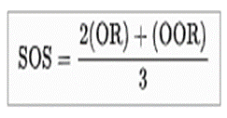
    - Total number of points scored on the road.
    - Road point difference.
    - Total number of points scored @ home.
    - Home point difference.
    - If still identical, a play-off is required.
    - Coin toss (2 teams) or drawing of lots (at least 3 teams).
- All teams play a 13-week schedule with 12-total regular-season games & 1 bye week:
  - The USFL Schedule Format = All teams play the other 6 conference teams twice (1h/1a) (12 games).
  - The USFL regular-season runs from the 4th or final Sunday of March and ends 12 weeks later (2021 example = March 28 to June 20).
  - The postseason runs from the on the final Sunday of June, & will end on the 2nd Sunday of July with the USFL Championship.
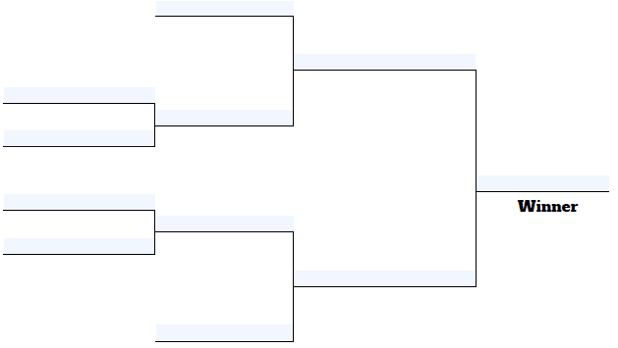
- The top 3 teams from each of the league's two conferences at each level qualify for the playoffs based on total points earned using the bonus points system:
  - At each level, all teams will be seated 1 through 3 per conference based on the number of bonus points that they have, & will never be reseeded.
  - 1st Round (Conference Semifinals) = 2v3; 1 gets a bye.
  - 2nd Round (Conference Championships). = 1 vs 2/3.
  - 3rd Round = the USFL Championship.
- All USFL playoff games will be played at the higher ranked team’s stadium, except for the USFL Championship Game:
- The locations of the USFL Championship will be chosen by the USFL 3-5 years before the game.
- Any of the following can host the USFL Championships:
- Any USFL or NCAA division 1 college team with a stadium capacity of at least 30,000 (including club and fixed suite seating).
- Stadiums may include temporary seating for the USFL Championships but seating must be approved by the league.
- Stadiums where the average game day temperature is above 100 °F (37 °C) must either have a roof or a waiver given by the league.
- There must be a minimum of 3,000 parking spaces within one mile of the stadium.
- The host stadium must have space for the Gameday Experience, a large pregame entertainment area, within walking distance of the stadium.
- The host city for the USFL championship must have space for the USFL Experience, the interactive football theme park which is operated the week prior to the Super Bowl. An indoor venue for the event must have a minimum of 850,000 square feet, and an outdoor venue must have a minimum of 1,000,000 square feet.
- Additionally, there must be space nearby for the Media Center, and space for all other events involved in the Super Bowl week, including golf courses and bowling alleys.
- The necessary infrastructure must be in place around the stadium and other Super Bowl facilities, including parking, security, electrical needs, media needs, communication needs, and transportation needs.
- There must be a minimum number of hotel spaces within one hour's drive of the stadium equaling 35% of the stadium's capacity, along with hotels for the teams, officials, media, and other dignitaries.
- There must be practice space of equal and comparable quality for both teams within a 20-minute drive of the team hotels, and rehearsal space for all events within a reasonable distance to the stadium.
- The practice facilities must have one field (turf or grass) for each team.
- All USFL games will be broadcast live on, Fox, FS1, Peacock, & NBC.

Gameplay Rules:
- Field Rules:
  - Field size = 100yds (91.4m) long and 53 1⁄3yds (48.8 m) wide, with two 10yd (9.1m) endzones at each end (i.e. a full-size field).
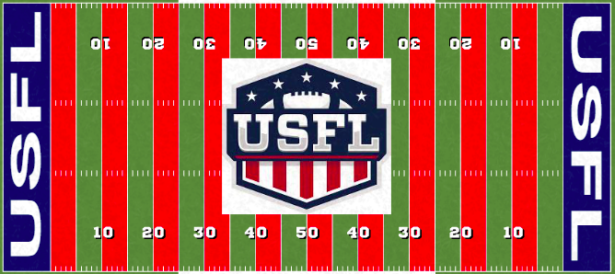
- Clock & Timing Rules:
  - Four 15-minute quarters with a 15-minute period at half-time & 2-minute periods between quarters:
    - The official time clock runs continuously unless stopped by any of the following:
      - Plays in which a touchdown or safety is scored (which must be automatically reviewed).
      - When a time out is called by either team.
      - Official reviews of penalties (including coaches challenges; instant replay reviews will be limited to 30 seconds).
      - PAT conversion plays after a touchdown.
      - The referee stops play to allow opposing teams to align properly after a play.
      - Incomplete passes, but only for the 1st & 3rd quarters.
      - The mandatory play stoppage with 2 minutes remaining in each half.
      - After the two-minute warning, the clock will stop for first downs in the 2nd & 4th quarters. Otherwise, the game clock is run only from the snap of the ball to when the referee declares that play dead (i.e. the clock stops after every play after the 2-minute warning).
  - A 35 second play clock will start winding once the official has spotted the ball, blown the whistle and signaled for the clock to wind. A play clock will wind in regular game play, conversions, and kickoffs.
  - There is a 2-minute warning at the end of the 2nd and fourth quarter.
  - All teams have no more than 2 timeouts per half.
  - During regulation the clock will stop during penalties or change of possession. Once the ball is spotted by the official the game and play clock will start.
  - Overtime Format:
    - Teams will meet at the 50-yard line for another coin flip to determine the possession of the first extra period, and which end zone each team will use.
    - The visiting team picks heads or tails.
    - Teams will attempt a max of 3 (for regular-season games only; no limit for post-season games) alternating two-point attempts from the two-yard lines.
    - One team’s offense will be on one end of the field, while the other team’s offense will be on the other end of the field to save time.
    - Whichever team has the most points after the three tries, or after one team gains an insurmountable lead, will be the winner.
    - If an offensive team turns the ball over to the defense, the ball is automatically dead and the defense cannot return the ball to their opponent's end zone.
    - A team can call one timeout per try.
    - Defensive penalties result in the ball moving up to the 1-yard line, while any subsequent defensive penalty on any play, even in future rounds, result in a score awarded to the offensive team.
    - Pre-snap offensive penalties result in the ball being re-spotted to the 5yd line, while post-snap offensive penalties result in a loss of down and no score
    - The USFL pre-season games will no longer have any overtime periods (i.e. be declared ties).
- Prior To The Snap:
  - Line of Scrimmage & Offside Rules:
    - 6 players are eligible to touch the ball on offense while the other 3 are required to line up in the center of the formation as linemen.
    - No chain crew will be used to determine first downs. Instead, the league uses proprietary technology similar to the NFL's Next Gen Stats:
      - A microchip is included in each ball to help pinpoint its location and determine whether the offense has reached the line to gain.
      - The ruling will be displayed on stadium scoreboards and television broadcasts, just as with the Hawk-Eye system being used to call in-or-out balls in tennis
      - Due to this, players cannot not throw the football into the stands or hand it off to a spectator following a touchdown. The penalty for such behavior is unsportsmanlike conduct, a 15-yard penalty, and if it is determined to be deliberate, a fine can be assessed to the offending player
    - The 3-5 offensive linemen (1 Center, 2 Offensive Guards, 1-2 Optional Tight Ends) must be on the line of scrimmage with a split no wider than 1yd in between each player:
      - 3 Linemen = 1 Center & 2 Offensive Guards.
      - 4 Linemen = 1 Center, 2 Offensive Guards, & 1 Tight End.
      - 5 Linemen = 1 Center, 2 Offensive Guards, & 2 Tight Ends.
    - The 2-4 defensive linemen (0-1 Nose Tackle, 2 Defensive Tackles, & 0-2 Defensive Ends) must line up at least 11” away:
      - 2 Linemen = 2 Defensive Tackles.
      - 3 Linemen = 1 Nose Tackle & 2 Defensive Ends.
      - 4 Linemen = 2 Defensive Tackles & 2 Defensive Ends.
    - All lineman (except for the center/long snapper) must line up in a 2-point or 3-point stance, unless either 1) the offense needs 5 yards or less to obtain a 1st down and/or b) the offense is inside the 25yd line (in which case they can line up in a 4-point stance).
    - The defensive lineman may stunt/twist (i.e. execute a planned maneuver by which they exchange roles to better slip past blockers of the offensive team at the beginning of a play).
    - Common Formations:
      - Offensive formations include the T, I, Spread, Shotgun, Pro set, & Pistol.
      - Defensive formations include a 2-3-3, 3-3-2, 3-2-3, 4-3-1, 3-4-1, 4-2-2, 5-3, and a 6-2 goal-line.
    - If either an offensive or defensive player is lined up offsides when the ball is hiked it will be a 5-yard penalty:
      - The play will be a free play for the offense unless the defender has a clear path to the QB because of his offsides, then it will be blown dead.
      - If any offensive player other than the quarterback moves early the play will be blown dead and the ref will call for a “reset”. The play clock will continue to wind when a reset is called. If a defensive player jumps early, the whistle will blow, the play clock will pause, and we will instantly reset.
      - A ref can give a warning for defensive and offensive offsides and opt to throw a flag on each infraction after the warning. The idea is to keep the game moving, prevent long discussions and explanations about offsides, and prevent the offense from having to re-huddle.
  - QB Cadence & Positioning:
    - The QB can start from the Shotgun or behind the center.
    - The QB cannot be deeper than 5 yards from the line of scrimmage when in the shotgun.
    - If the QB moves early (rolls before cadence) it’s a 5-yard penalty.
    - The QB must be set just like the Offensive Line. All QB cadences must consist of 3 sounds and the offense can move on any of the 3 sounds:
      - For example, if your cadence is Down, Set, Go you can go on either Down, Set, or go but there is no going on 2 or trying to draw the defense offsides.
    - If the QB needs to audible and has already started his cadence he must stand up and point both arms to each sideline while yelling “CHECK”. Once the audible is complete the QB must get set again and restart his entire cadence.
  - Rules for Wide Receivers (WR) and Defensive Backs (DB):
    - Any eligible receiver lining up near an offensive lineman on the line of scrimmage must raise their hand and declare themselves a Tight End.
    - There are no formation rules for receivers and backs, only the QB and 3 down linemen have to be in a set position.
    - No more than 2 offensive players can be in motion at one time.
    - DBs cannot lead with their head on open field tackles.
    - DBs cannot launch themselves into a defenseless receiver without attempting to wrap up and make a good form tackle.
    - Players cannot lead with an elbow to make a tackle. You must attempt to wrap up on the secondary.
    - DBs may blitz but must obey the Pass Rushing Rules listed below.
    - Only 5 offense players are eligible to touch the ball:
      - The player to whom the ball is snapped cannot advance the ball past the line of scrimmage (thus eliminating such plays as the bootleg or scramble).
      - However, if the ball is tossed to another player, that player can run or throw the ball and the player to whom the ball was snapped is still an eligible receiver.
      - Teams are able to attempt two forward passes on the same play, so long as the ball never crosses the line of scrimmage before the second pass.
- All USFL league games will include kickoffs, field goals, and punts:
  - To start each half and after every score, the defending team will kick (i.e. place kick or punt) the ball off from their own 25yd line. The player kicking the ball can get a running start but cannot pass the 25yd line.
  - Kickoff Formation Rules:
    - No kicking team member may line up further back than one yard behind the ball.
    - The kicking team must also have 4 players on each side of the kicker.
    - Only a max of 2 gunners may line up outside the numbers.
    - The receiving team must have at least 6 players in the setup zone between the kicking team's 35yd and 50yd lines.
  - There is no blocking by either team allowed from the kicking teams 25 yd line to the kicking team’s 40yd line.
  - The ball must travel a minimum of 20 yards (to the kicking team’s 45yd line) and stay inbounds:
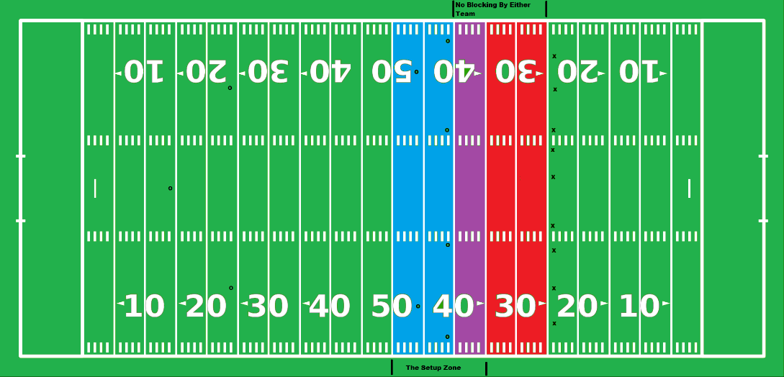
    - Gunners cannot be double-team blocked until the ball reaches the kicking team’s 45yd line.
  - If the ball lands in the end zone and has NOT been touched a returner and has traveled the minimum distance, the returner may down the ball in the end zone or choose to return it; however, the ball is still live.
  - The USFL uses two different types of touchbacks:
    - A major touchback occurs when a kick travels into the endzone in the air & either 1) rolls out of bounds before the return team can retrieve it or 2) the return team is forced to down the ball, which results in the receiving team taking possession at the 25.
    - A minor touchback occurs when the ball bounces into the endzone & either 1) rolls out of bounds before the return team can retrieve it or 2) the return team is forced to down the ball, which results in the receiving team taking possession at the 15.
    - Both types of touchbacks will result in the kicking team receiving 1 point if the ball travels out of the end zone or a player on the return team takes a knee in the end zone (i.e. a “rouge” from the CFL).
  - Kickoffs that go out of bounds via the sidelines, regardless of whether a player touches the ball or not, will have the receiving team gaining possession at the spot where it went out of bounds
  - Teams can request to attempt an onside kick under more conventional kickoff rules. If a team opts for an onside kick, the ball must travel at least 10 yards before it can be recovered by the kicking team (as with other leagues) but may not travel more than 20 yards downfield in the air from the spot of the kick.
  - Teams may also attempt an "onside conversion", a scrimmage play from their own 15-yard line and gaining at least 20 yards (essentially, a 4th-and-20th play):
    - A team is not allowed to attempt such a play after a field goal, touchdown, or safety unless any of the following applies:
      - The team that scored is trailing by at least 14 points.
      - During the final 3 minutes of the 1st half.
      - During the final 5 minutes of the 2nd half.
  - Fair Catch / No-Yards Rules:
    - Like in the CFL, punts & kicks are allowed at any point of time in the game (i.e. any player can kick the ball at any time, including kickoffs):
      - Any kick that goes into the end zone is a live ball, except for a successful field goal, rouge, or if the goalposts are hit while the ball is in flight.
    - All punt or kickoff coverage teams must give a 5yd empty zone around the opposing receiver until he has received the ball:
      - A returner cannot opt for a fair catch on all throw-offs by clearly waiving his hand side to side above his head (i.e. Fair catches are not recognized).
      - All of the players offside (i.e., in front of the kicker at the time of the kick) may neither touch the ball nor be within 5yds of the member of the receiving team who fields the kick. violation of this rule is a penalty for "no yards".
      - The penalty for no-yards is 15yds (if the ball is in flight) or 5yds (if the ball has been grounded).
      - For punts, the ball must go at least 10 yards before it can be recovered by the kicking team.
    - Any unhandled ball from any place kick or punt (except for kickoffs) may be legally recovered by the kicker or any player behind the kicker at the time of the kick so long as the ball travels at least 10 yards:
      - The ball doesn't have to be touched by the receiving team in order for the possession to count.
      - In such a case, the kicker is exempt from the No-Yards rule. Thus, a player from Team A may punt or kick the ball 40 yards, chase the ball upfield, then recover an untouched ball for a Team A first down. Such instances are rare since the player would have to elude plenty of blocking to reach the ball. When it does happen, this play is highly exciting.
      - Examples = Montreal at Toronto - Wild Ending - October 29, 2010, Montreal Alouettes Perfect Fake Field Goal vs. Lions Wk. 11 2012.
    - With the exception of a rouge, kicking/punting the ball out of bounds is a 10yd penalty:
      - Coffin corner punts would be treated as touchbacks and brought to the receiving team’s 35yd line.
- Advancing the ball:
  - Teams will be given 4 downs to make 15yds (14m), instead of the traditional 10yds (9m):
    - Teams with the lead and possession of the ball have to gain positive yards on a play from scrimmage or the clock will be stopped until the next snap.
    - Teams are required to go for it on 4th down if they are inside the 25yd line:
      - Punting on 4th down is not allowed inside the 25yd line unless the defense punts the ball out of desperation, similar to what happened in this CFL play.
      - However, teams may punt the ball if the ball is snapped from the 25yd line.
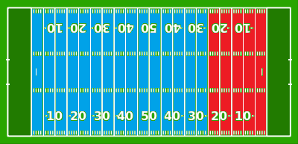
  - North-south handoffs are allowed.
  - Passing Rules:
    - 2 feet in for in bounds and TDs. If a player would have landed in bounds but is pushed out, he is still in.
    - A "defenseless player" now includes receivers tracking the quarterback or looking back for the ball, including inside the legal contact (10 yards from the line of scrimmage) zone:
      - Bump and run coverage (i.e. defensive backs being allowed to hit wide receivers any time before the quarterback releases the ball as long as the hit comes from the front and/or the side) is only allowed within the first 10yds from the line of scrimmage.
    - Teams are allowed to throw a forward pass twice on any given play as long as the ball does not pass the original line of scrimmage before the second pass:
      - Any pass batted back to the quarterback can be thrown again.
      - All players behind the line of scrimmage will be eligible receivers, including those on the offensive line (i.e. this eliminates the "illegal touching of a forward pass" penalty).
      - Offensive linemen may advance downfield on a forward pass play in which the pass does not cross the line of scrimmage; however, offensive linemen are still prohibited from advancing downfield before a forward pass that crosses the line of scrimmage is in the air.
    - No "Tuck Rule" = If a passer brings his arm forward in a passing motion and then loses possession of the ball as he is attempting to tuck it back toward his body, it is considered a fumble.
    - Pass Interference Rules:
      - Team A’s ball at the spot of the foul, first down (if the foul occurs fewer than 10 yards beyond the previous spot).
      - Team A’s ball, first down, 10 yards from the previous spot (if the foul occurs 10 or more yards beyond the previous spot).
      - No fouls for pass interference or ineligible player downfield will be called if the ball fails to cross the line of scrimmage
- Pass Rushing Rules:
  - No more than 4 defenders (or 5 with the DH) can rush the passer:
    - The penalty for violating this rule is illegal defense (signaled as unsportsmanlike conduct), with a 10-yard penalty and a first down.
    - Any player who aligns on the line of scrimmage either prior to or at the snap is designated as one of the five players regardless of whether he rushes.
  - The defensive line can only hold up or block a receiver within 5 yards of the line of scrimmage.
  - Contact after 10 yards is not allowed when a player doesn’t have the ball:
    - Violations will result in a 5-yard penalty, but not an automatic first down
    - Defensive holding (DB holding receiver) will result in 5-yard penalty, but not an automatic first down.
    - Contact on a receiver during a pass that is ruled catchable, is a spot found and called pass interference.
  - If a player has a blind side shot on the QB, they must hit him high. They cannot lower their shoulder into the QBs back or legs if they can’t see you.
- Having full-contact practices twice in the same day is prohibited during the preseason, regular-season, & postseason:
  - All teams are allowed no more than 2 full-contact practices each week during the regular season & post-season:
    - However, all teams must have a 1-day break in between practice & a game.
    - Players no longer wear shoulder pads and other protective gear in in non-contact practices.
    - There are no limits for practices with robotic tackling dummies.
  - All teams can still have 2-a-days, but the extra session has to be either film study, weight lifting, or a walkthrough.
  - No conditioning can take place at the walkthrough, and players can’t be in helmets or shoulder pads unless the tackling involves robotic tacking dummies.
- Tackling & Contact Rules:
- Tackles must be made by attempting to wrap up:
    - The only time it is acceptable to not wrap is when forcing a player out of bounds.
    - All players must tackle in between the shoulders & the knees:
      - Tackling below the knees is only permitted if you are the first available tackler and you attempt to wrap up. If you are the second tackler you must hit above the waste and you must attempt to wrap up.
      - Players are not permitted to throw a shoulder or elbow to try and knock someone down, you must attempt to wrap up!
      - No head hunting or close lining. Do not wrap around a player’s neck or head, doing so will result in the player being suspended for 1 quarter and a 15-yard penalty will be enforced.
      - To make a safe tackle keep your eyes to the sky get your butt low, hit and wrap up. Guys tackling with their heads down or throwing their body at the ballcarriers’ legs with no attempt to wrap up will be flagged 15 yards.
- A 15yd penalty is awarded against the team who commits either of the following:
    - Both types of fouls are called “targeting” fouls:
      - Any “forcible contact” to the head or neck area of a “defenseless” opponent. Example of a “defenseless” player are players who:
        - are in the act of, or having just thrown, a pass (or has just thrown a pick).
        - are catching a pass or kick (or trying to) and hasn’t had time to become a “ball carrier.”
        - are in the act of kicking, or has just kicked.
        - are on the ground, or a player out of the play.
        - gets blocked from his blind side.
        - has the ball and has had his forward progress stopped.
        - has the ball and is sliding or giving himself up.
      - Leading with the crown of the head to make “forcible contact” anywhere (i.e. a head-down hit or spearing).
    - “Inadvertent” head contact won’t be treated as a penalty.
- The Designated Hitter (DH) Rules:
    - The Designated Hitter (DH) is an extra defensive back that has to start the play at least 15 yards away from the line of scrimmage:
      - i.e. an additional 10th player on the field for the defense (the yellow player on the diagram).
      - The DH must be in either a 3-point or 4-point stance prior to the snap.
      - They are not allowed unlimited motion prior to the snap like the other backfielders.
      - They can only blitz the QB unless they pass and/or hand off the ball to another player.
      - Only defensive backs (i.e. safeties & cornerbacks) can be designated as the DH.
    - They can only be played on 3rd downs, & no one’s allowed to block them until any of the following occurs:
      - They reach the original line of scrimmage.
      - The QB leaves the pocket.
      - The QB passes and/or hands off the ball to another player.
      - The QB fumbles the ball.
- Blocking Rules:
    - No holding at all, except for the inside the jersey. The penalty for holding will be 10 yards from the original line of scrimmage and the offense will repeat the down.
    - Clipping (blocking behind the back) will result in a 15-yard penalty from the original line of scrimmage. Blocking in the back is only permitted inside the tackle box behind the line of scrimmage while a defender is being pass blocked.
    - Blocking below the waist is not allowed; this will result in a 15-yard penalty from the original line of scrimmage.
    - No intentional hands to the face. Penalty will be 15 yards from the original line of scrimmage.
    - Do not blind side a defender that has no chance in making the play. If you blind side someone that is 10 yards away from the play you will receive a 15-yard penalty. It is also a judgment call by the referee to eject a player for this penalty depending on it severity.
    - All players are prohibited from leading with the crowns of their heads on kickoffs & punts.
- Defensive players are prohibited from leaping over or hurdling the offensive line in an attempt to block field goal or extra point attempts.
- The nameplate area of the jersey has been added to the current horse-collar tackle rule.
- When a runner now slides feet first, the runner is considered defenseless, and a hit on the runner will result in a targeting penalty (i.e. meaning a 15-yard personal foul will be enforced and the player will be ejected for at least the remainder of the game after the second offense).
- No pile-ons. If the player is down and you jump on the pile you will be ejected.
- If a player forward progress is stopped the play will be whistled dead by the ref.
- Players must sit out at least 1 game after sustaining a concussion.
- No leg whipping or tripping:
    - Defenders can no longer trip the runner to bring him to the ground.
    - However, this rule does not include defenders attempting to tackle a ball carrier below the waist.
- All players who leave the tackle box are prohibited from blocking below the waist toward the initial position of the ball.
- All players (both offensive & defensive) get a max of 4 fouls (i.e. flags) per game:
  - The Card System:
    - 1st = warning (Blue Card).
    - 2nd = sent off the field for the next 4 plays or the end of the current possession (whichever comes first) with a substitute (Yellow Card).
    - 3rd = sent off the field for the next 8 plays or the end of the current possession (whichever comes first) without a substitute (Black Card).
    - 4th = sent off the field for the rest of the game without a substitute for next 12 plays or the end of the current quarter/overtime period (whichever comes first) (Red Card).
  - Referees are required to announce how many penalties each player has committed, & keep notes on which players have committed fouls (preferably on a little notebook):
    - Example = “Pass Interference. Defense #40. That is his 1st/2nd/3rd/4th foul. The ball will be placed at the spot of the foul, automatic first down”.
  - All players sent off the field are still eligible to start in the next game, unless the player either a) committed a targeting foul and/or b) has 3 straight games of receiving red cards:
    - In such a case of committing a targeting foul, such players are ineligible to start the first half of the next game regardless of whether they got ejected for targeting before or after halftime.
  - All targeting fouls (see above) are still automatic ejections (i.e. red cards) in addition to the 15yd penalty:
    - All targeting penalties must be subject to video review. If the hit is not deemed to be targeting by the video review, the player must be allowed to stay in the game and the yardage penalties will not be enforced.
  - Reviews:
    - Instant replay reviews will be limited to 90 seconds.
    - The sky judge (i.e. an additional official in the press booth for the sole purpose of reviewing on-field decision) swill conduct all reviews.
  - Penalty yardage will be assigned using the NFL system.
- Coaching Challenges:
  - Each team gets at least 1 challenge per half:
    - However, coaches will have unlimited challenges if they keep winning them.
    - The only time he loses the right to challenge a play is if they get one of their challenges wrong.
  - Coaches can challenge anything, including uncalled penalties:
    - However, coaches are required to specifically call out the penalty and players involved when challenging uncalled penalties.
- Referee Rules:
  - A ref must have the following at all times:
    - A penalty flag.
    - Whistle
    - Stop Watch
    - Knowledge of the USFL rules and access to printed or digital rule book.
    - Proper referee attire.
- Scoring Rules:
  - 6 points for a touchdown (TD).
  - Conversions or Points After Touchdown (C or PAT):
    - 1 point for a kicked (i.e. from a tee without a long snapper) convert (or PAT) kicked from the 15yd line; All kicked converts must be kicked from a tee.
    - 2 points for a passed or rushed conversion (3yds).
    - 3 points for a passed or rushed conversion (10yds).
    - All teams can waive "unnecessary" extra point attempts at the end of the game.
    - All defensive players are prohibited from leaping or hurdling over offensive linemen on field goal or PAT attempts.
    - The scoring team's extra point decision cannot be changed after a penalty or a timeout.
    - On a convert attempt after a touchdown, the defending team may return a missed kick convert to the kicking team's end zone for 1 point, or if the convert was a rush or pass play may return a fumble or interception for 2 points.
    - The team being awarded the touchdown has the option of either:
      - Scrimmaging from their own 20-yard line (but must gain at least 15yds in order to retain possession), or
      - Kicking the ball off from their own 25-yard line (can punt, drop kick, or place kick the ball).
  - Field Goals (FG):
    - 3 points for a field goal under 50 yards.
    - 4 points for a field goal 50+ yards (the 40yd line must be painted dark gray to symbolize a 4-point line).
    - If the field goal is missed, but the ball is not returnable after crossing the end line, then it constitutes a rouge/single as long as the attempt was at least 50yds.
    - On a field goal attempt, the defending team may return a missed field goal to the kicking team's end zone for a Touchdown.
    - Any punt that goes through the uprights will also count as a field goal.
  - 2 for a Safety Touch (St):
    - A safety is scored when any of the following conditions occur:
      - The ball becomes dead in the goal area of the team in possession of the ball, except for an incomplete forward pass. (Examples = ball-carrier runs out of bounds, ball-carrier is tackled/takes a knee, & the ball is fumbled out of bounds).
      - The ball touches or crosses the dead line or a sideline in goal after having been directed from the field of play into the Goal Area by the team scored against or as the direct result of a blocked scrimmage kick.
      - The offense commits a foul in its own end zone (examples = the ball carrier is penalized for intentional grounding or an offside pass in his own goal area).
    - The team being awarded the 2 points has the option of either:
      - Scrimmaging from their own 25-yard line, or
      - Kicking the ball off from their own 25-yard line (can punt, drop kick, or place kick the ball), or
      - Having the opposing team kick off the ball from their own 20-yard line (can punt, drop kick, or place kick the ball).
    - However, the team that conceded the safety also has the option of running an option play from their own 25yd line that must go at least 15 yards in order to retain possession, but only under the following circumstances:
      - Option #1 = if they are down by at least 14 points.
      - Option #2 = the game is in the final 5 minutes.
      - If the play succeeds, then the next possession starts on the 45yd line.
      - If the play fails, then the team that scored the safety will start their possession on their own 35yd line.
    - This is different from a Rouge/Single (see below) in that the team scored against begins with possession of the ball & loses possession after the score occurs.
  - 1 for a Rouge or Single (Ro or Si):
    - A rouge is awarded to a kicking or punting team (Team A) if an opposing player (Team B) either:
      - Catches or recovers a punt or missed field goal in their own end zone but is prevented by Team A from returning the ball back out onto the field of play,
      - Elects to drop to one knee while still in the end zone before having returned the ball to the field of play, or
      - Elects to run with the ball from the end zone out of bounds rather than enter the field of play.
    - A rouge is also awarded to a kicking or punting team when any of the following scenarios occurs:
      - A field goal attempt at least 50yds or longer that goes out of the end zone through the endline.
      - A punt at least 50yds or longer that goes out of the end zone through the endline.
      - A kickoff goes that either a) goes through the uprights, b) lands in and bounces out of the end-zone, or c) goes out of the end zone on the full regardless of whether it is touched or not.
    - A rouge is also awarded to a defense (Team A) if they either:
      - Force an interception,
      - Recover a fumble,
      - Block a field goal, or
      - Force a turnover on downs (unless the turnover happens inside the 20yd line).
    - A rouge is not awarded in the following situations:
      - If a ball is downed in the end zone after being intercepted in the end zone.
      - If a ball is fumbled outside the end zone.
      - If the kicked ball hits the goalposts.
      - Kicks that pass out the sidelines of the end zone (punts & field goal attempts only).
    - After a rouge, the team conceding the score is given possession of the ball on their 25-yard line (i.e. the touchback rule).
    - This is different from a Safety (see above) in that team scored against receives possession of the ball after the score.
  - Mercy Rule:
    - If a team has at least a 42-point lead at the start of the 4th quarter, the game is automatically called as a win for the team with the lead.

Pricing Minimums (on a “per person” basis):

Tickets:
All ticket prices are in 2017 US$ & must be adjusted for inflation.
Section: | Single Ticket: | Season Ticket: | Group Ticket(s):
 | Includes only a single game | Includes all 7 home games | The group must include at least 5 people, regardless of their ages
Grass / Family | At Least $14 | At Least $112 | At Least $8
Endzone | At Least $18 | At Least $144 | At Least $12
Upper / Outer Sideline | At Least $22 | At Least $176 | At Least $16
Middle Sideline | At Least $34 | At Least $248 | At Least $28
Lower Sideline | At Least $42 | At Least $306 | At Least $36
Front Row | At Least $56 | At Least $392 | At Least $50
Suite | At Least $112 | At Least $734 | At Least $106

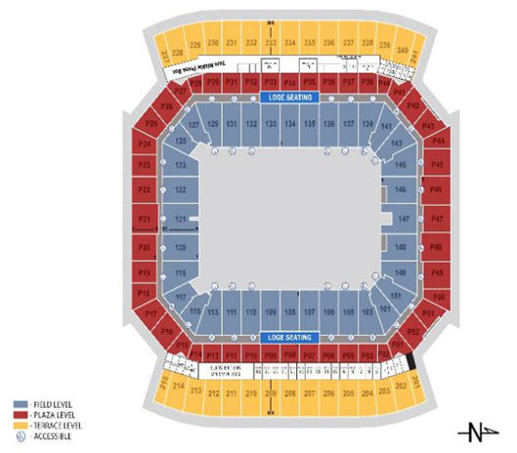
Concessions:
Item: | Main Price:
Hot Dog | At least $2.99, but no more than $3.83
Soda | At least $2.79, but no more than $3.43
Beer | At least $4.72, but no more than $5.81
Programs | Preferably fee, but no more than 83¢
Parking | At least $1.63, but no more than $4.47

Broadcasting & Miscellaneous Rules:
- Game-day inactive players must be announced at the same time for all USFL games regardless of when they kick off, unless an injury occurs during practice.
- Player Celebrations:
  - All player celebrations (individual or group) for scoring are permitted only in the end zones or the bench areas:
    - However, the ball cannot be thrown or spiked into the fans as a celebration of a score because the ball is embedded with RFID tracking chips, allowing fans to “discover the speed, spin rate and trajectory” of the football.
    - Doing so will result in a 15yd unsportsmanlike conduct penalty.
  - Referees can no longer penalize players for celebrations as long as the following rules are adhered to:
    - Celebrations are not excessively long (i.e. more than 2 minutes in the end zone; no restrictions for bench areas).
    - Celebrations are not obscene in any manner (examples = overtly racist, flashing genitals, etc.).
    - So, if a player like Antonio Brown wants to twerk, let him. If Tajae Sharpe pretends to sleep, allow it. If Josh Norman wants to shoot a bow and arrow after a pick, allow it.
- Each end zone and 50-yard line will be decorated with either of the following:
  - The team logo.
  - The USFL logo (preferably for teams that share stadiums).
  - The logo of the “main” host team (preferably for teams that share stadiums with either high school and/or college teams).
- National Anthem Policy:
  - Personnel who choose not to stand for the Anthem may stay in the locker room or in a similar location off the field until after the Anthem has been performed.
  - All players and team personnel present on the sideline “shall stand and show respect for the flag and the Anthem.”
  - Each franchise may develop its own work rules, consistent with the above principles, regarding its personnel who do not stand and show respect for the flag and the Anthem.
  - All USFL teams must donate at least $10,000 (in 2017 USD) toward LOCAL social justice initiatives (i.e. no national organizations) every fiscal year:
    - Half of the donation must come from the owners, with the other half coming from the players.
    - If any USFL player kneels during the national anthem while on the field, each individual player involved must donate at least another $500 respectively toward local social justice initiatives for each offense committed.
    - These rates must be adjusted for inflation every year.
  - The leagues have the power to fine any player & their respective franchise that has representatives who do not stand or "show respect" while present on the sideline for the anthem:
    - These rates must be annually adjusted for inflation.
    - The minimum fine is 2017 US $1,000 per player & $1,500 for per franchise which will double for each offense.
    - Each individual player(s) will no longer eligible to play in any games after their 4th offense, but they will still be paid (if they are a paid player).

